# API Testing-

**Service 1 (SOAP/ RSET)**

Application🡪 **Frond End/ UI**

**Main Server**

**Service 2 (SOAP/ RSET)**

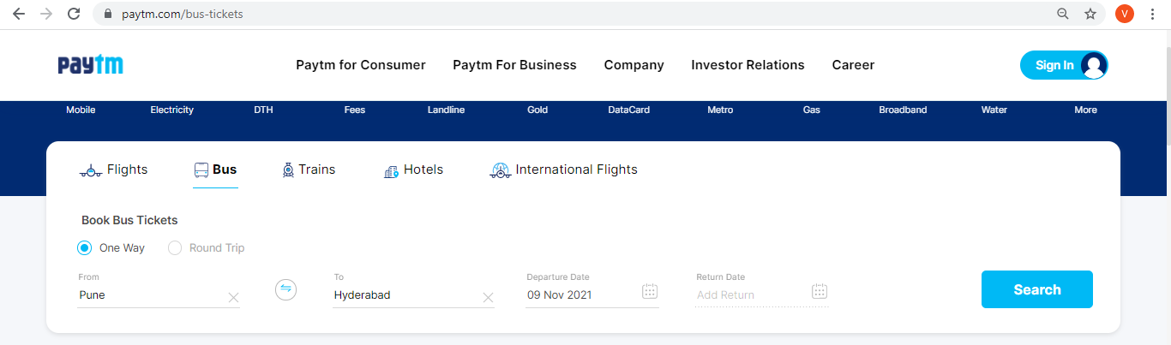

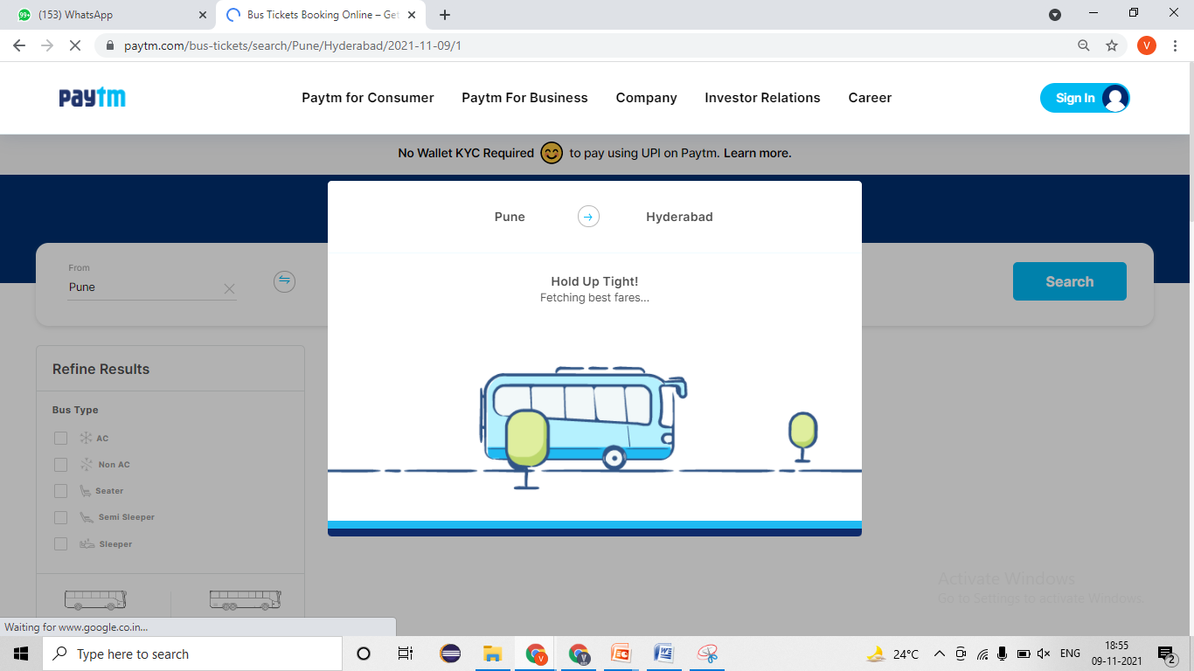

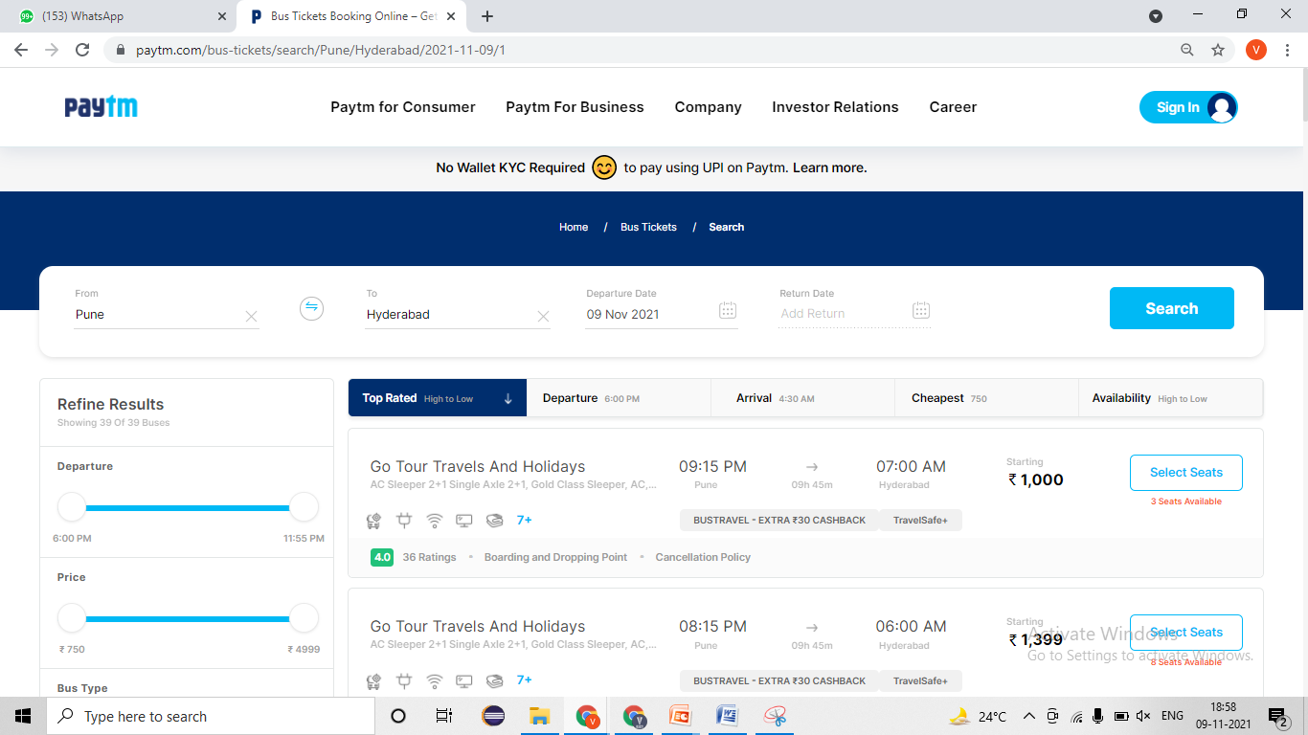

# SOAPUI Tool-

## SOAP Service-

* **Developer will provides -**
* SOAP Service- **WSDL file**= <http://www.dneonline.com/calculator.asmx?wsdl>
* Authentication/ Barrier token/ Username & password = bdewafdfscvgbhgfsdf
* Time for response < 60 sec
* Unit Testing document- Steps for testing, URL/URI, Tables name, etc

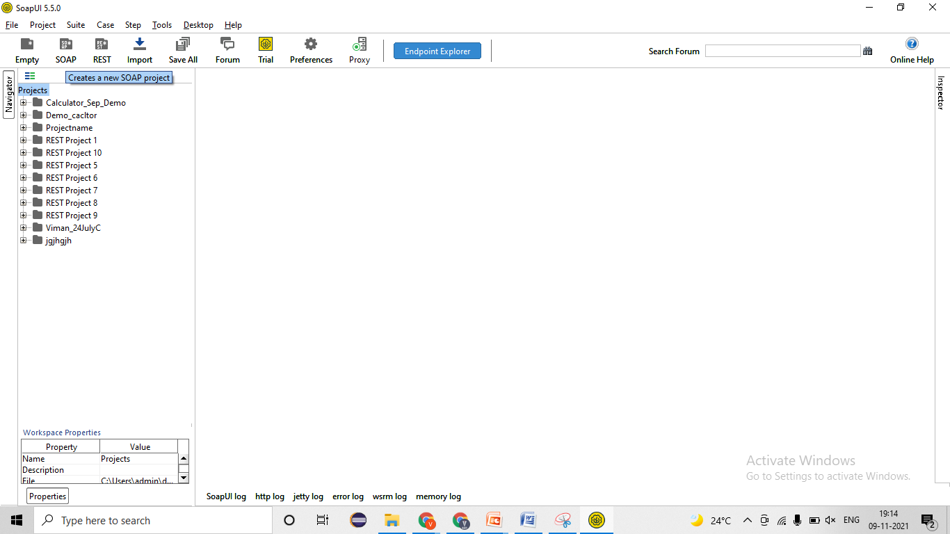

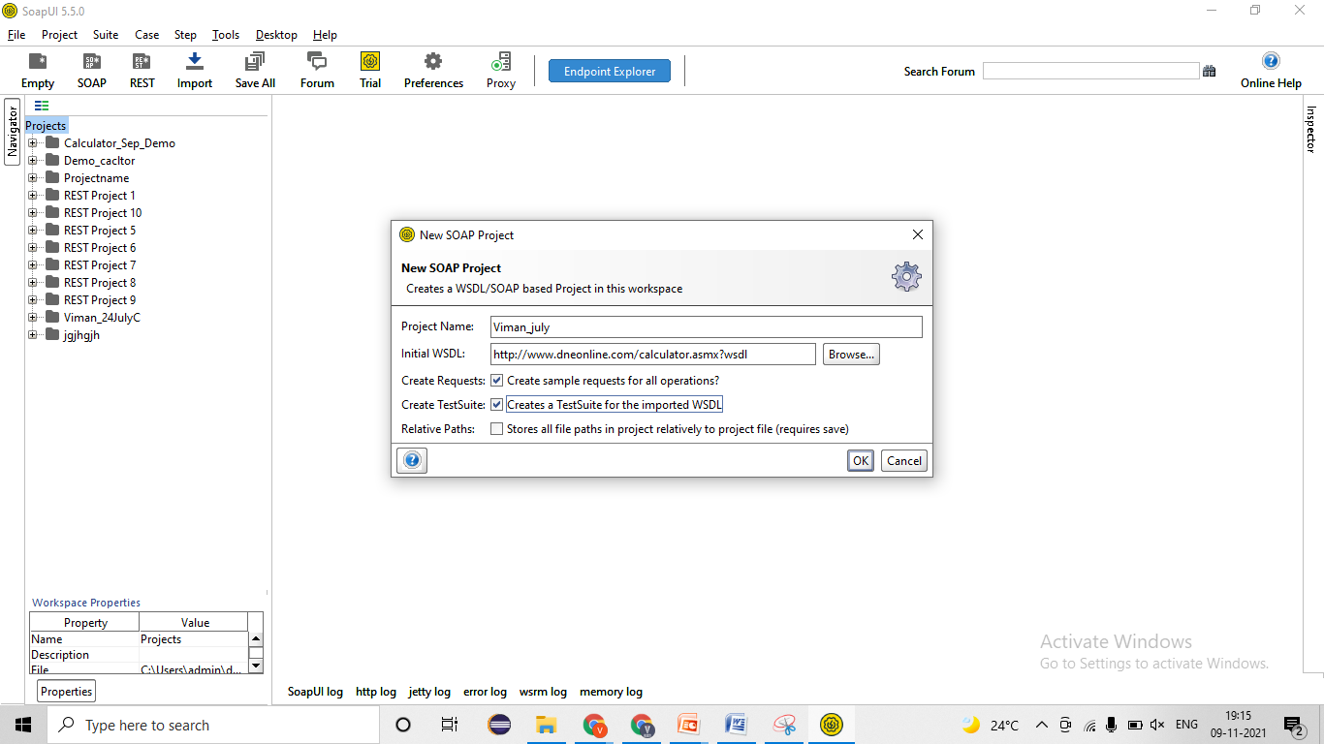

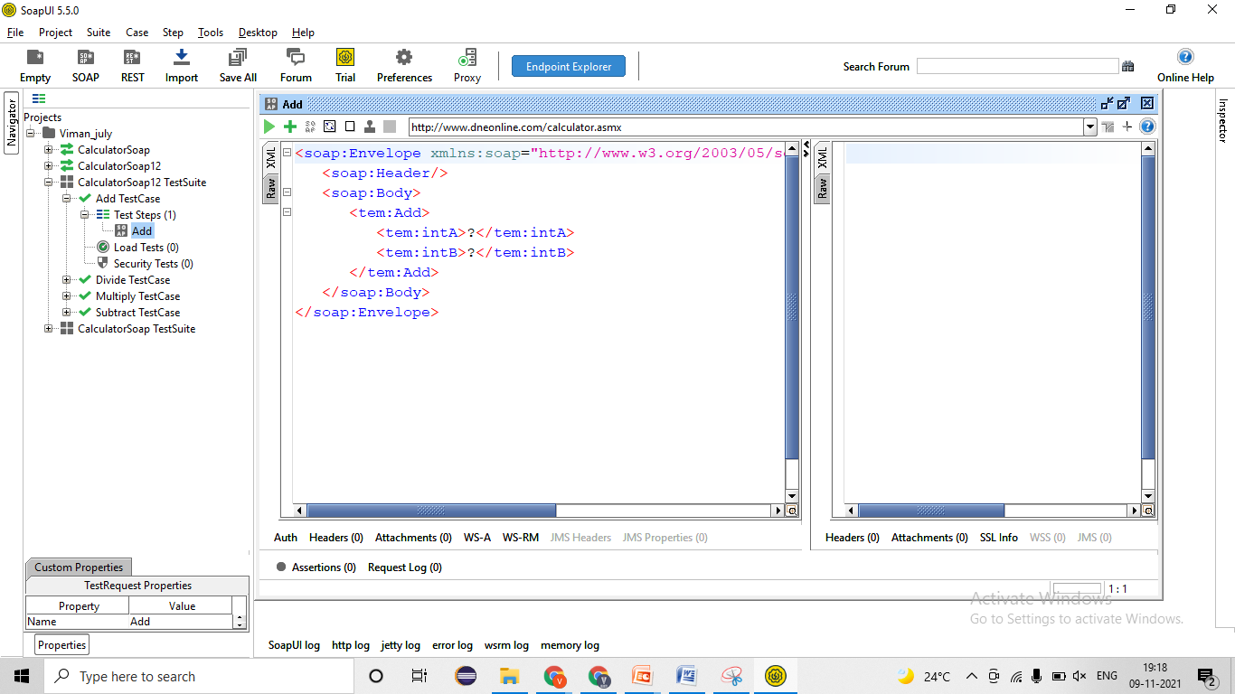

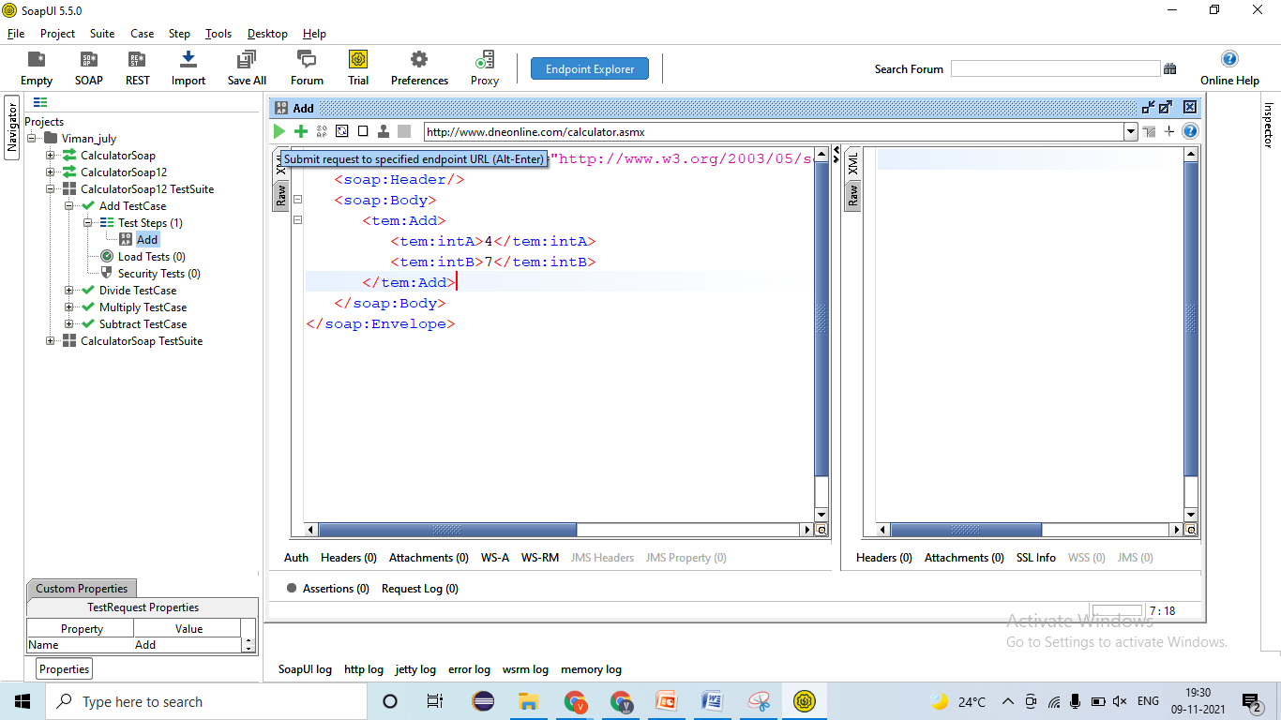

1. Validating SOAP service response=Pass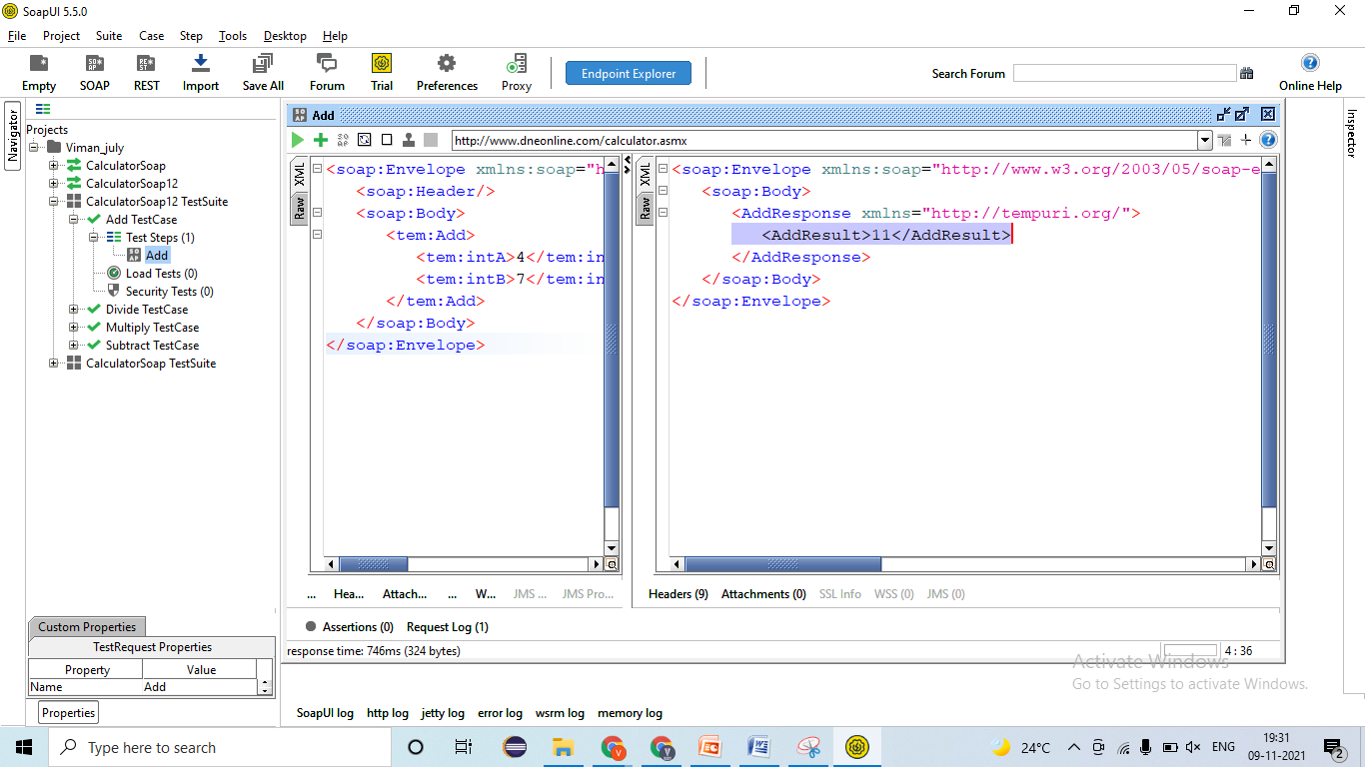
2. Validating Data and count of data in response= Pass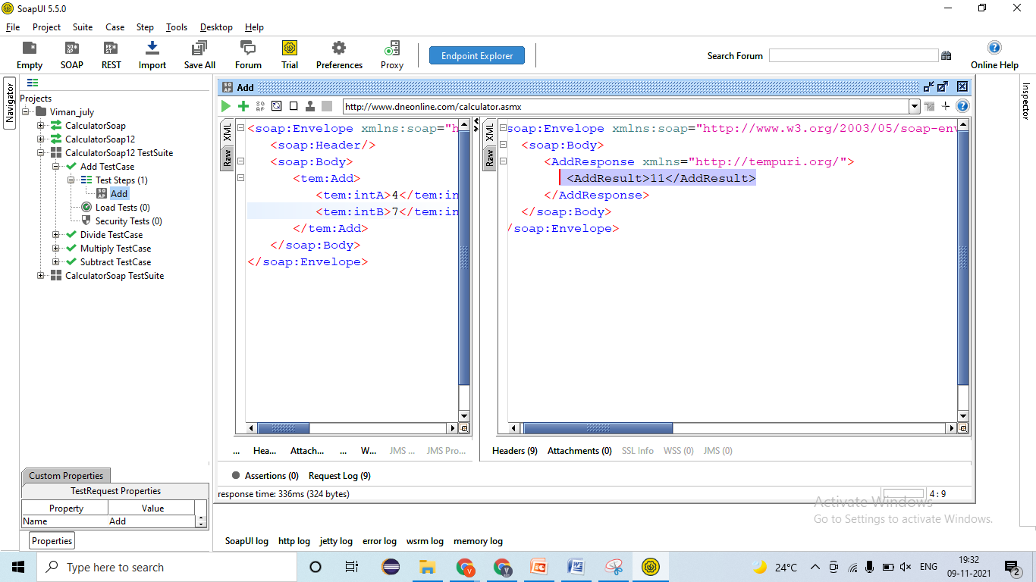
3. Validating Tagname/Attributes presents in responses🡪 Tagname= AddResult =Pass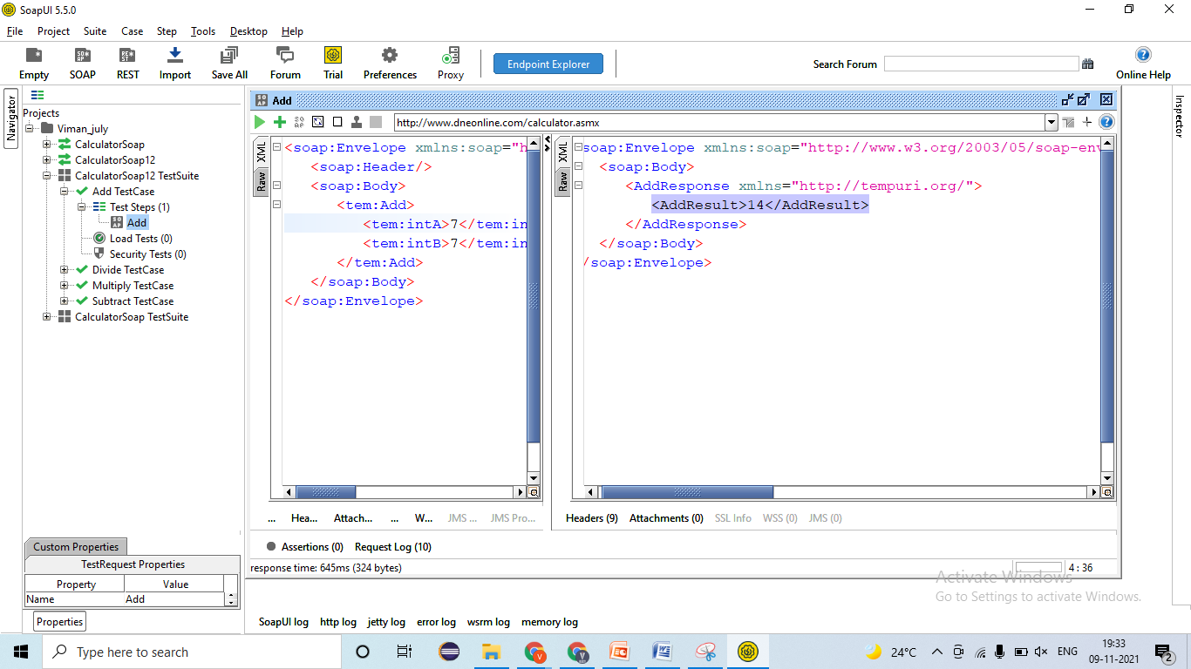
4. Validating different Status code in responses🡪 EC- 200-Ok=Pass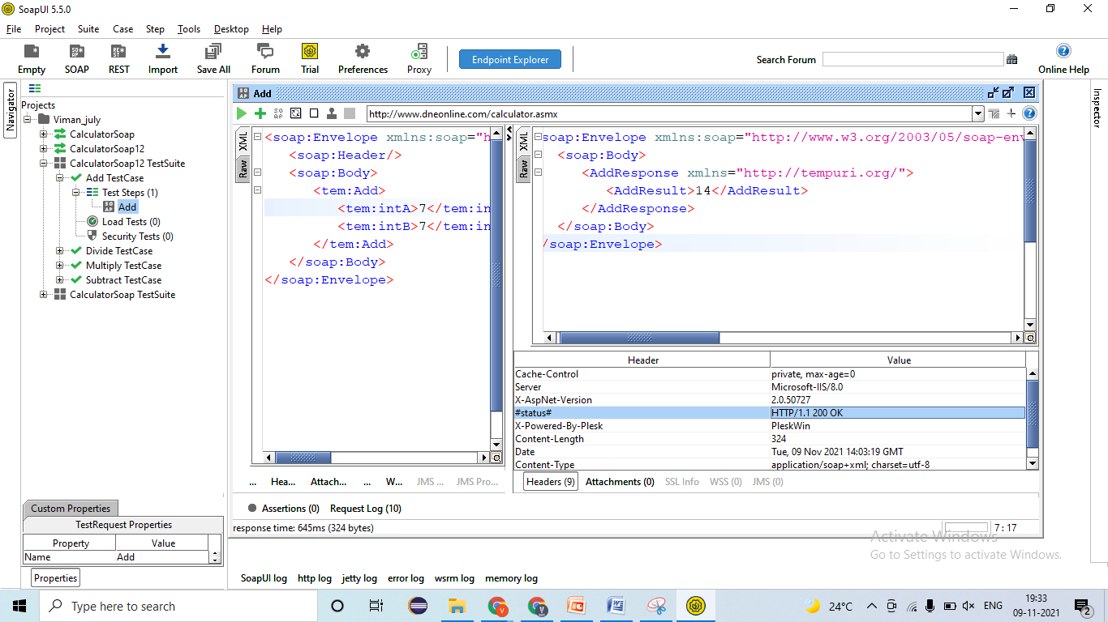
5. Validating Time taken for responses🡪 EC = Time < 60 sec = Pass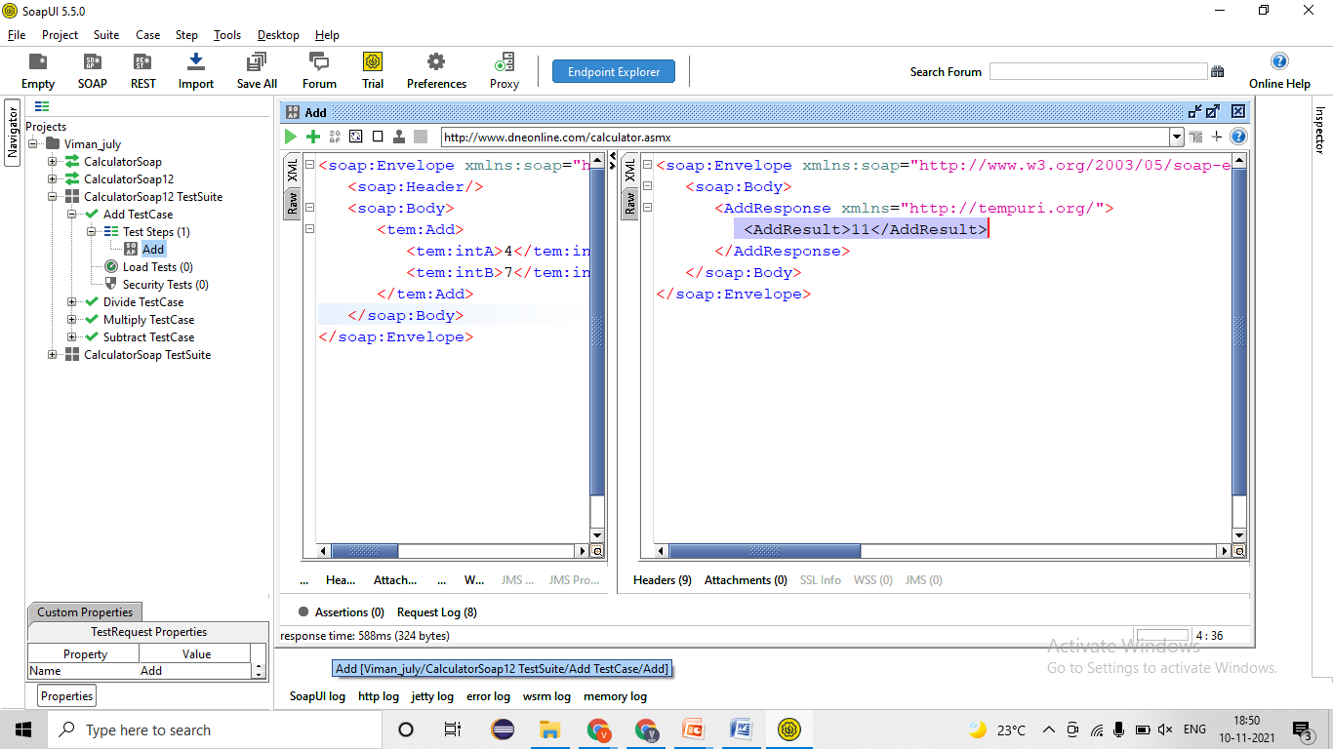
6. Applying Assertion for verification

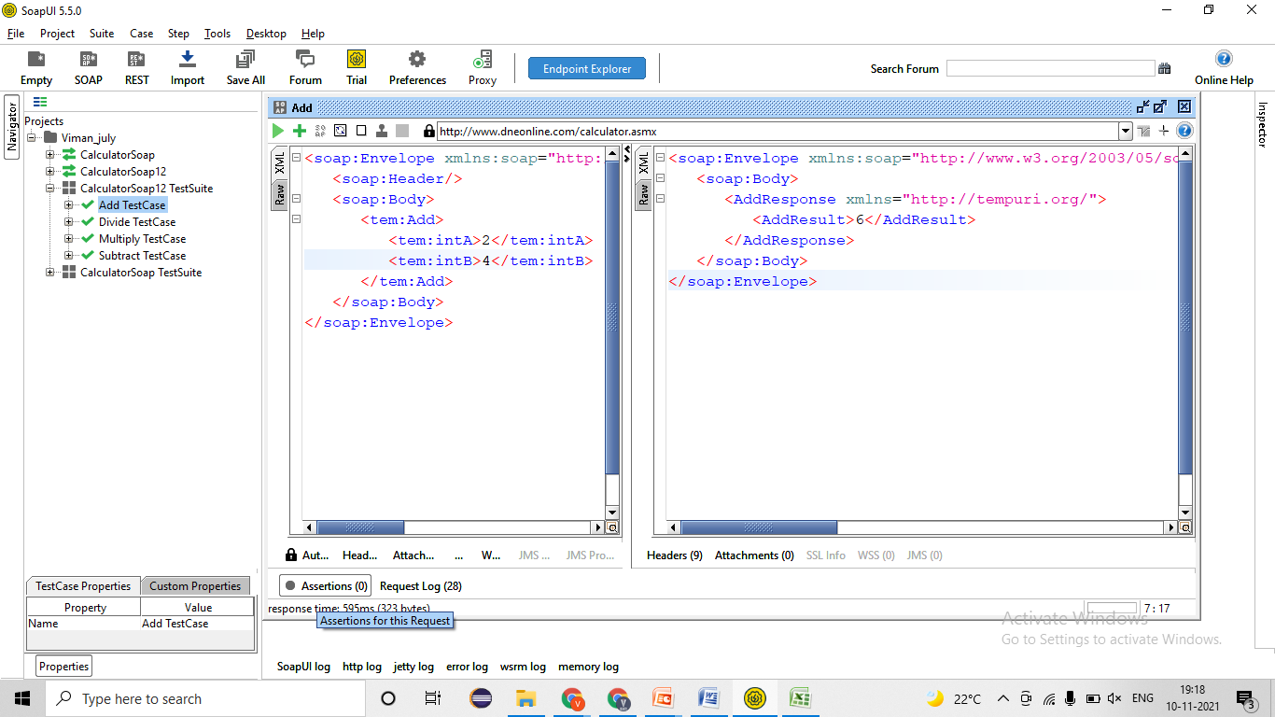

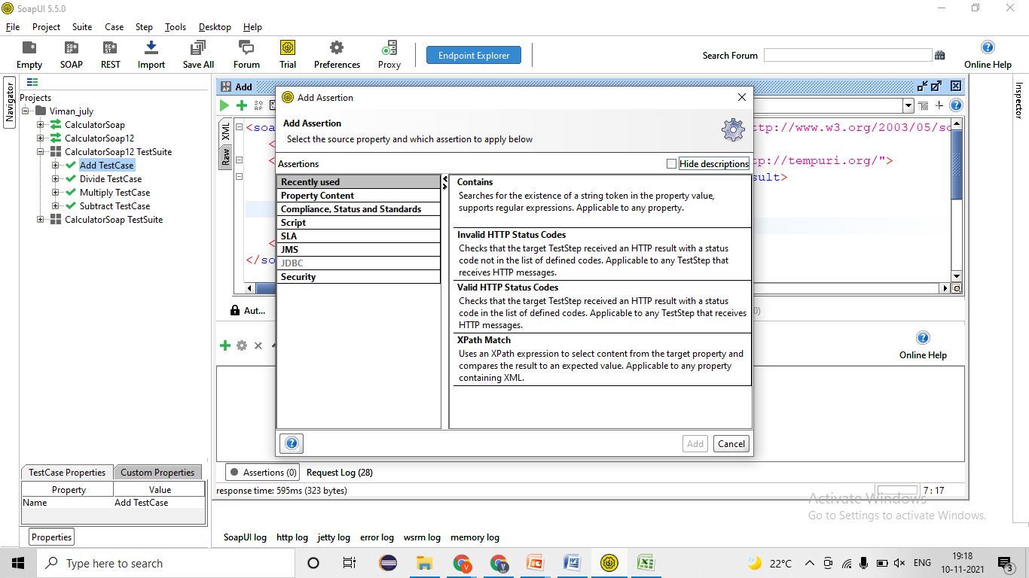

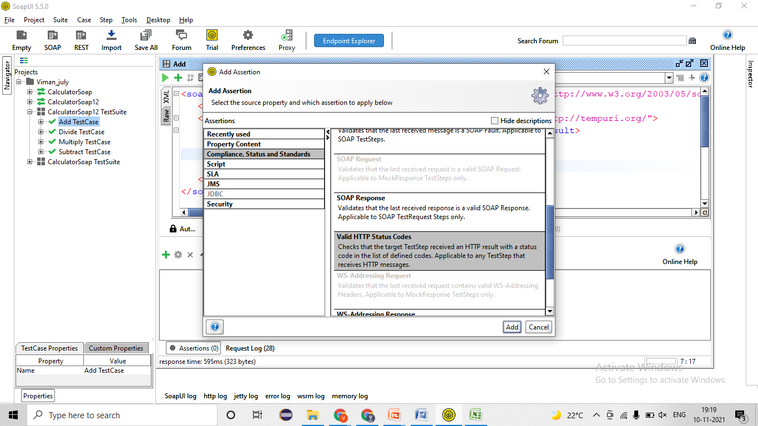

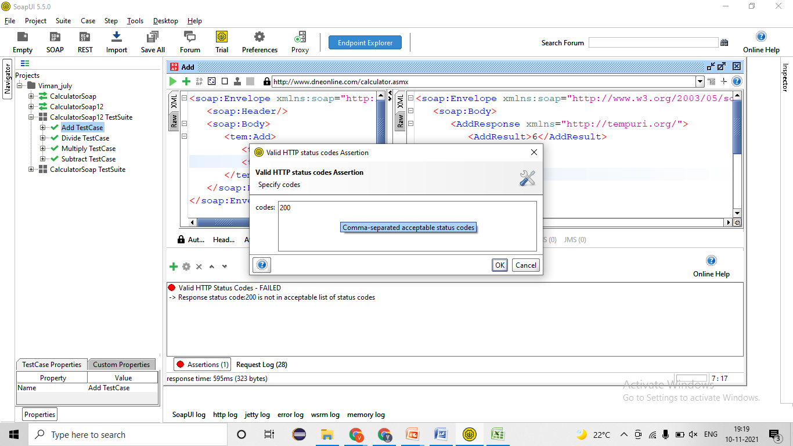

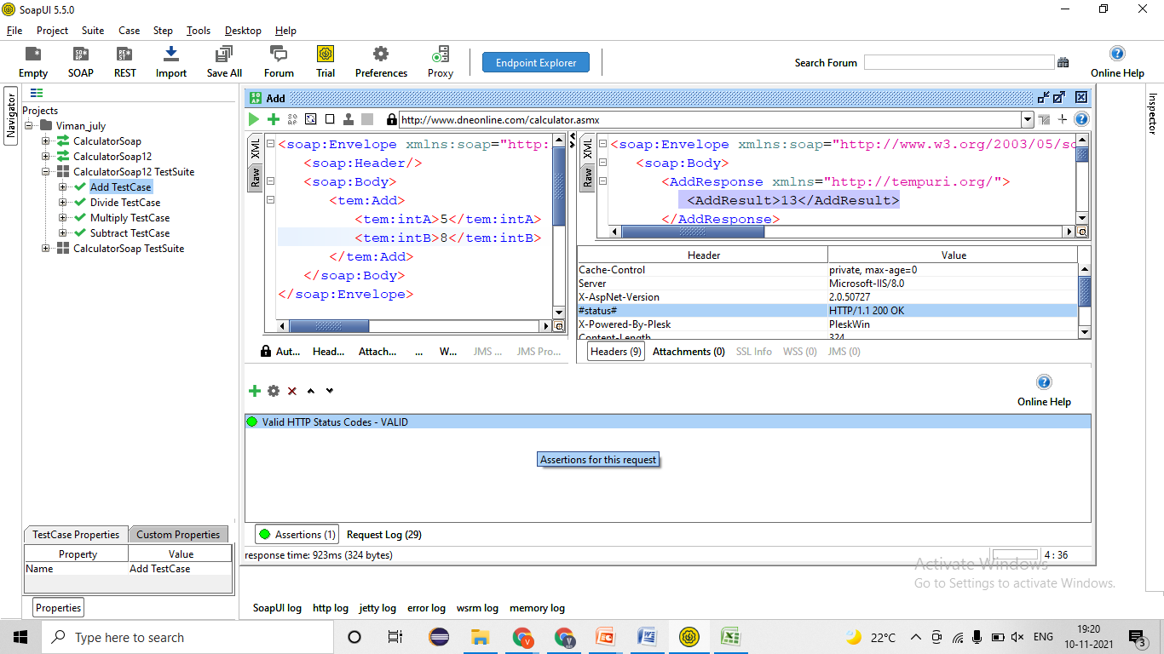

1. Validating the Functionality by passing test data
   1. Verify SOAP service by adding 1 digits no. in Add functionality 🡪 EC = 1 digits no. should be added=Pass 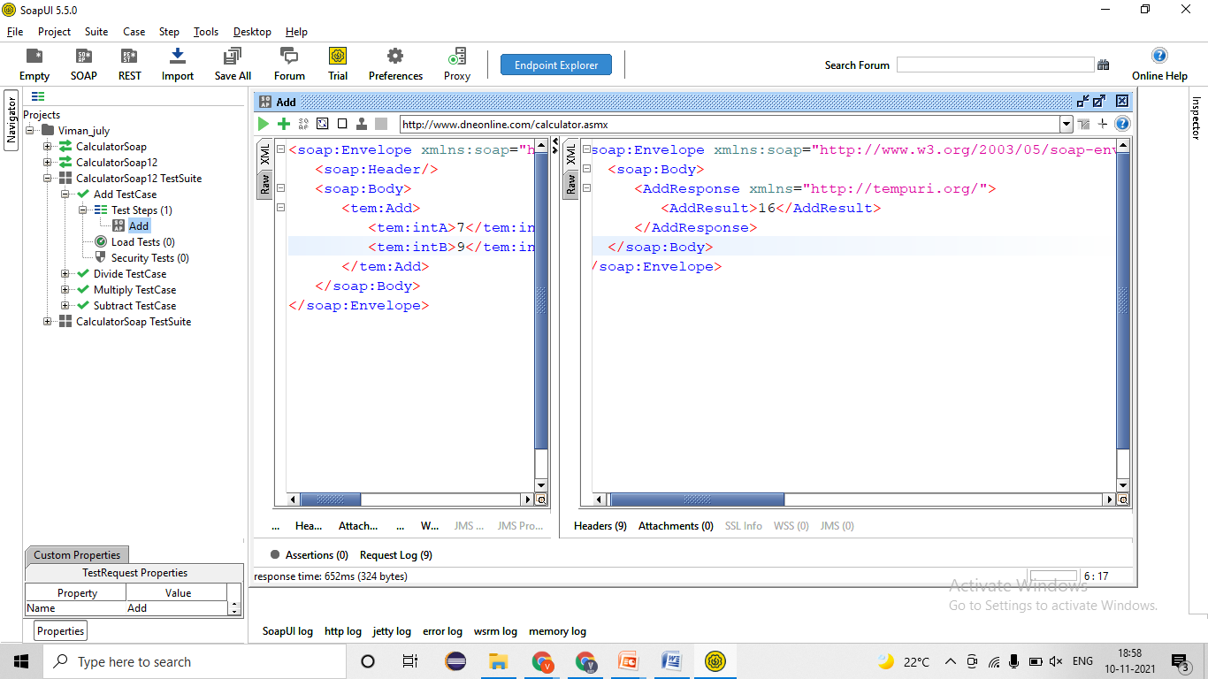
   2. Verify SOAP service by adding 2 digits no. in Add functionality 🡪 EC = 2 digits no. should be added=Pass 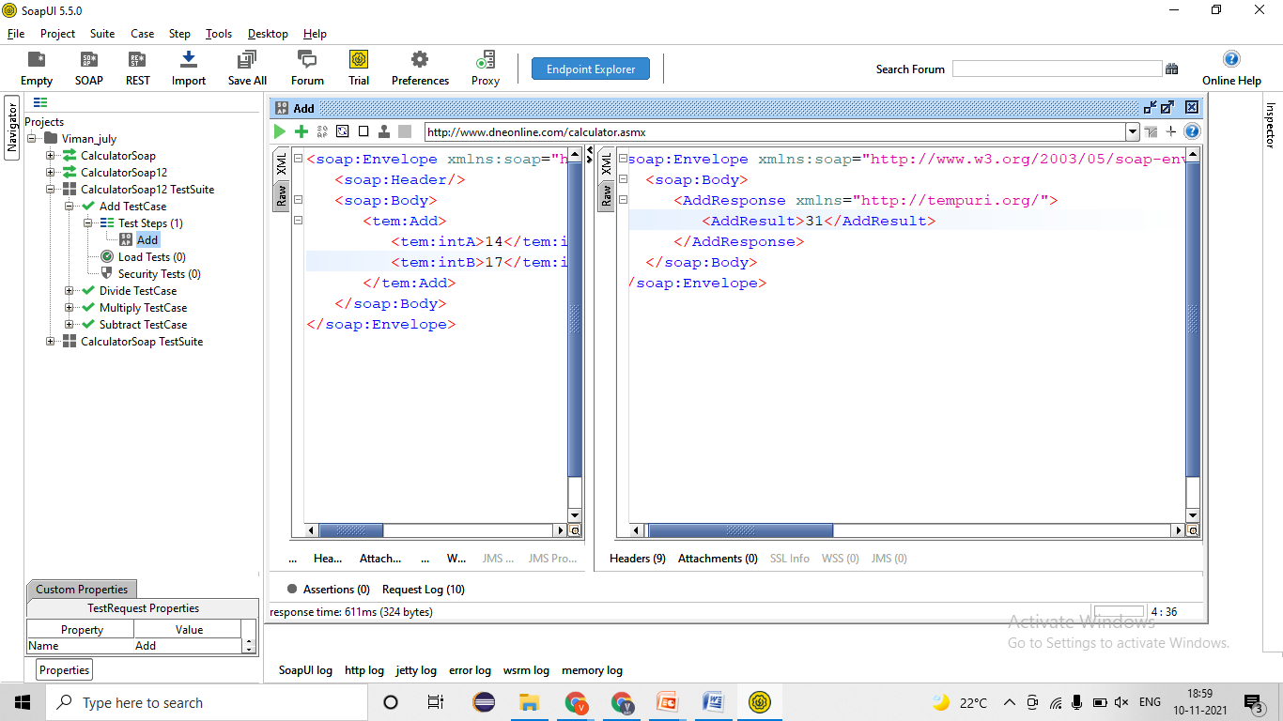
   3. Verify SOAP service by adding 3 digits no. in Add functionality 🡪 EC = 3 digits no. should be added=Pass 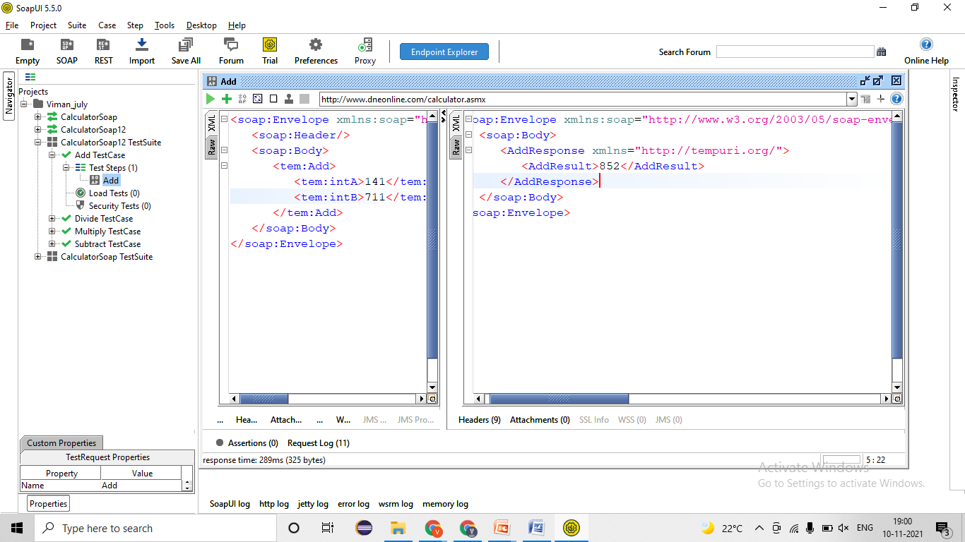
   4. Verify SOAP service by adding –ve 1/2/3/4 etc digits no. in Add functionality 🡪 EC = –ve 1/2/3/4 etc digits no. should be added=Passs 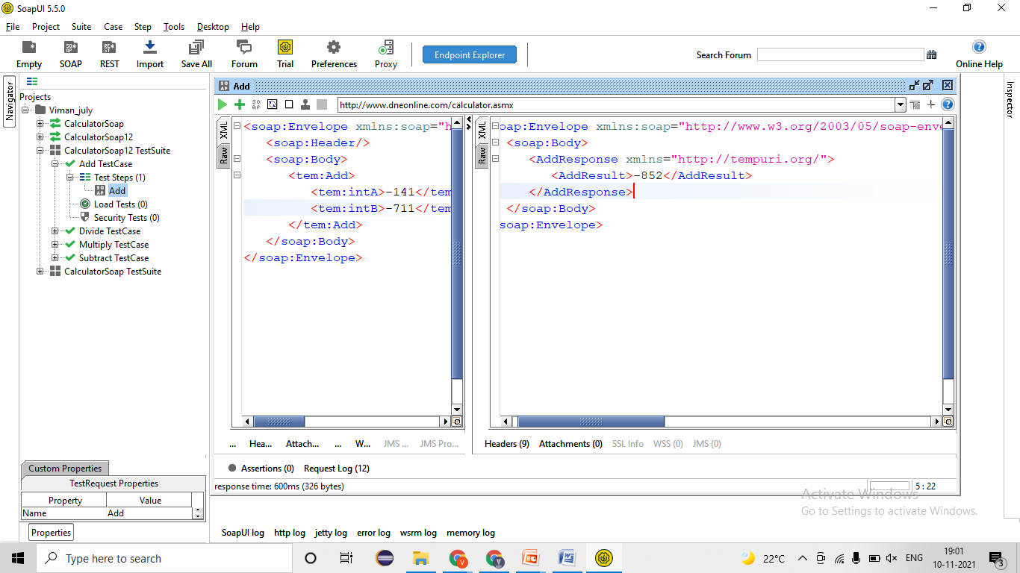
   5. Verify SOAP service by adding –ve 1/2/3/4 etc digits no. and +ve 1/2/3/4 etc digit no. in Add functionality 🡪 EC = –ve 1/2/3/4 etc digits no. should be added=Pass 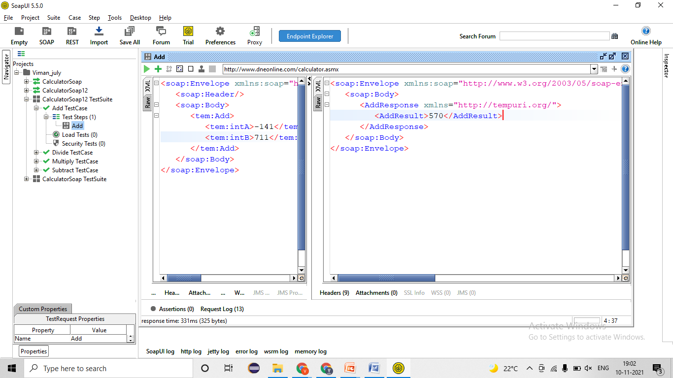
   6. Verify SOAP service by adding 1/2/3/4 etc digits no. in substration functionality 🡪 EC = 1 digits no. should be added
   7. Verify SOAP service by adding 1/2/3/4 etc digits no. in Multiply functionality 🡪 EC = 1 digits no. should be added
   8. Verify SOAP service by adding 1/2/3/4 etc digits no. in Division functionality 🡪 EC = 1 digits no. should be added
2. Validating NEGATIVE test cases !
   1. Verify SOAP service by adding decimal no. in Add functionality 🡪 EC = decimal no. should not be added=Pass 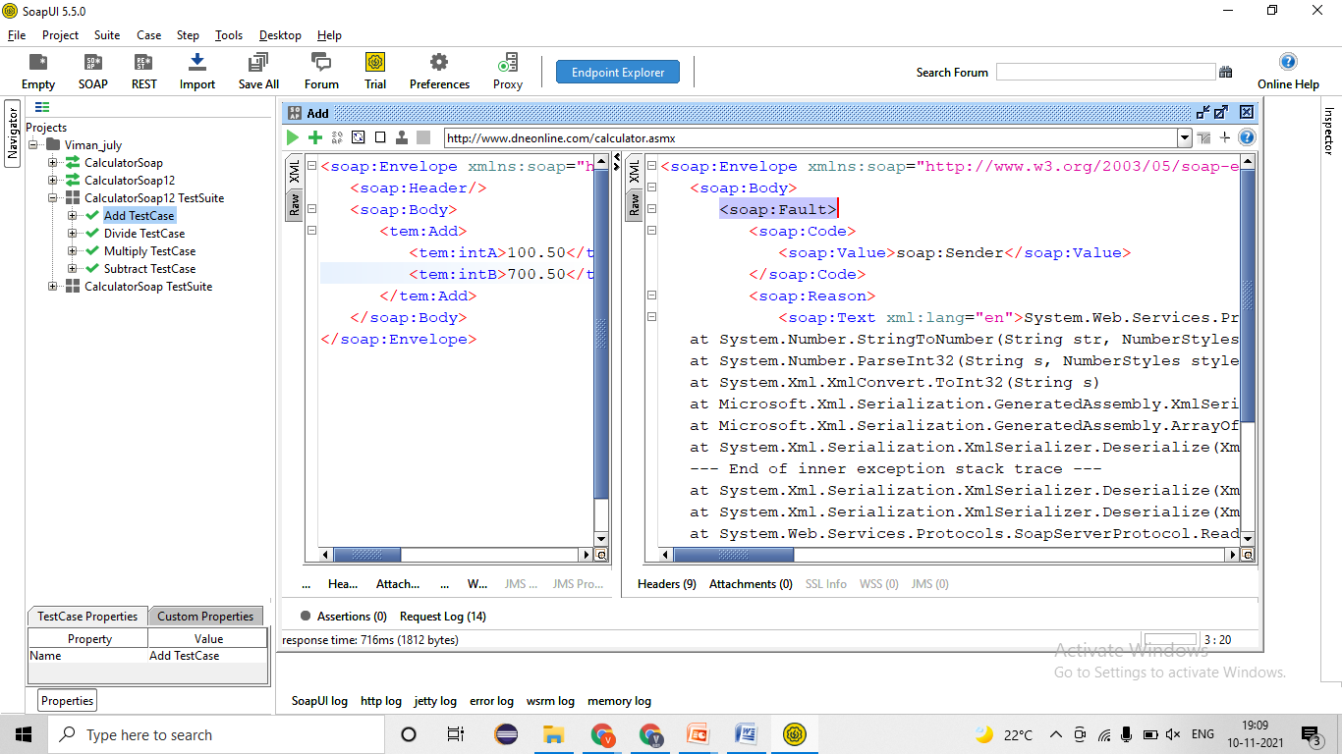
   2. Verify SOAP service by adding fractional in Add functionality 🡪 EC = fractional no. should not be added=Pass 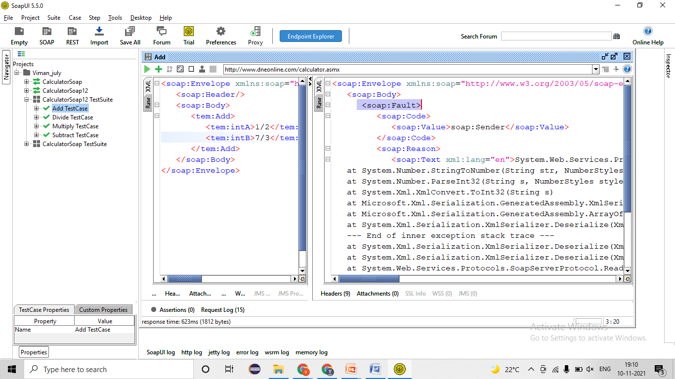
   3. Verify SOAP service by adding Alphabet/ charter/ special charter in Add functionality 🡪 EC = Alphabet/ charter/ special charter no. should not be added=Pass 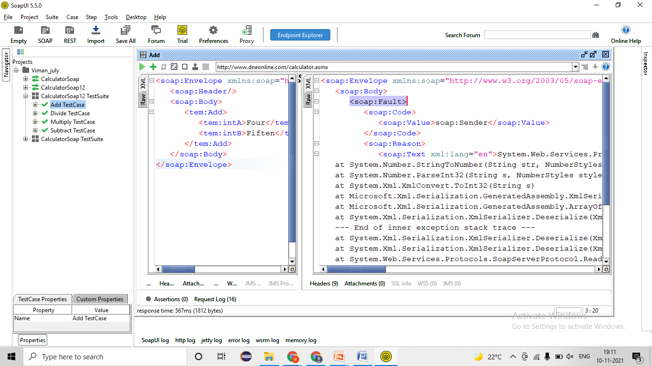
   4. Verify SOAP service by adding Lager no./ complex in Add functionality 🡪 EC = Lager no./ complex no. should not be added=Pass 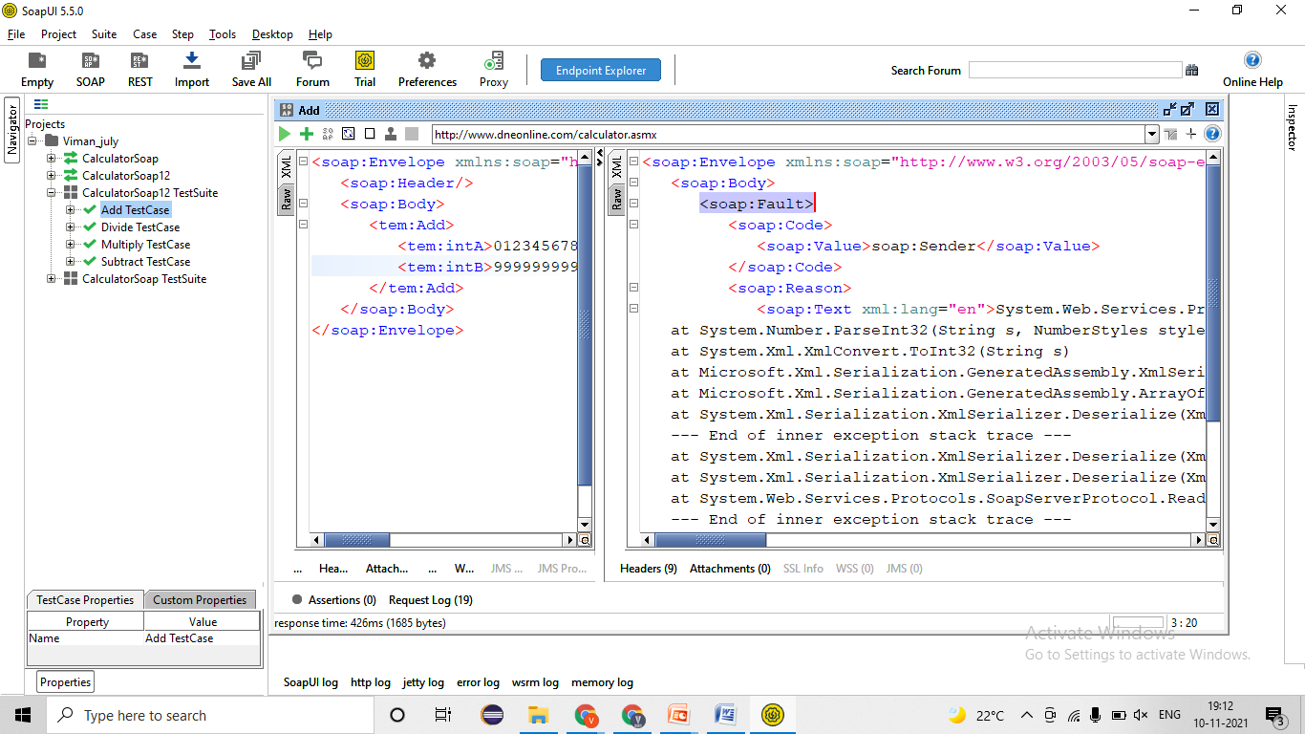
   5. **Verify SOAP service by adding null/ blank in Add functionality 🡪 EC = null values no. should not be added=Pass** 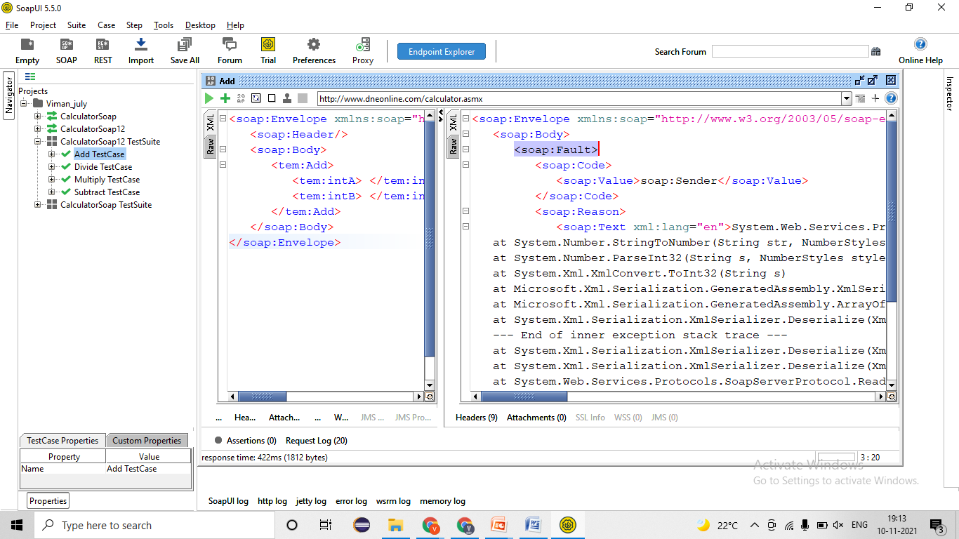
   6. **Verify SOAP service by adding wrong WSDL file link 🡪 EC = Service should not be work=Pass** 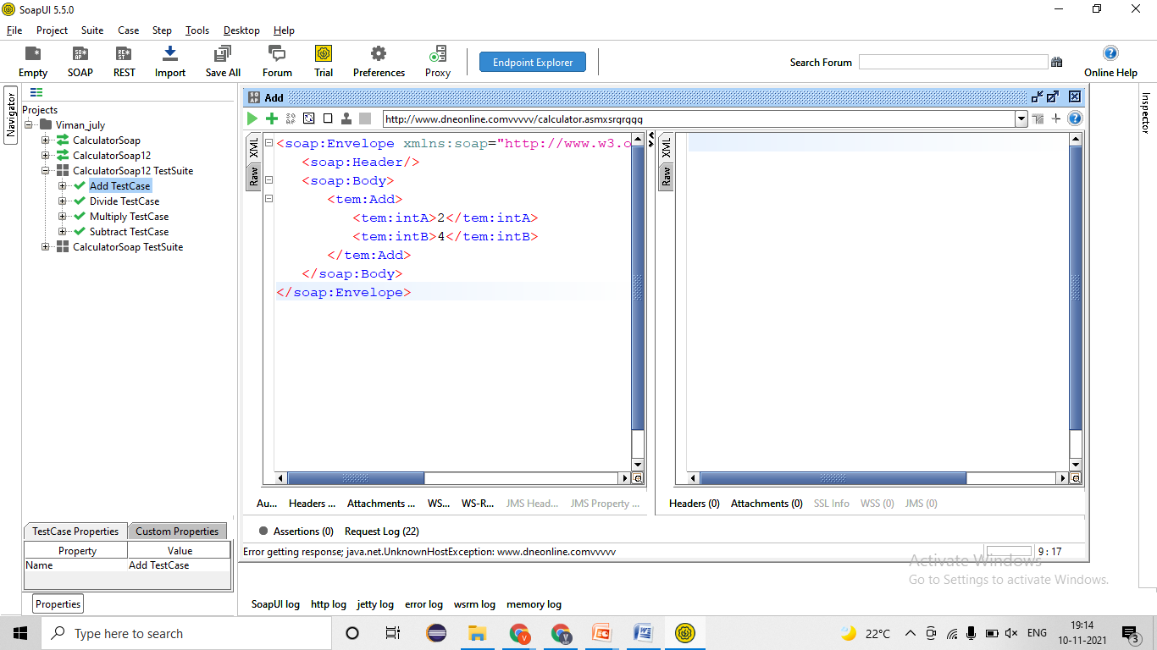
   7. **Verify SOAP service by passing wrong API key/ Barrier token/ Username & password 🡪 EC = Service should not be work**

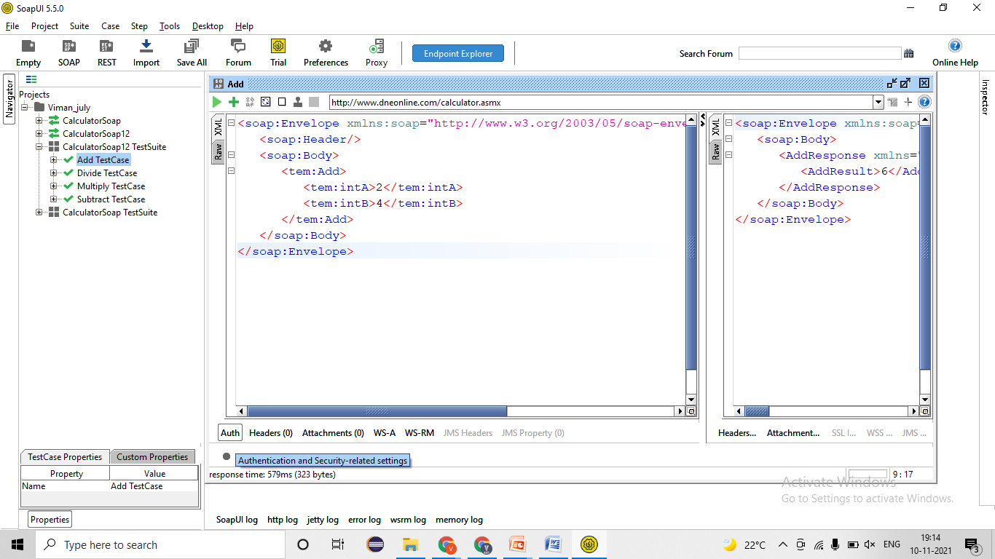

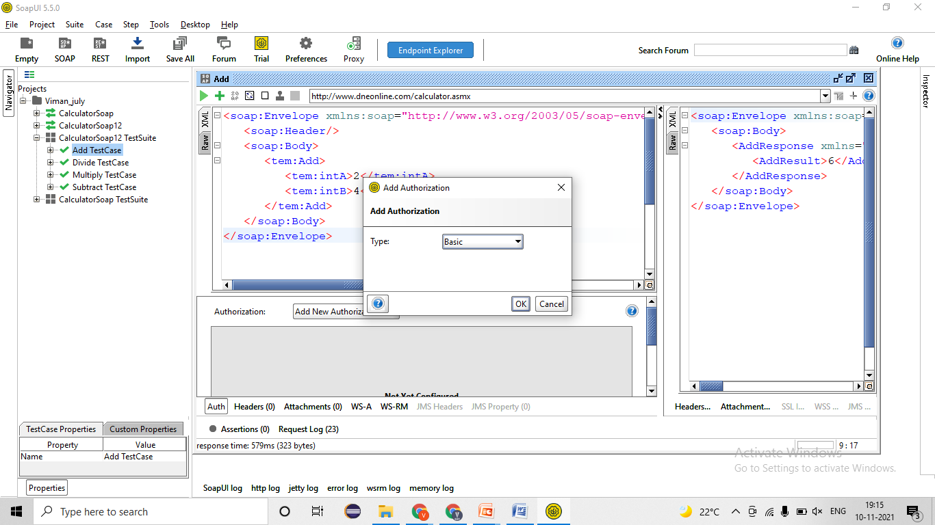

## RSET Service-

Swagger 🡪 https://reqres.in/

### Get Method/Request-

* **Developer will provides -**
* REST Service- **URl/URI file**= <https://reqres.in/api/users?page=2>
* Authentication/ Barrier token/ Username & password/API Key = bdewafdfscvgbhgfsdf
* Time for response < 60 sec
* Unit Testing document- Steps for testing, URL/URI, Tables name, etc

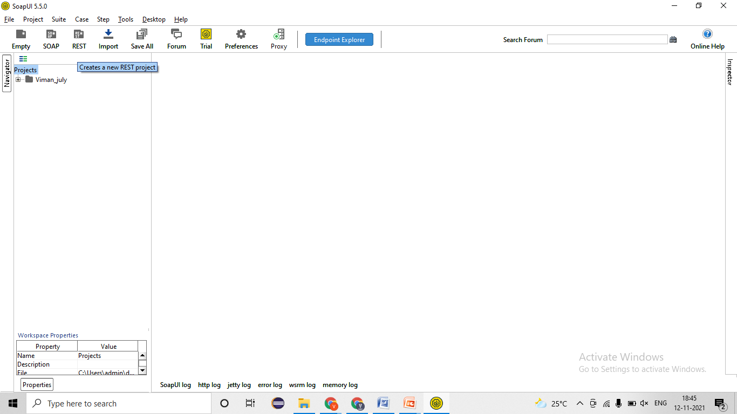

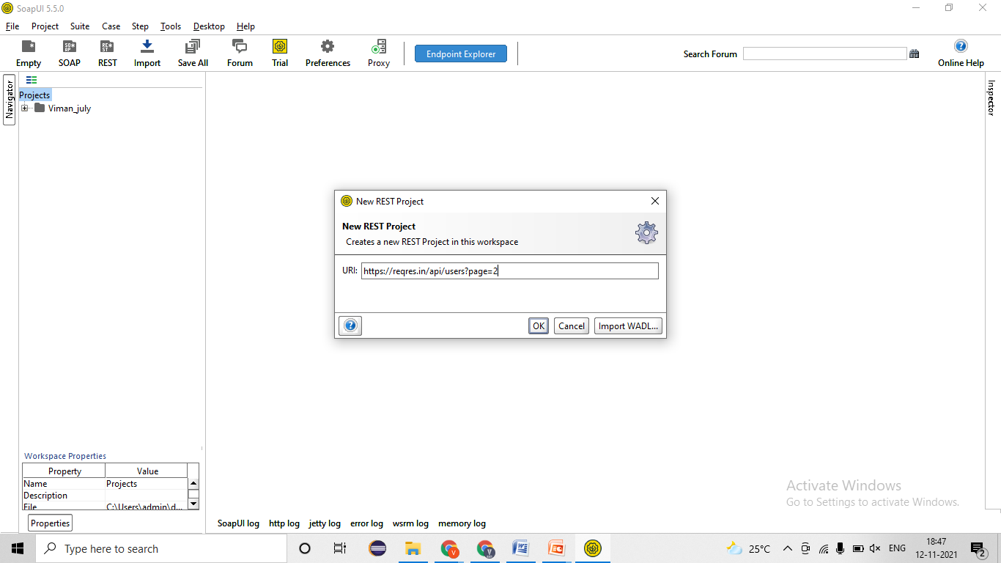

1. Validating Rest service response🡪 EC= Rest response should be get – 200-Ok =Pass 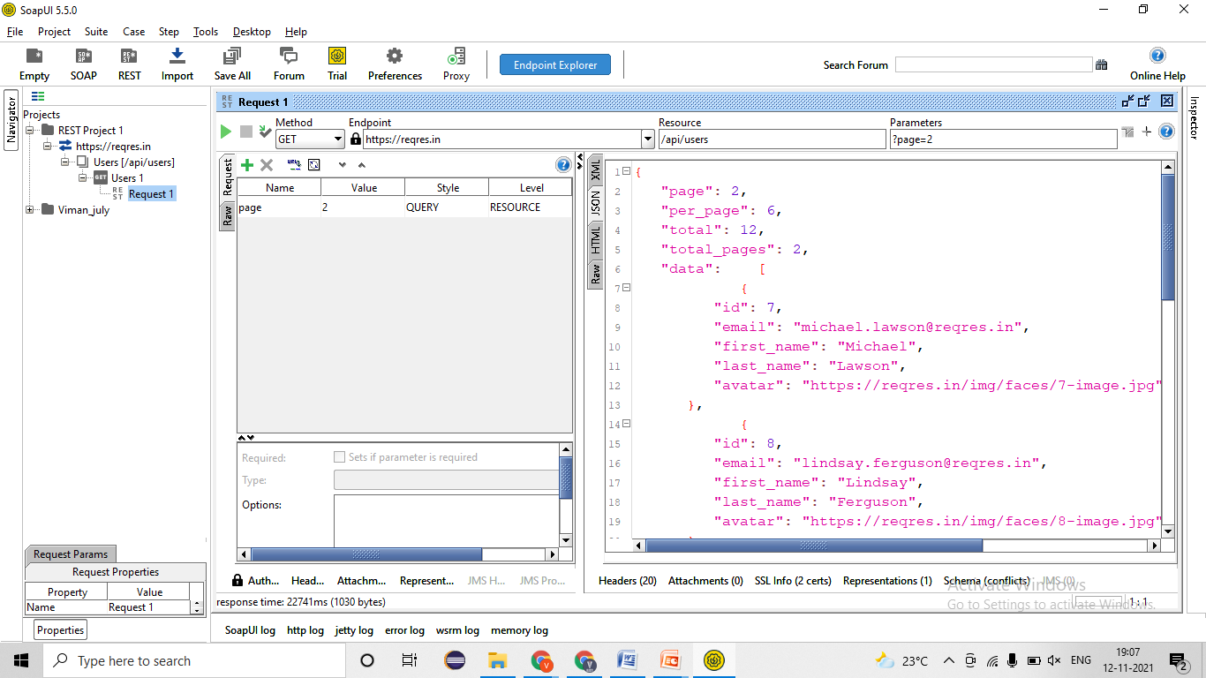
2. Validating Data and count of data in response🡪 EC- Data should come one times only – 200-ok= Pass 
3. Validating Tagname/Attributes presents in responses🡪 EC- ID, Fname, Eamilid, Lname, Avart, etc -200-ok= Pass 
4. Validating different Status code in responses🡪 EC- 200-ok=Pass 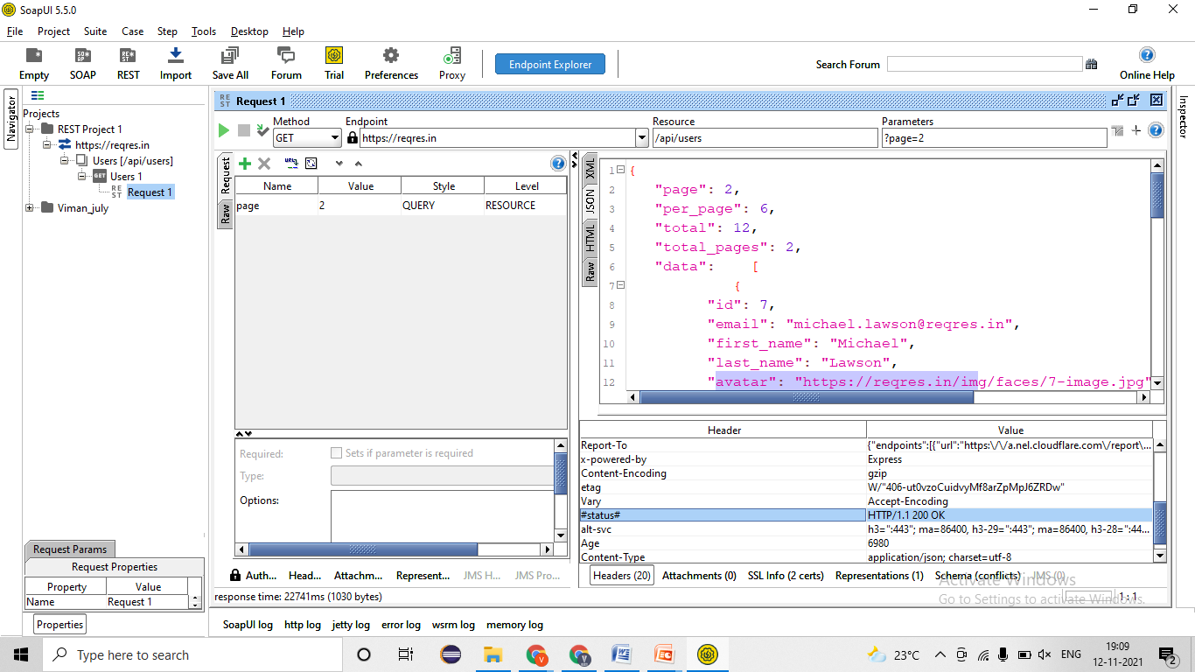
5. Validating Time taken for responses🡪 EC –Time < 60 sec = Pass 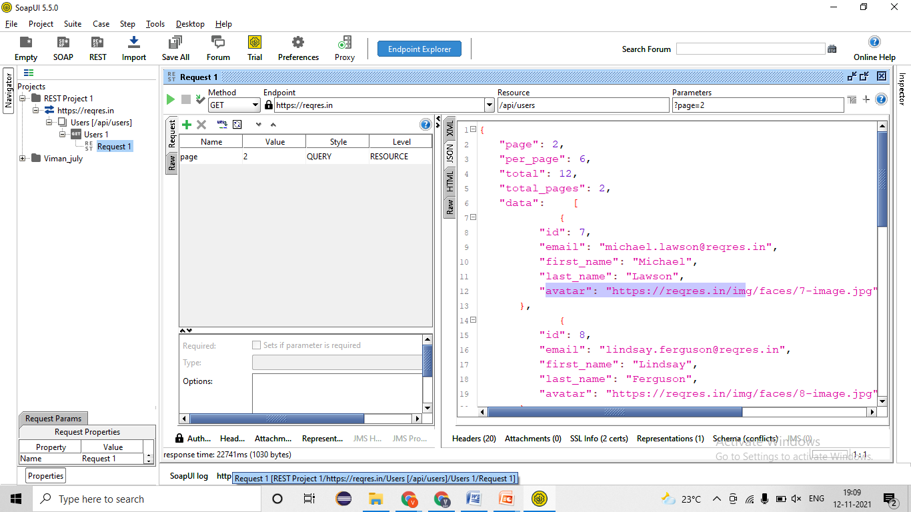
6. Applying Assertion for verification 🡪

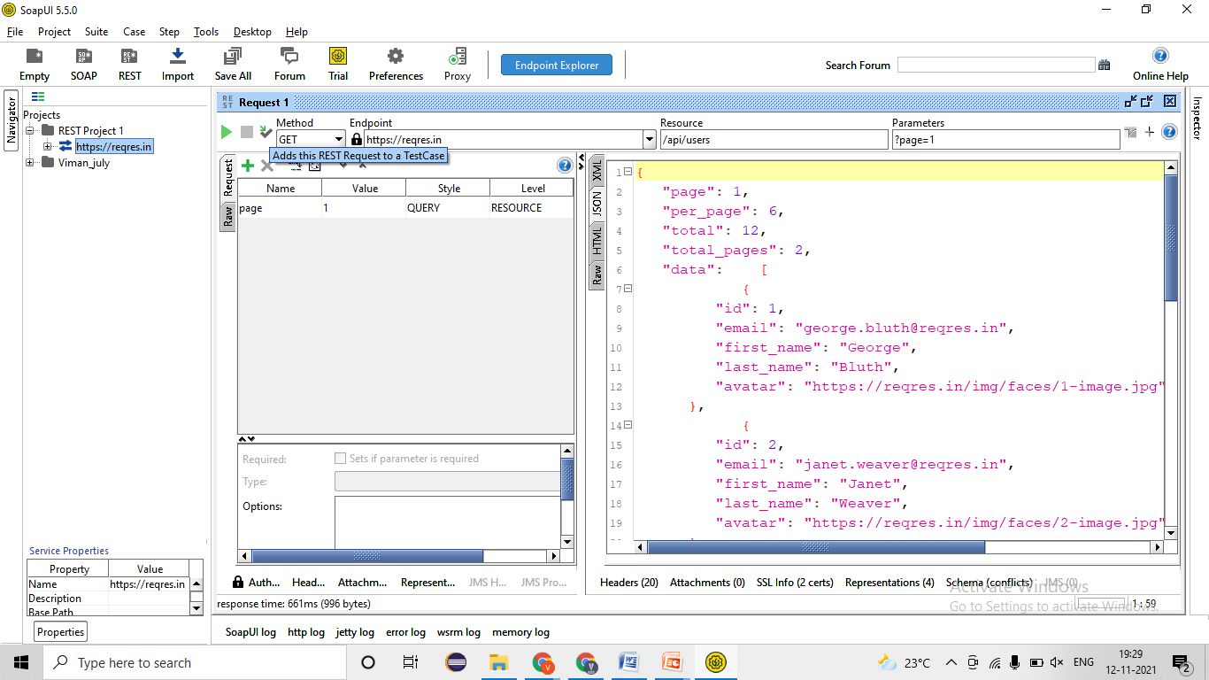

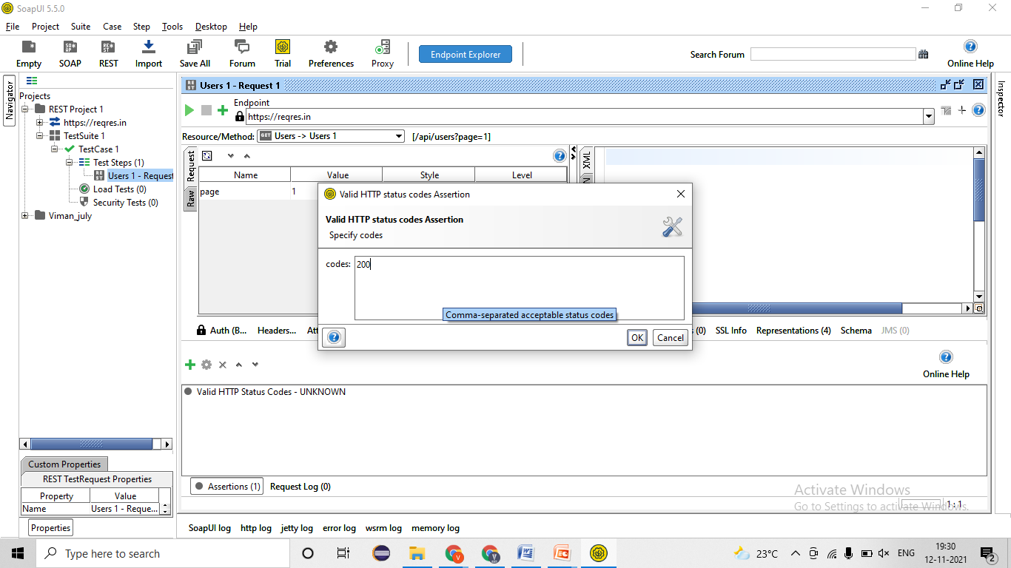

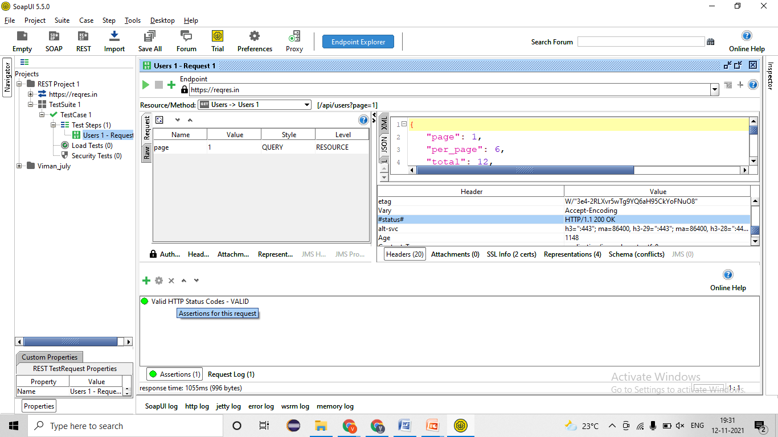

1. Validating the Functionality by passing test data
   1. Verify the total employees present in Rest service 2/ Server 2 🡪 EC= 200-ok=Pass 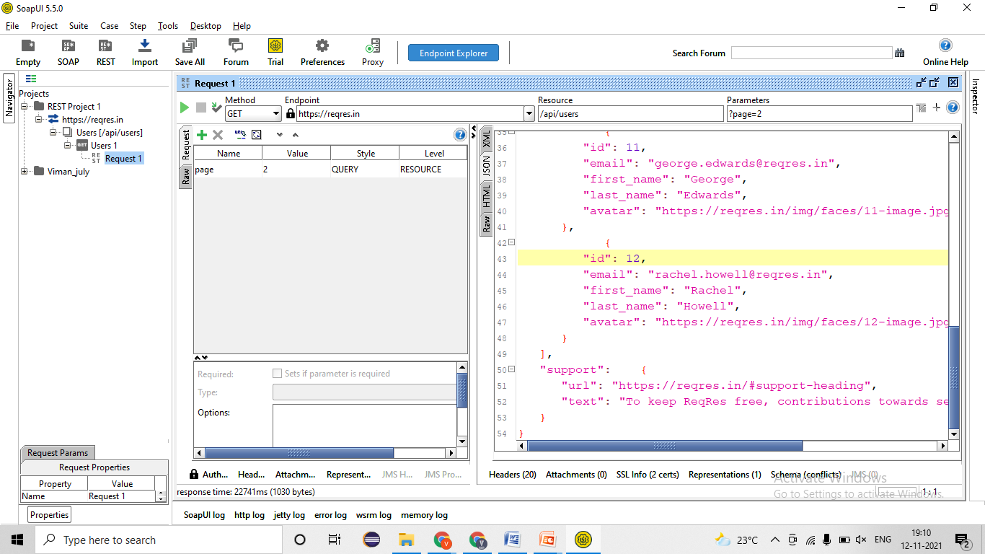
   2. Verify the page=1 employees data present in Rest service 2/ Server 2 🡪 EC= 200-ok=Pass 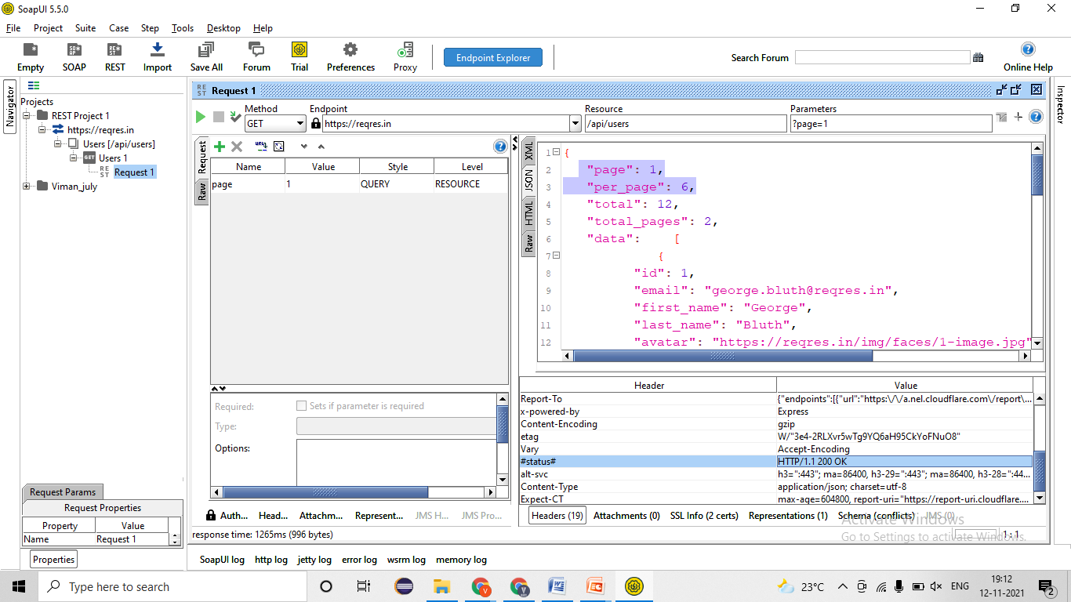
   3. Verify the page=2 employees data present in Rest service 2/ Server 2 🡪 EC= 200-0k=Pass 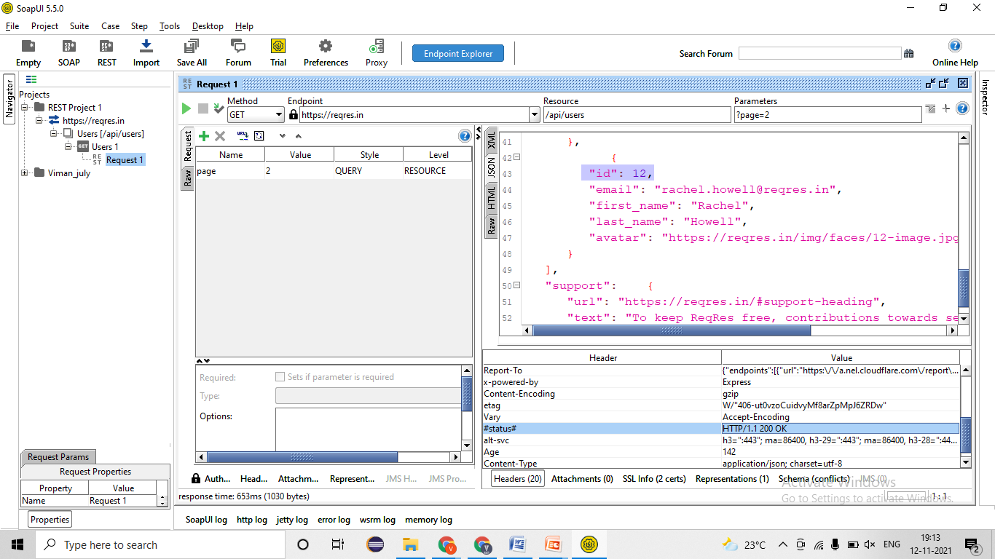
   4. Verify the page=3 employees data present in Rest service 2/ Server 2 🡪 EC= 200-ok=Pass 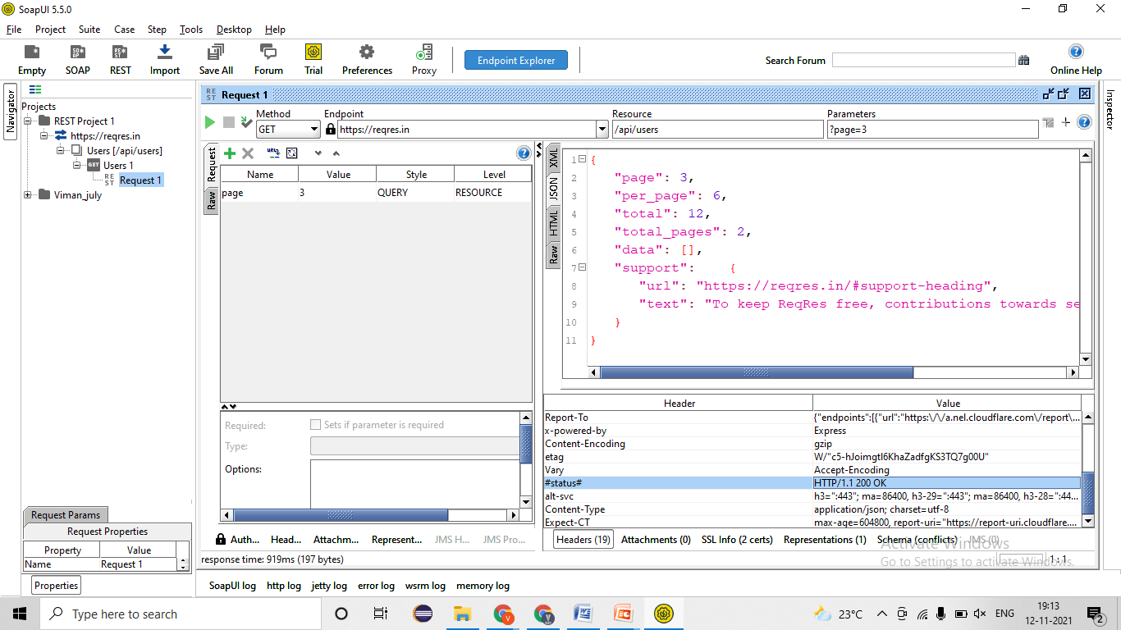
   5. Verify the page=4/5/6/7/etc employees data present in Rest service 2/ Server 2 🡪 EC= 200-ok=Pass 
2. Validating NEGATIVE test cases!
   1. Verify the bypassing charter in page=one/two/three employees data present in Rest service 2/ Server 2 🡪 EC= 400-Bas request=**Fail- defect** 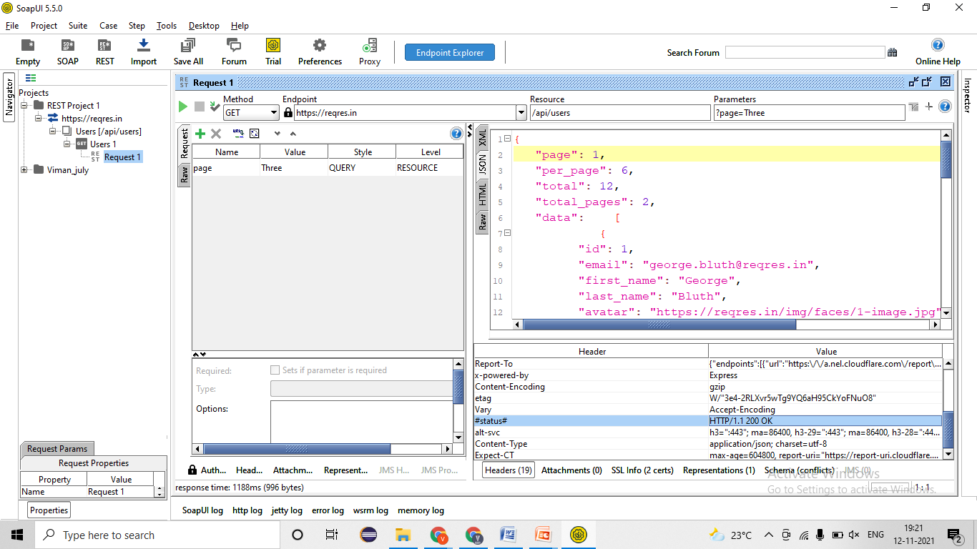
   2. Verify the page=Null/ Blank employees data present in Rest service 2/ Server 2 🡪 EC= 400-Bas request= Fail- Defect 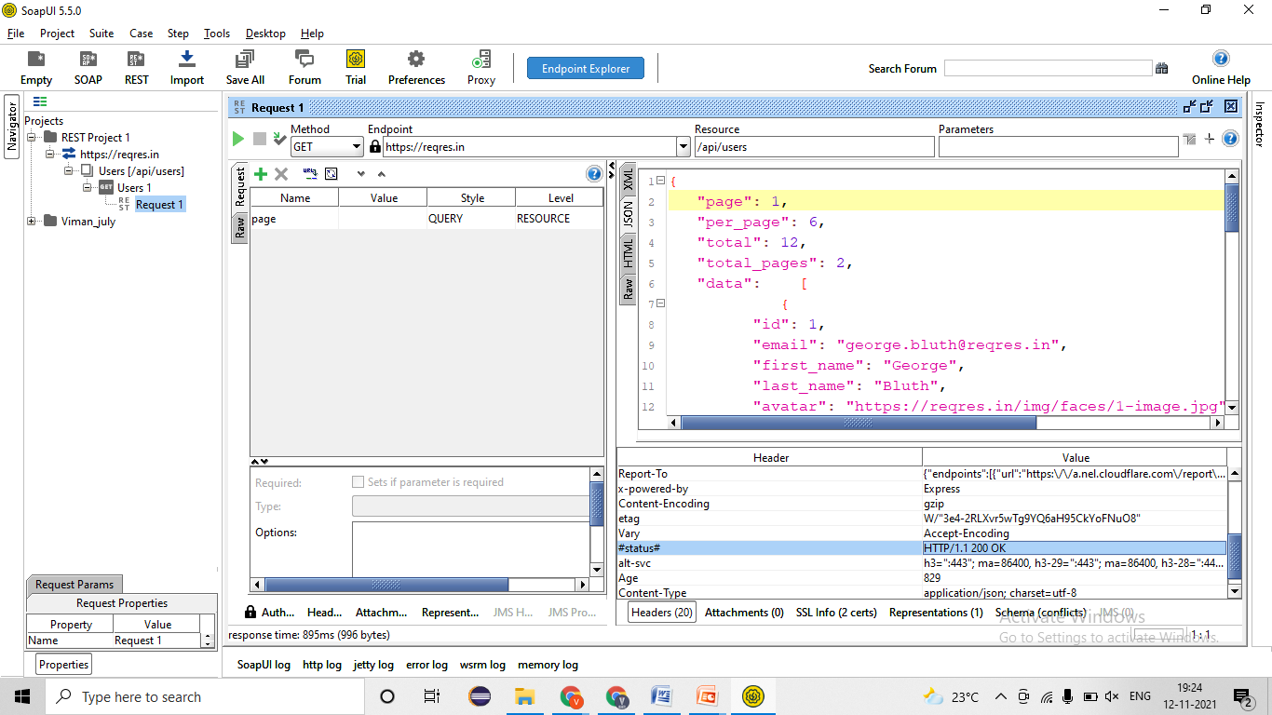
   3. Verify GET request by passing wrong URL/URI 🡪 EC= 404- Not Found= Pass 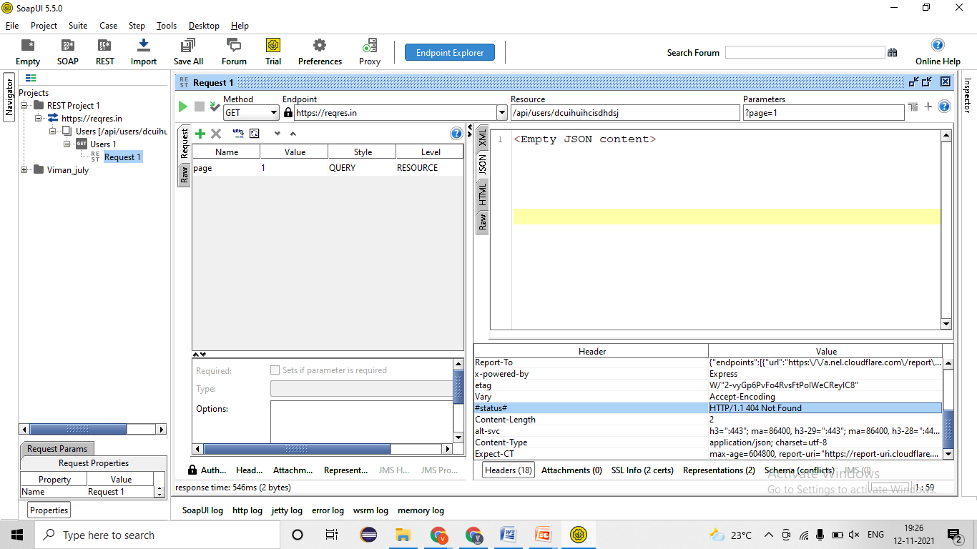
   4. Verify GET request by passing wrong Barrier token/ API Key 🡪 EC= 401- Un-authorized
   5. Verify by changing GET request into another request by 🡪 EC= 405- Method not allowed=Pass 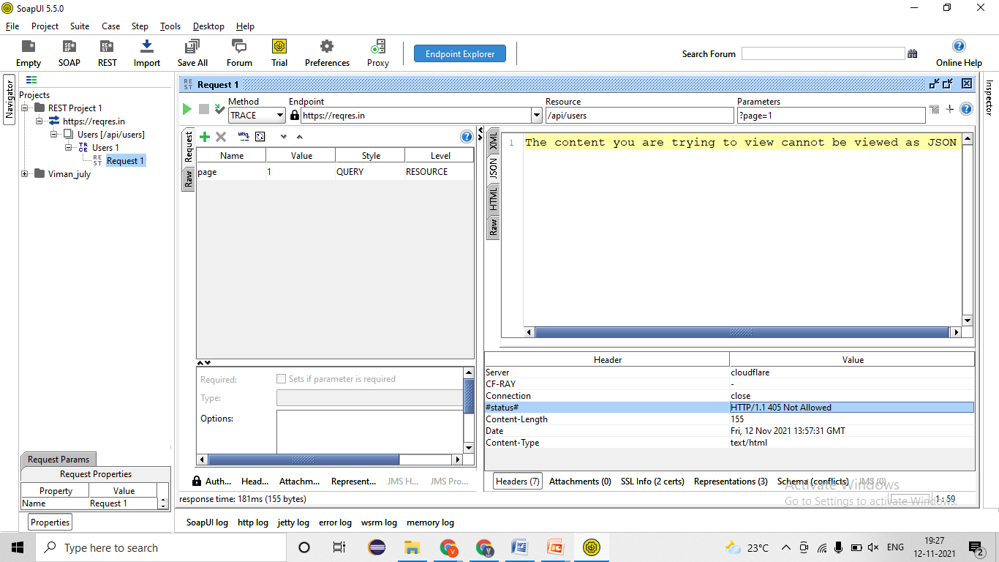

### POST Method/Request-

* **Developer will provides -**
* REST Service- **URl/URI file**= <https://reqres.in/api/users>
* Body/ Payload-

|  |
| --- |
| {  "name": "morpheus",  "job": "leader"  } |

* Authentication/ Barrier token/ Username & password = bdewafdfscvgbhgfsdf
* Time for response < 60 sec
* Unit Testing document- Steps for testing, URL/URI, Tables name, etc

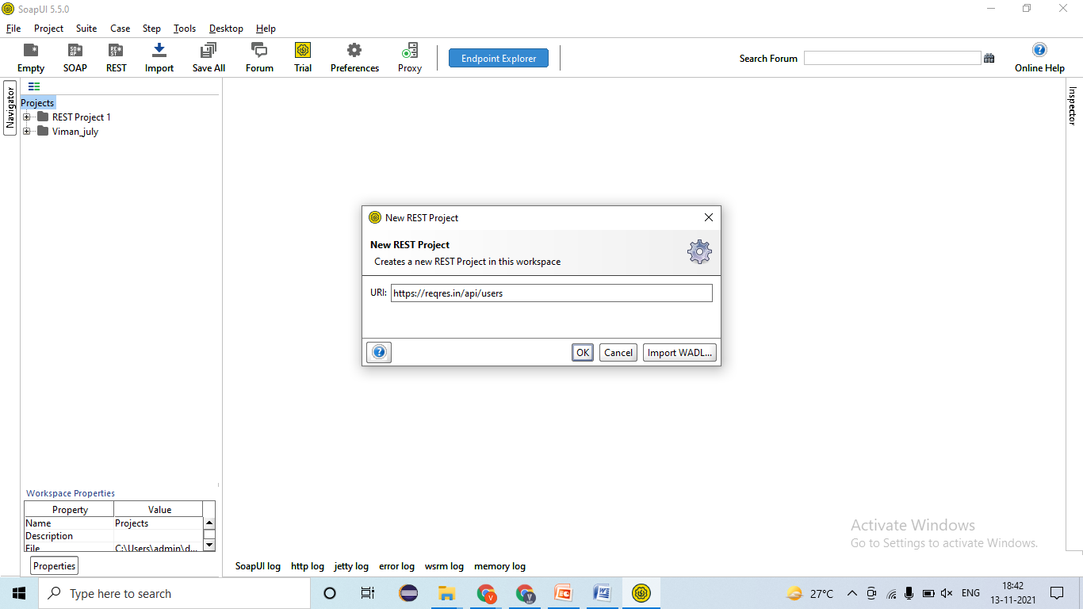

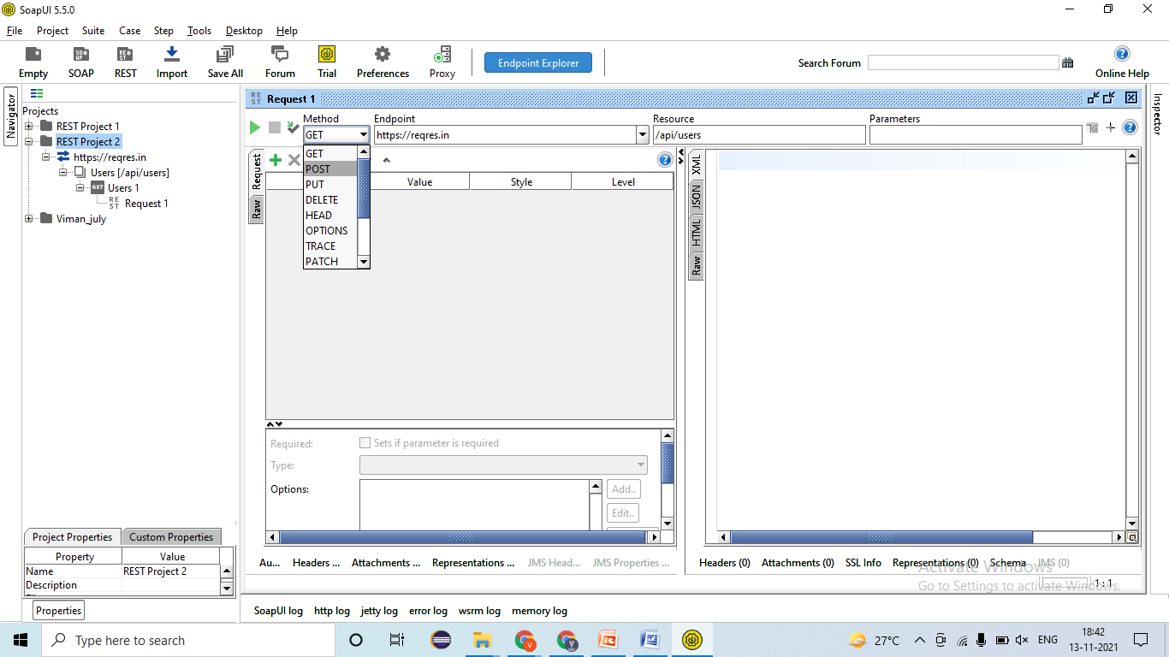

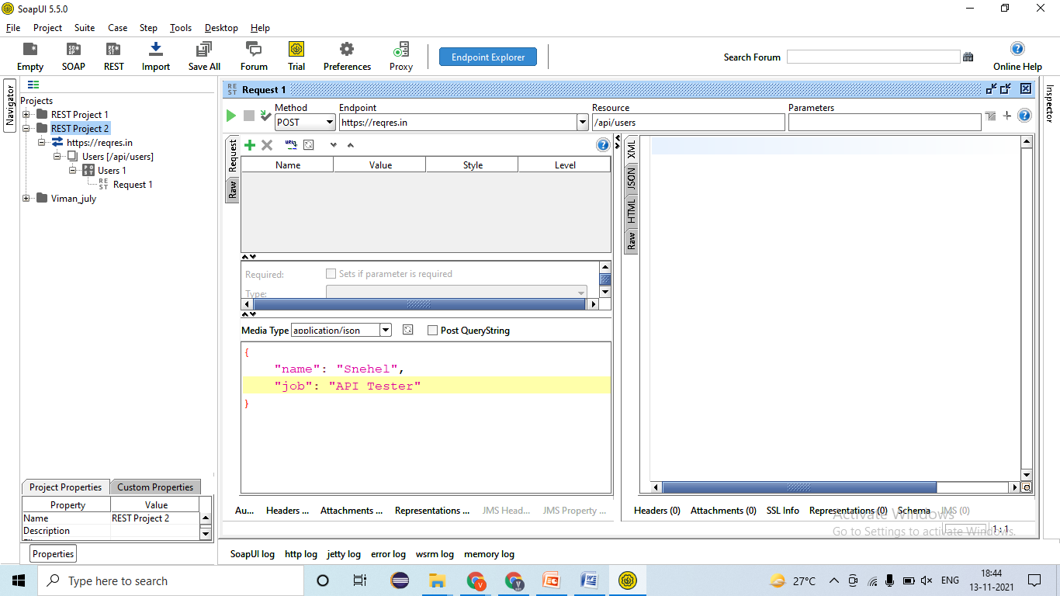

1. Validating Rest response🡪 EC- Rest response should be present=Pass 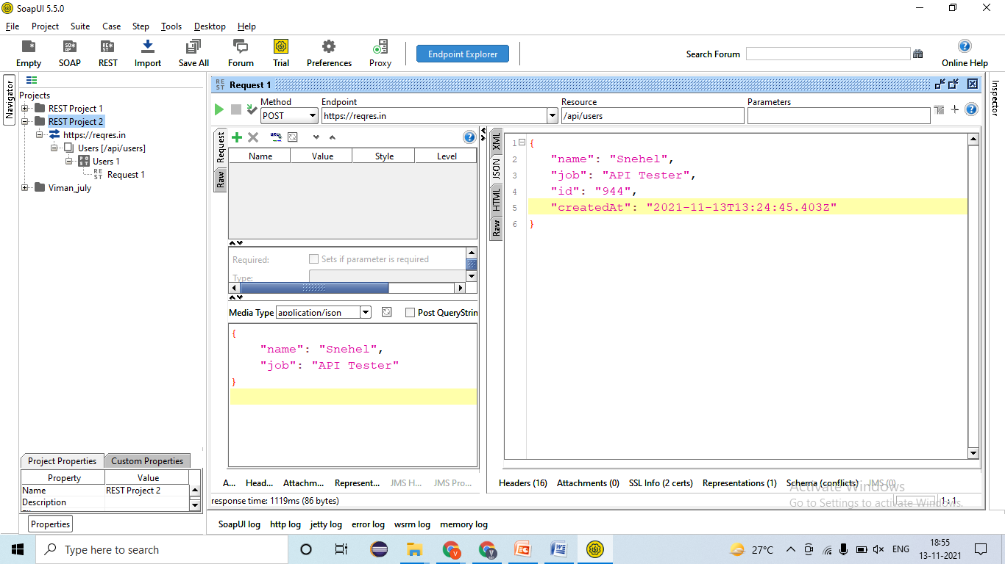
2. Validating Data and count of data in response🡪EC- Data should create only once =Pass 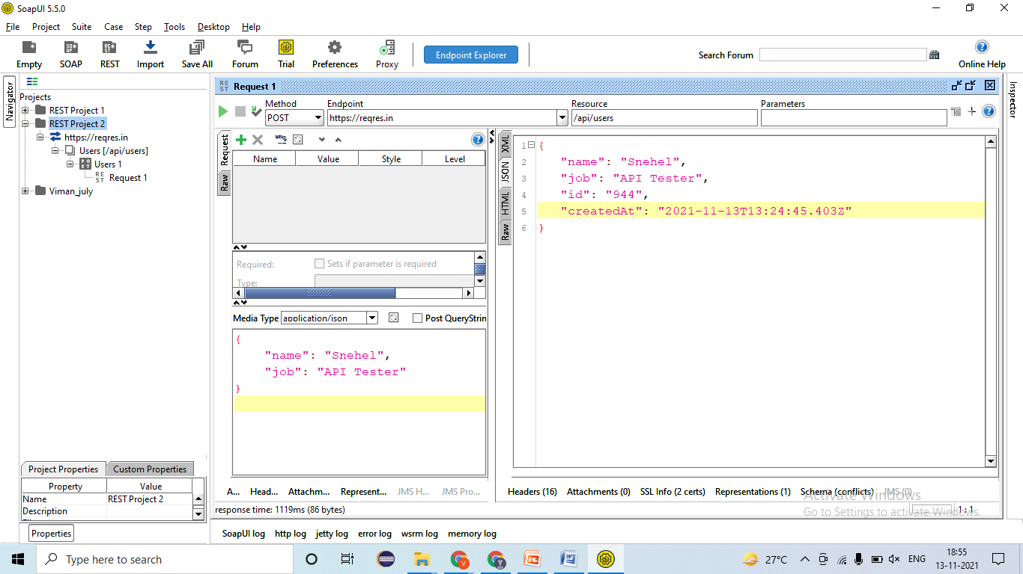
3. Validating Tagname/Attributes presents in responses🡪EC- ID, Name, Job, CreatedAt =Pass 
4. Validating different Status code in responses🡪EC – 201- Created=Pass 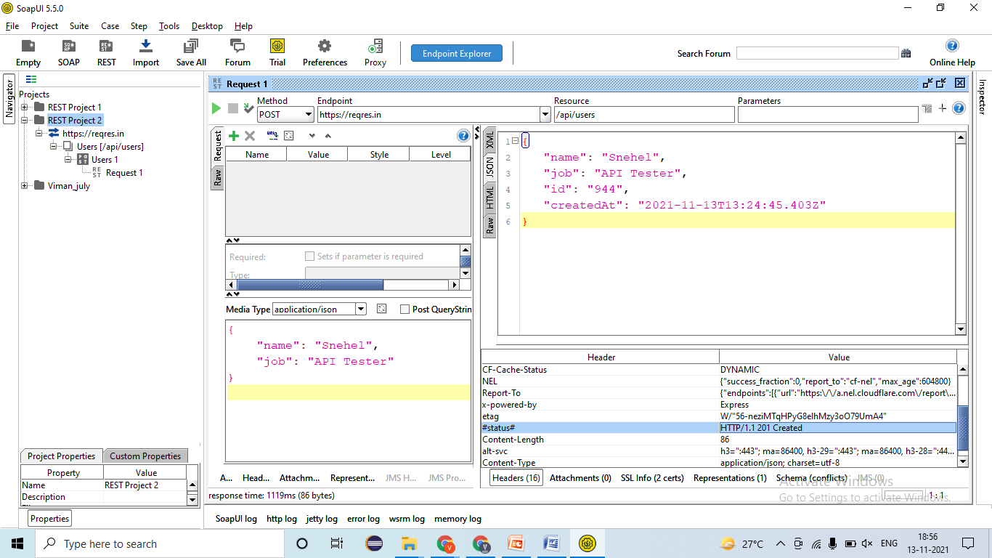
5. Validating Time taken for responses🡪 EC – resonse < 60sec= Pass 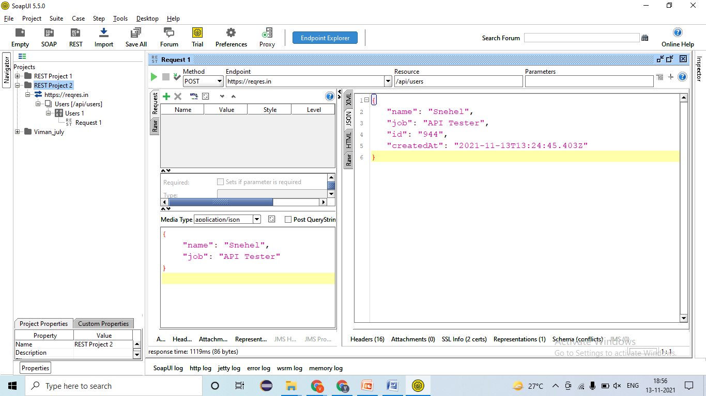
6. Applying Assertion for verification 🡪
7. Validating the Functionality by passing test data
   1. Verify the POST request by passing API Tester as Job 🡪 EC- Data should be created & 201- created=Pass 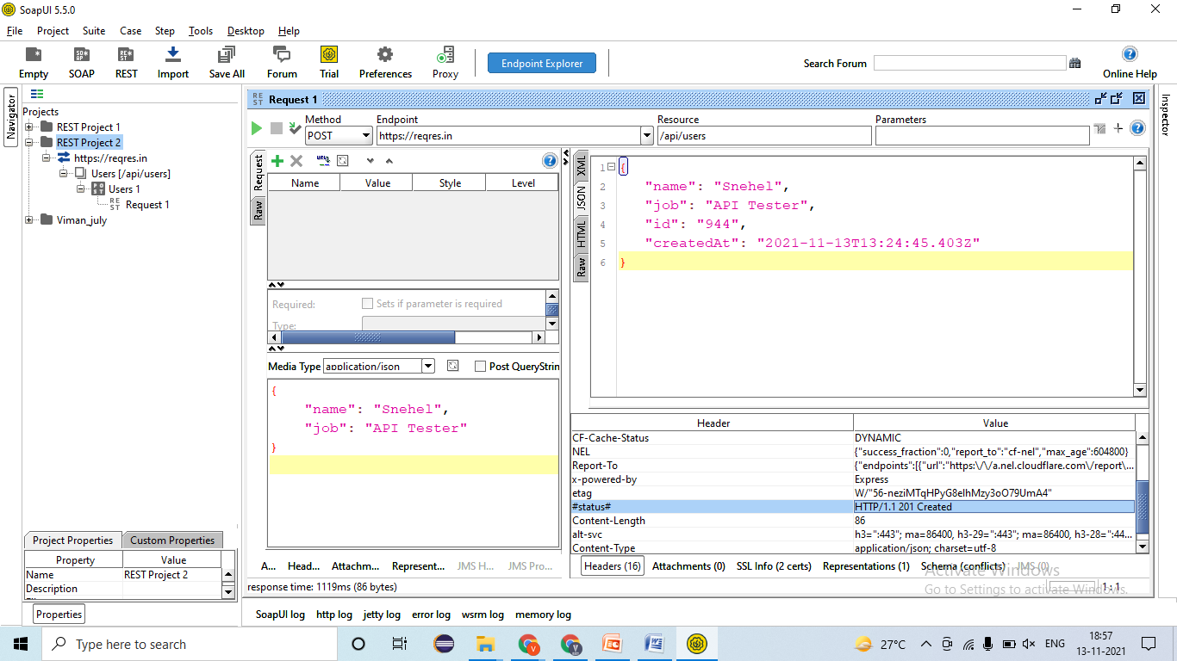
   2. Verify the POST request by passing Manual Tester as Job 🡪 EC- Data should be created & 201- created=Pass 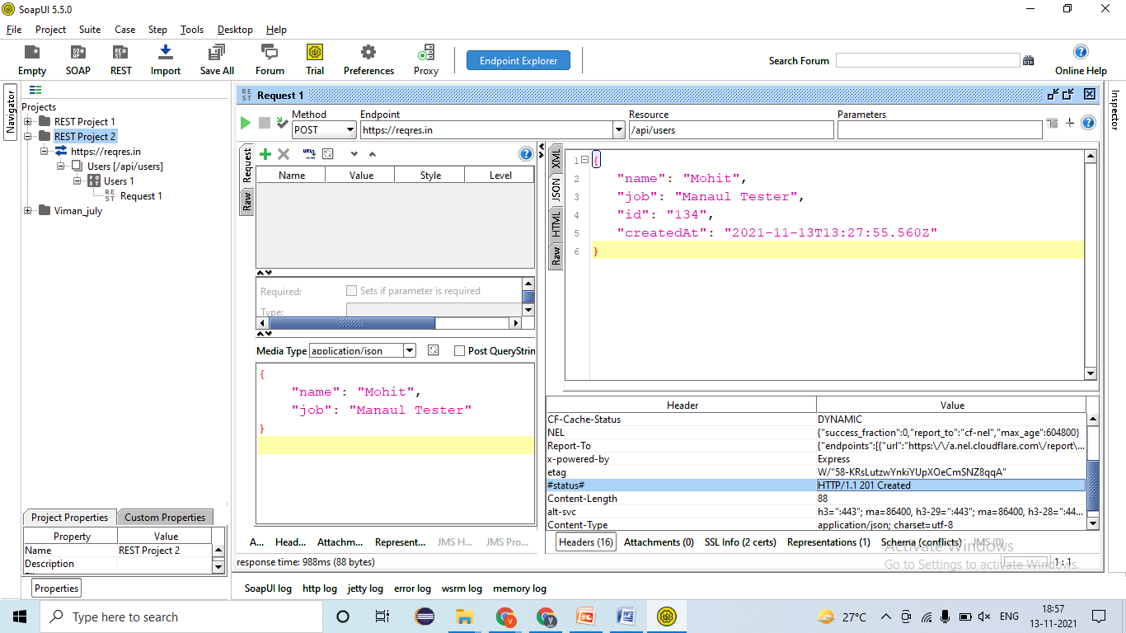
   3. Verify the POST request by passing Automation Tester as Job 🡪 EC- Data should be created & 201- created=Pass 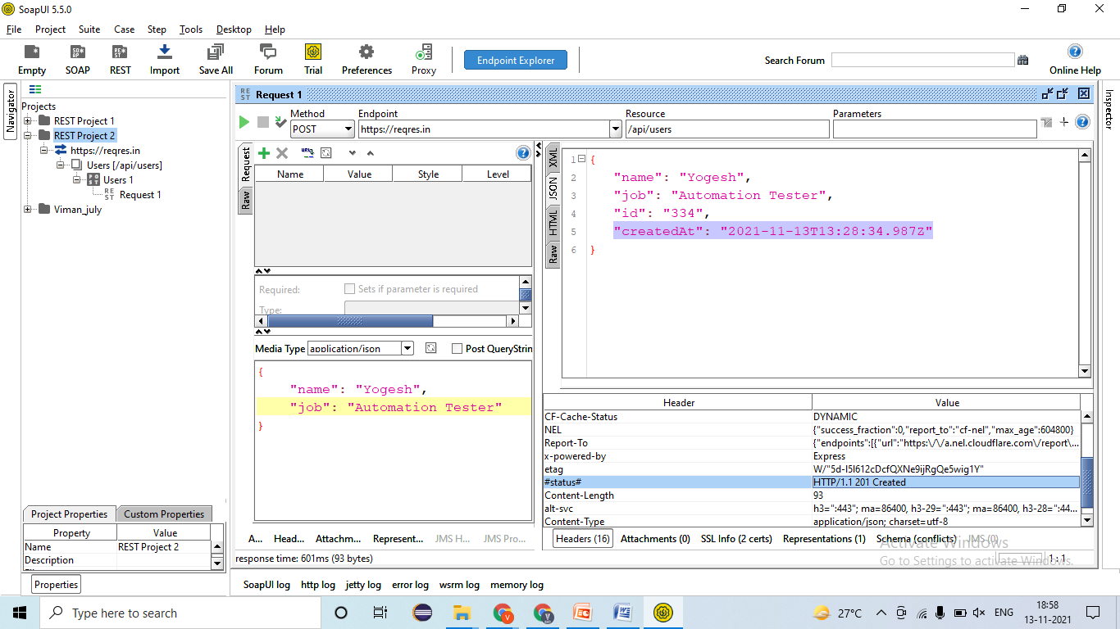
   4. Verify the POST request by passing DB Tester as Job 🡪 EC- Data should be created & 201- created=Pass 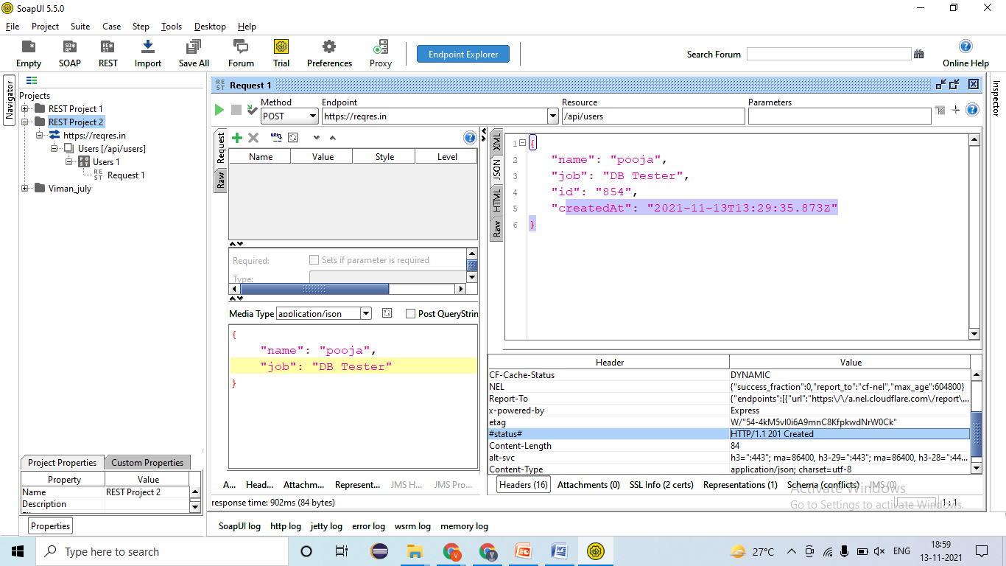
8. Validating NEGATIVE test cases!
   1. Verify the POST request by passing Wrong URI/URL🡪 EC- 404- Not Found=Fail- defect (JIRA/ HPALM) 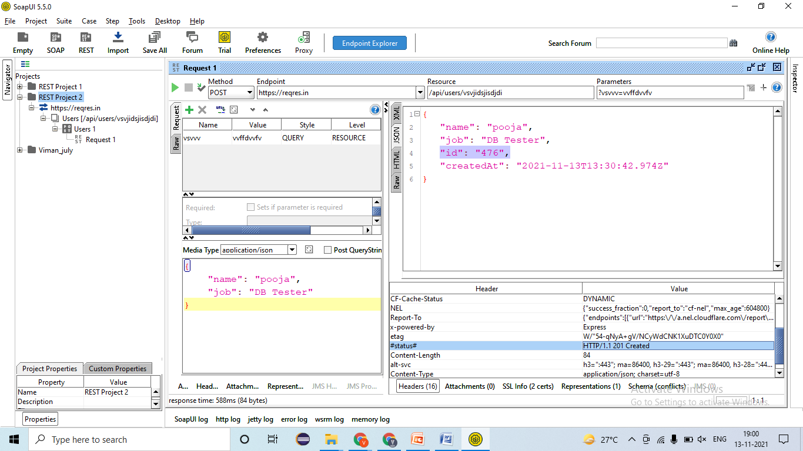
   2. Verify the POST request by passing Null/ blank Body/ Payload 🡪 EC- 400- Bad request=Fail - defect 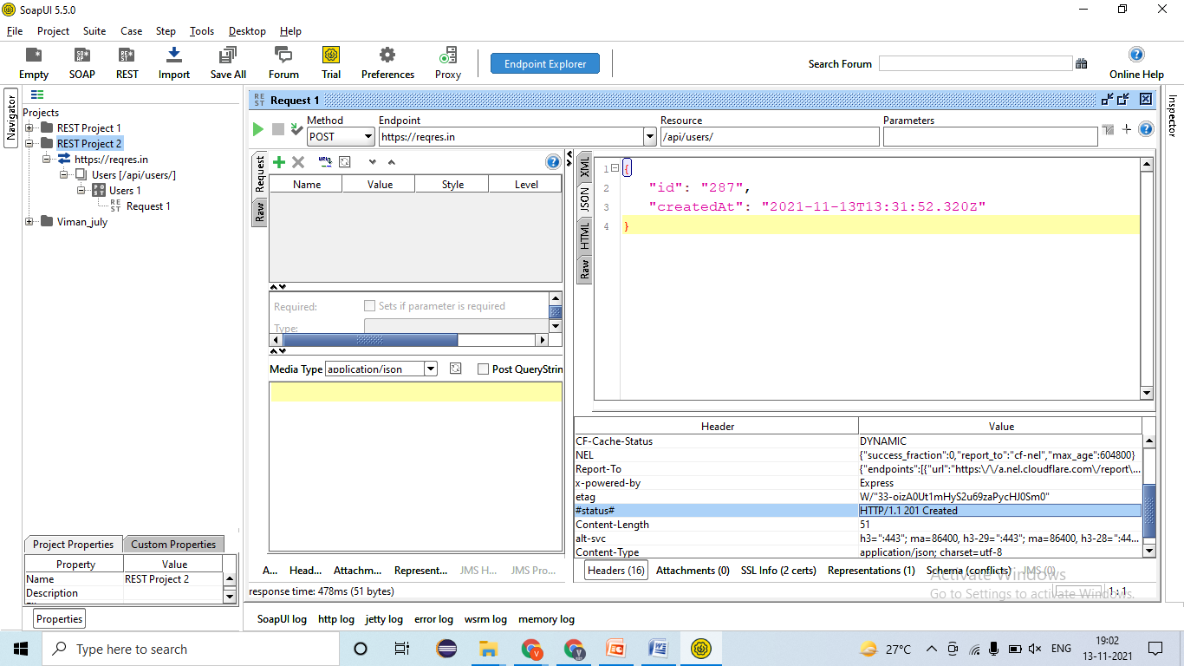
   3. Verify the POST request by passing wrong Body/ Payload 🡪 EC- 400- Bad request=Pass 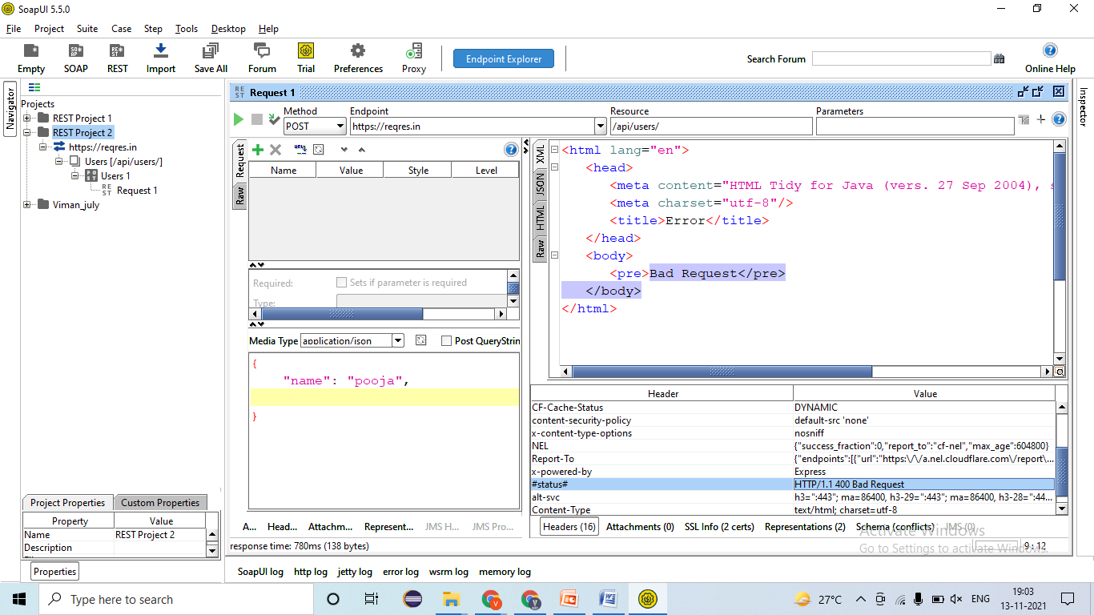
   4. Verify the POST request by passing wrong API key Body/ Payload 🡪 EC- 401- Un-authorized=
   5. Verify the by changing POST request into another method (TRANCE) 🡪 EC- 405- Method not allowed= Pass 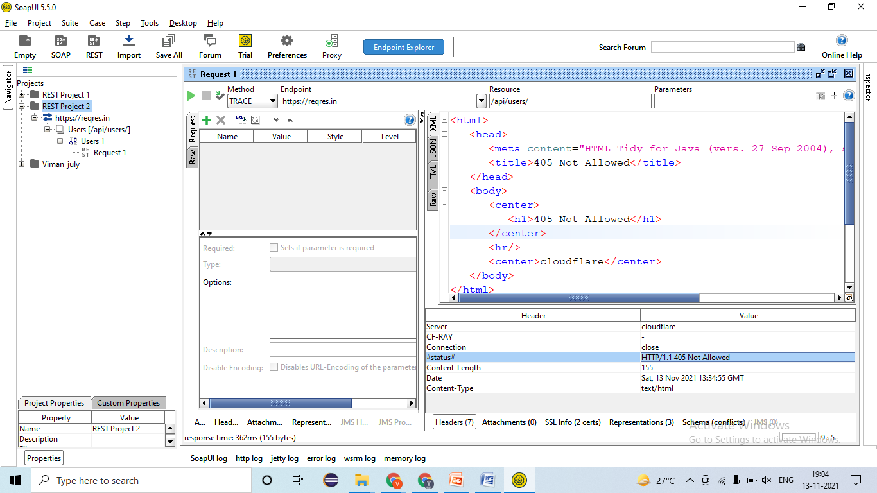

### PUT Method/Request-

* **Developer will provides -**
* REST Service- **URl/URI file**= <https://reqres.in/api/users/2>
* Body/ Payload-

|  |
| --- |
| {  "name": "morpheus",  "job": "leader"  } |

* Authentication/ Barrier token/ Username & password = bdewafdfscvgbhgfsdf
* Time for response < 60 sec
* Unit Testing document- Steps for testing, URL/URI, Tables name, etc

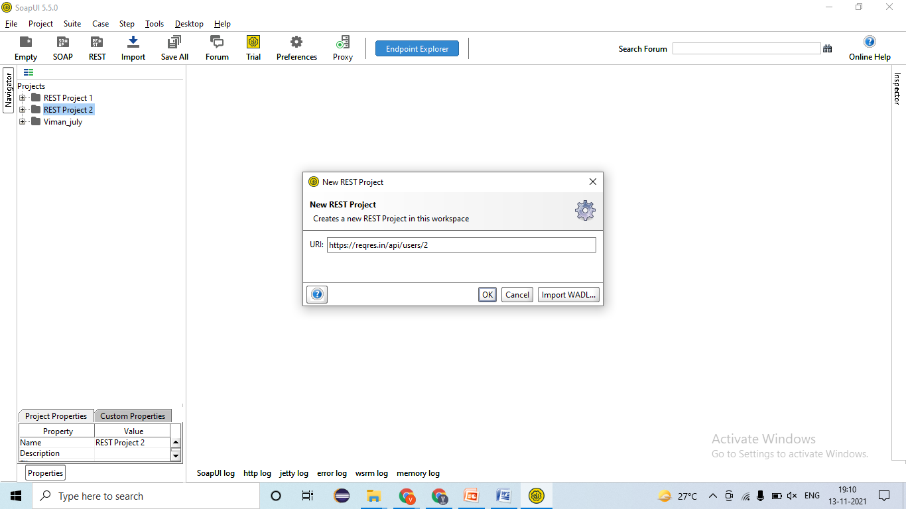

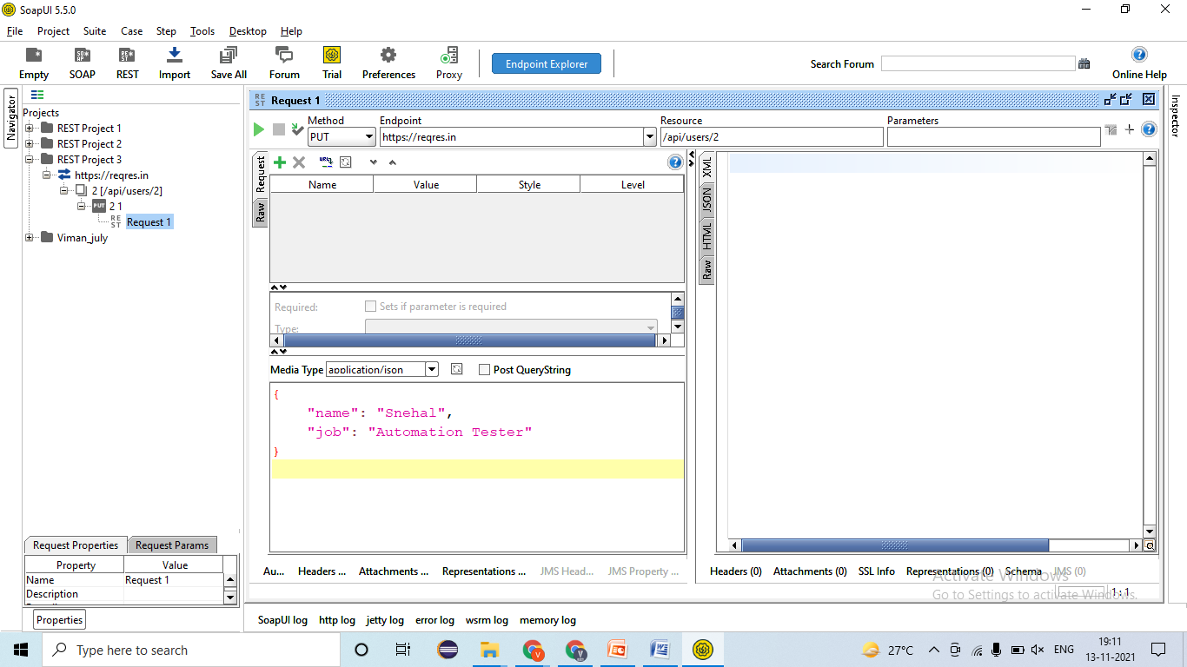

1. Validating Rest response🡪 EC- Rest response should be present=Pass
2. Validating Data and count of data in response🡪EC- Data should create only once =Pass
3. Validating Tagname/Attributes presents in responses🡪EC- Name, Job, CreatedAt =Pass
4. Validating different Status code in responses🡪EC – 201- Created=Pass
5. Validating Time taken for responses🡪 EC – resonse < 60sec= Pass
6. Applying Assertion for verification 🡪
7. Validating the Functionality by passing test data
   1. Verify the PUT request by changing API Tester Job to Automation Tester🡪 EC- Data should be updated & 202- Accepted=Fail - defect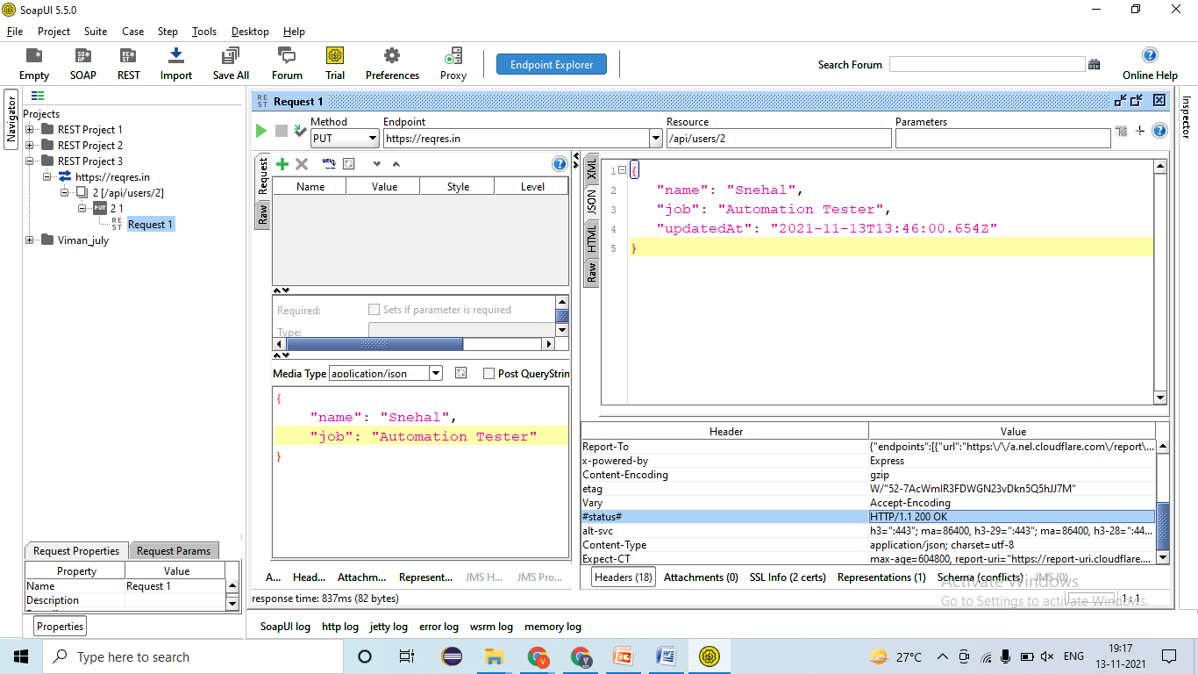
   2. Verify the PUT request by changing Manual Tester Job to API Tester🡪 EC- Data should be updated & 202- Accepted=Pass
   3. Verify the PUT request by changing Automation Tester Job to Manual Tester🡪 EC- Data should be updated & 202- Accepted=Pass
   4. Verify the PUT request by changing DB Tester Job to API Tester🡪 EC- Data should be updated & 202- Accepted=Pass
8. Validating NEGATIVE test cases!
   1. Verify the PUT request by passing Wrong URI/URL🡪 EC- 404- Not Found=Fail- defect (JIRA/ HPALM)
   2. Verify the PUT request by passing Null/ blank Body/ Payload 🡪 EC- 400- Bad request=Fail - defect
   3. Verify the PUT request by passing wrong Body/ Payload 🡪 EC- 400- Bad request=Pass
   4. Verify the PUT request by passing wrong API key Body/ Payload 🡪 EC- 401- Un-authorized=
   5. Verify the by changing PUT request into another method (TRANCE) 🡪 EC- 405- Method not allowed= Pass

### DELETE Method/Request-

* **Developer will provides -**
* REST Service- **URl/URI file**= <https://reqres.in/api/users/2>
* Authentication/ Barrier token/ Username & password = bdewafdfscvgbhgfsdf
* Time for response < 60 sec
* Unit Testing document- Steps for testing, URL/URI, Tables name, etc

# POSTMAN Tool-

Swagger 🡪 <https://reqres.in/>

## Collection –

* Collection is nothing but bunch of request / method, which we can run throw single run

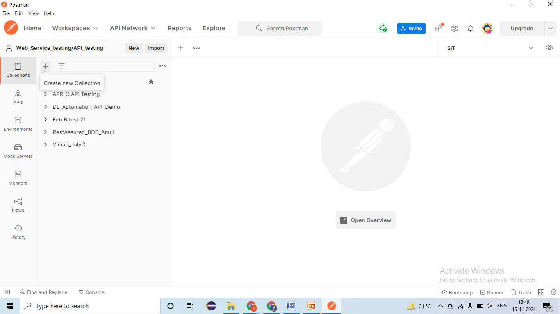

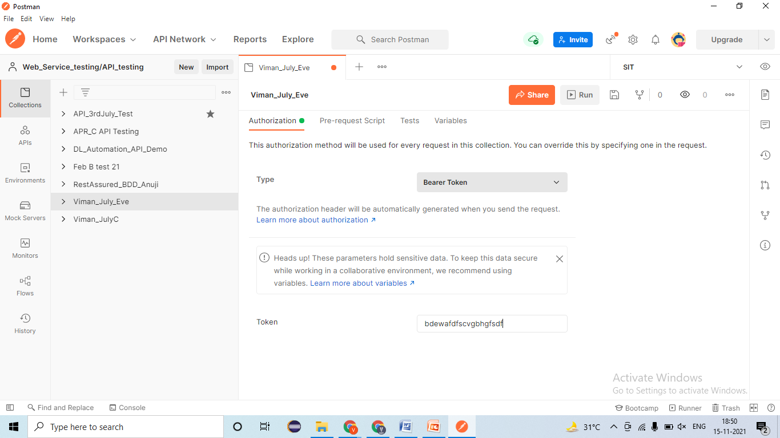

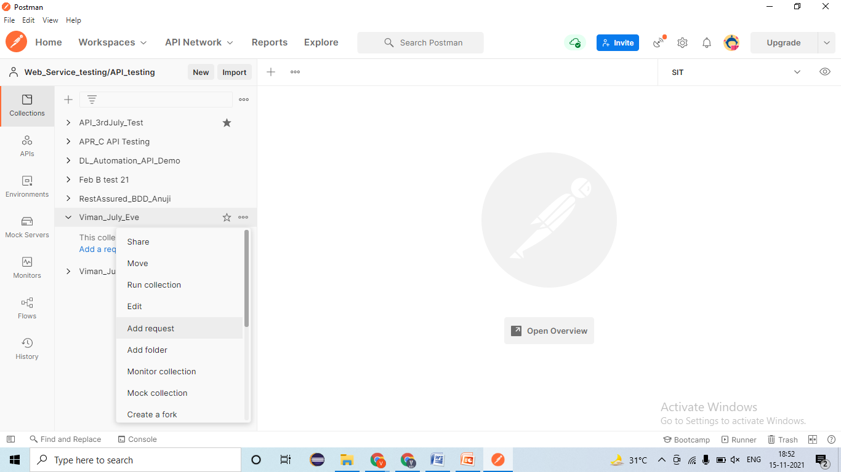

**How to run collection-**

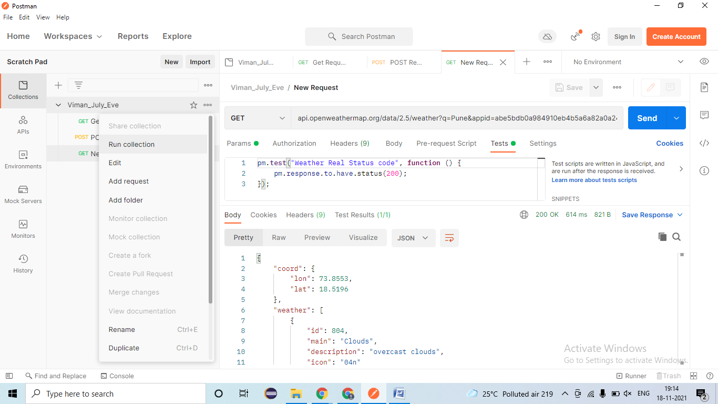

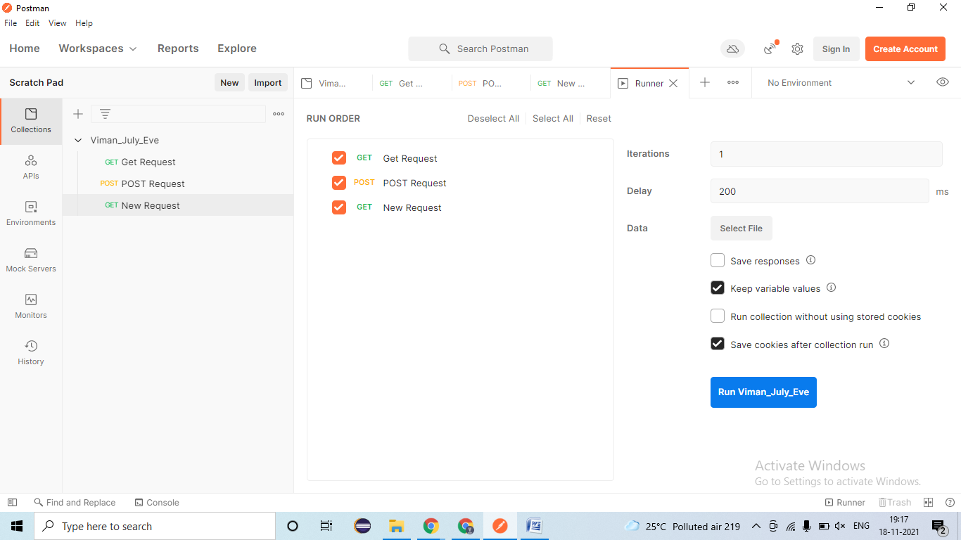

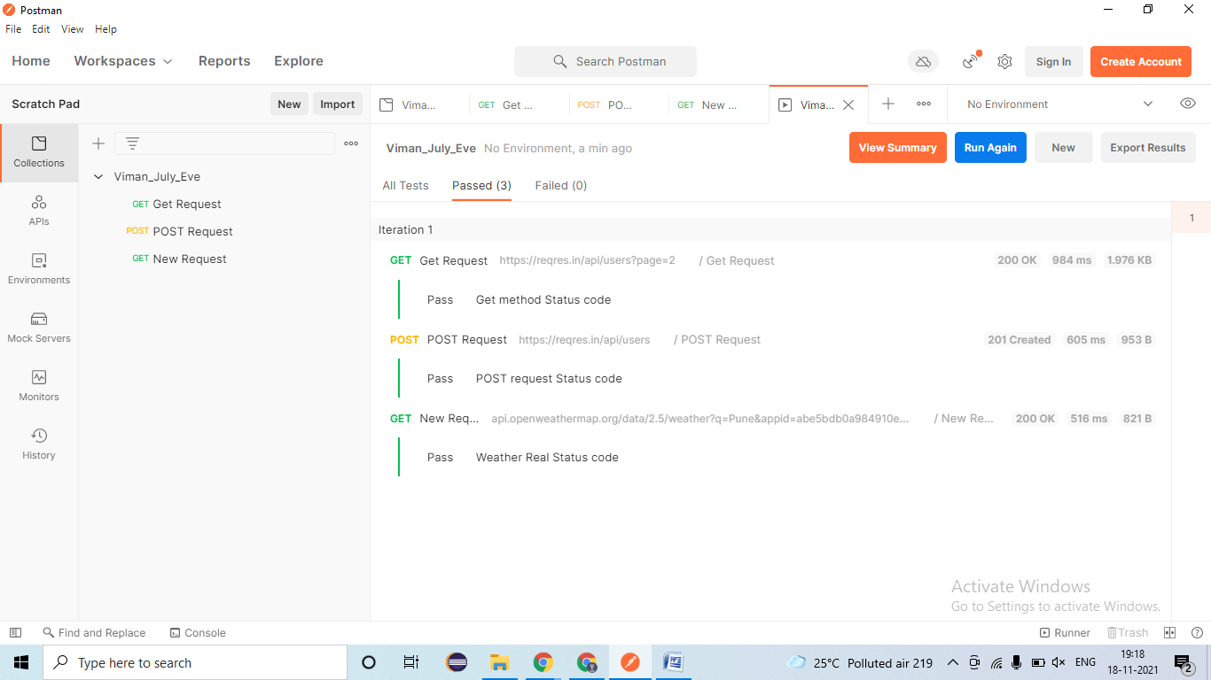

## REST Services-

### Get Method/Request-

* **Developer will provides -**
* REST Service- **URl/URI file**= <https://reqres.in/api/users?page=2>
* Authentication/ Barrier token/ Username & password/API Key = bdewafdfscvgbhgfsdf
* Time for response < 60 sec
* Unit Testing document- Steps for testing, URL/URI, Tables name, etc

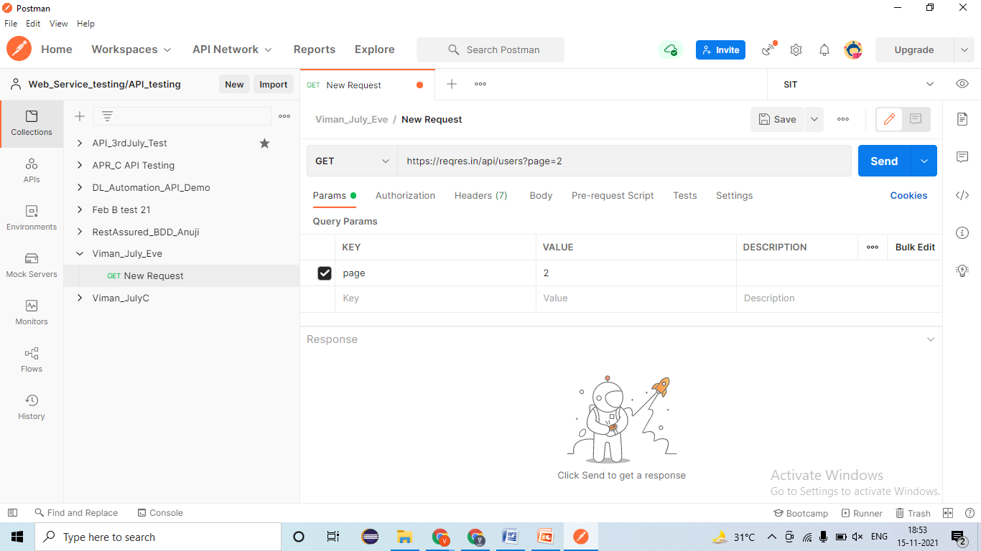

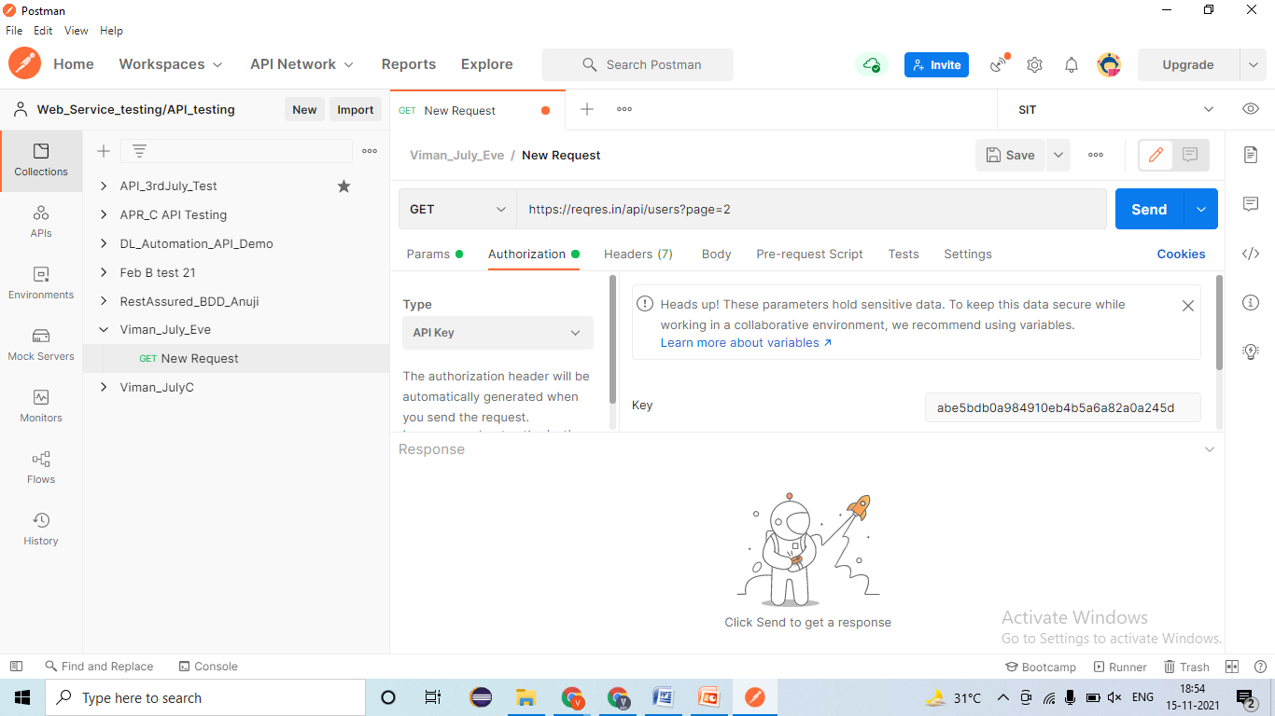

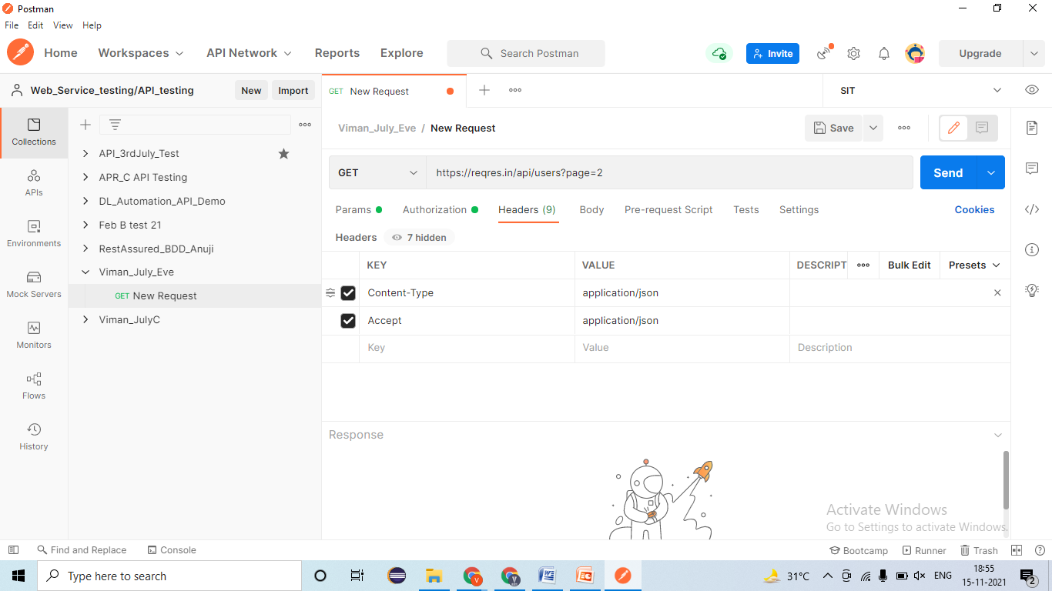

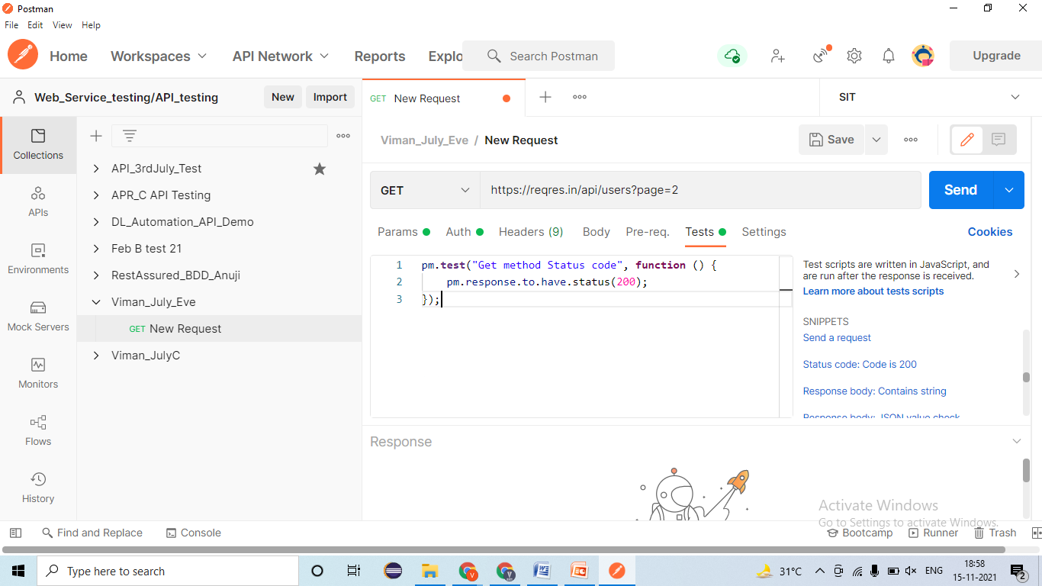

1. Validating Rest service response🡪 EC= Rest response should be get – 200-Ok =Pass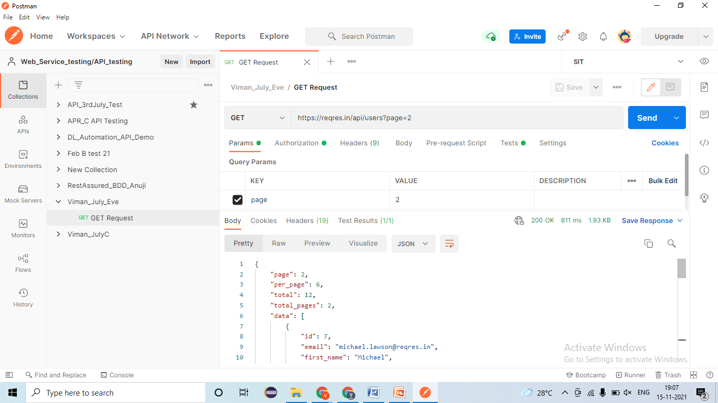
2. Validating Data and count of data in response🡪 EC- Data should come one times only – 200-ok= Pass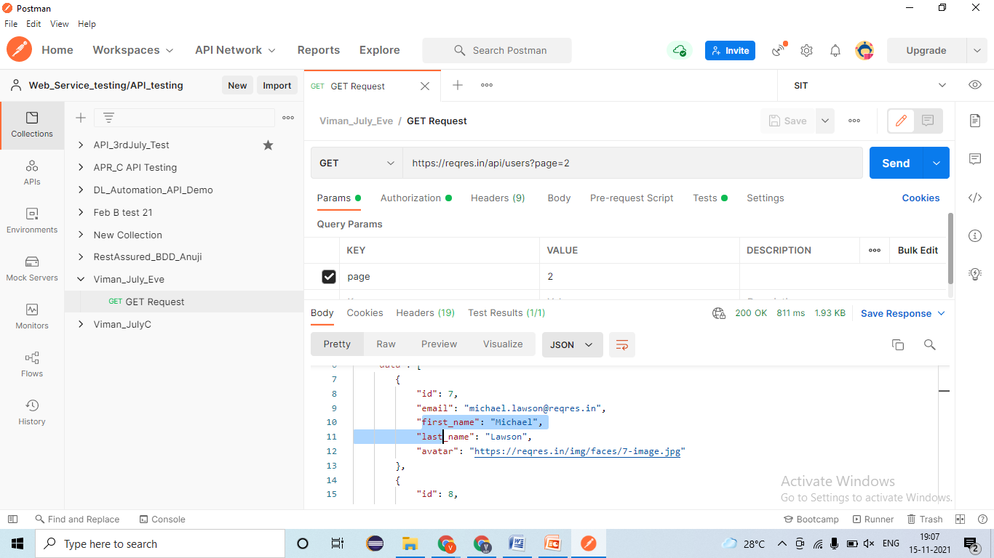
3. Validating Tagname/Attributes presents in responses🡪 EC- ID, Fname, Eamilid, Lname, Avart, etc -200-ok= Pass 
4. Validating different Status code in responses🡪 EC- 200-ok=Pass 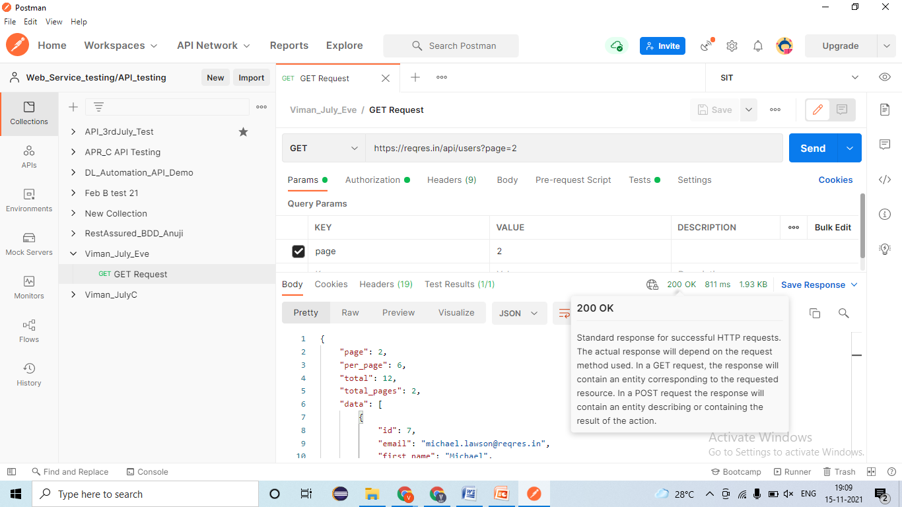
5. Validating Time taken for responses🡪 EC –Time < 60 sec = Pass 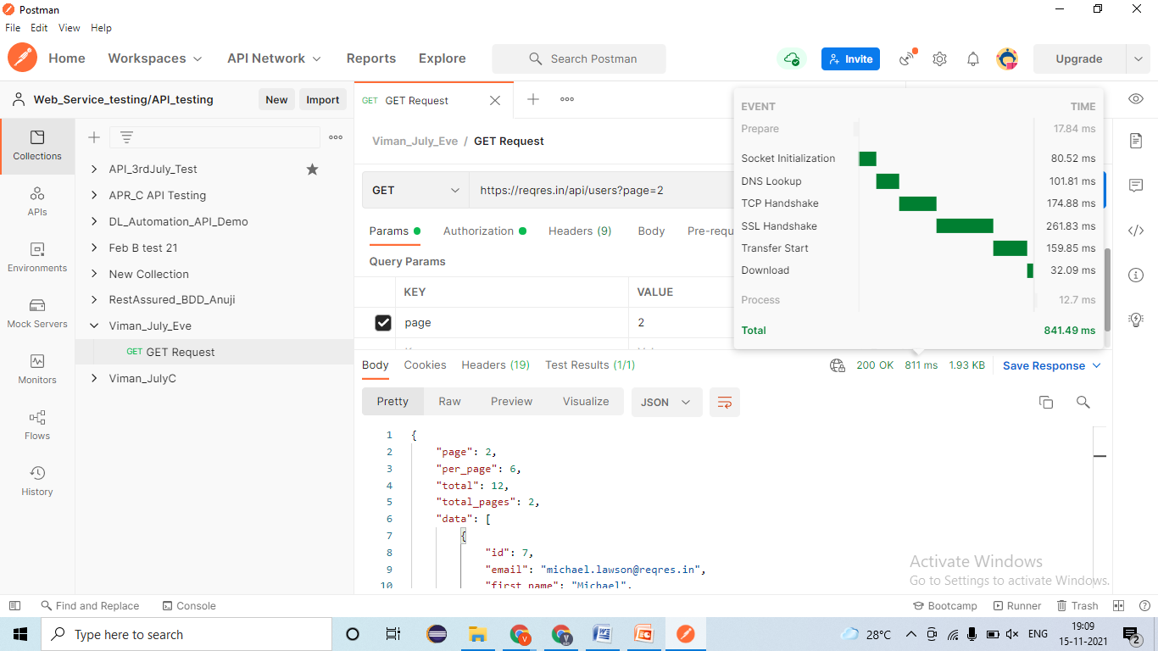
6. Applying Assertion for verification 🡪

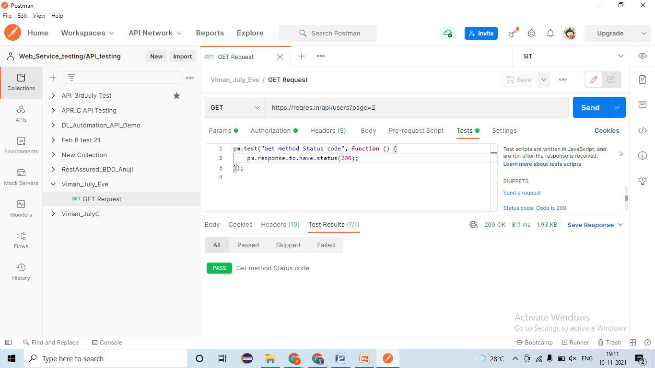

1. Validating the Functionality by passing test data
   1. Verify the total employees present in Rest service 2/ Server 2 🡪 EC= 200-ok=Pass 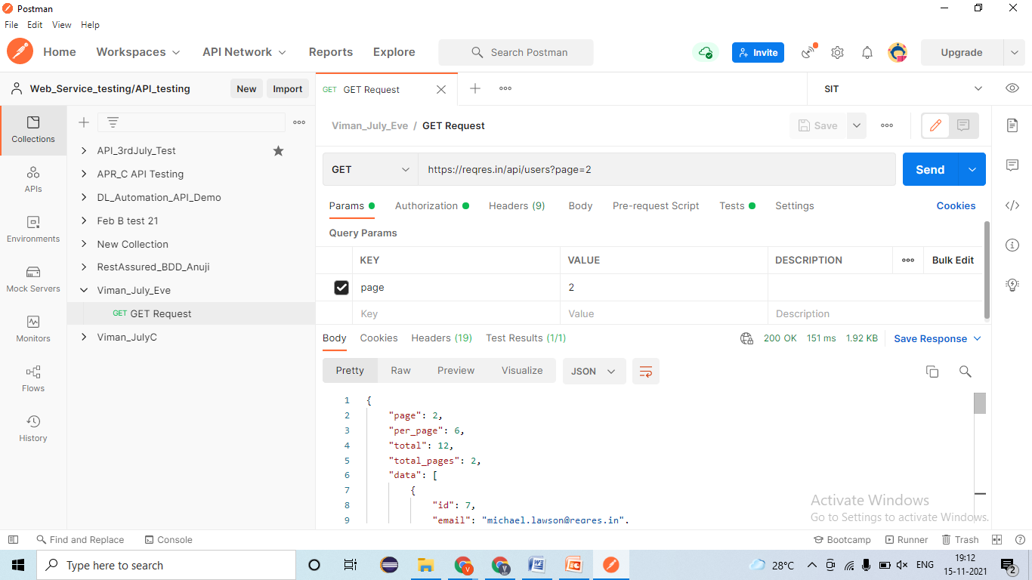
   2. Verify the page=1 employees data present in Rest service 2/ Server 2 🡪 EC= 200-ok=Pass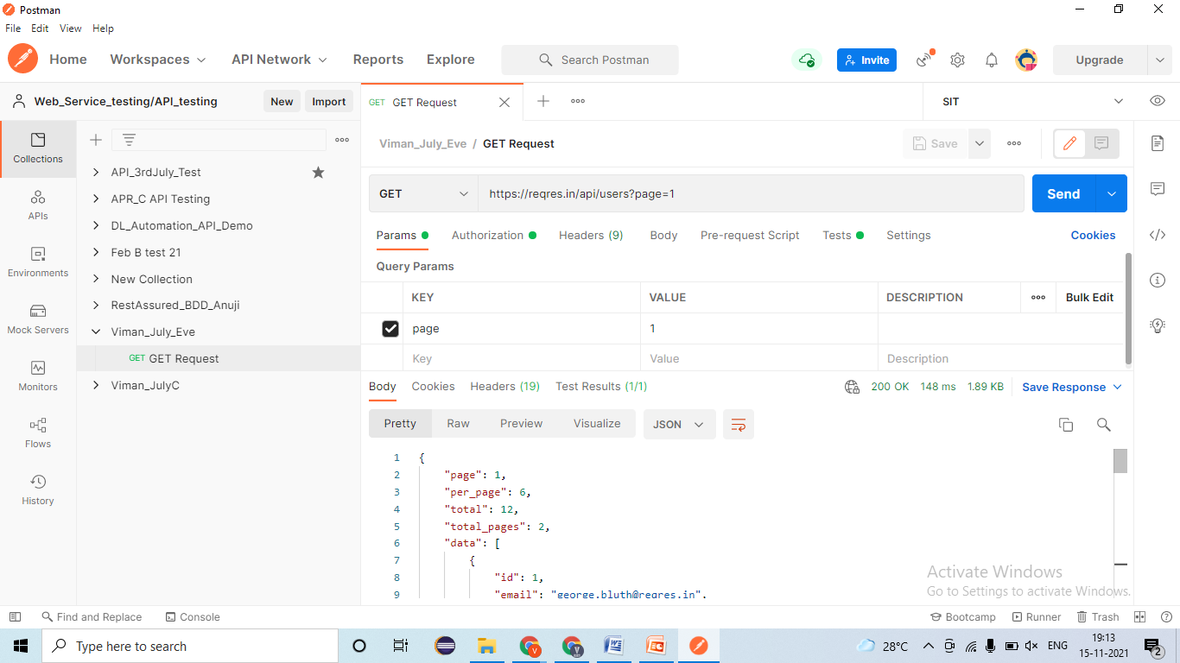
   3. Verify the page=2 employees data present in Rest service 2/ Server 2 🡪 EC= 200-0k=Pass 
   4. Verify the page=3 employees data present in Rest service 2/ Server 2 🡪 EC= 200-ok=Pass 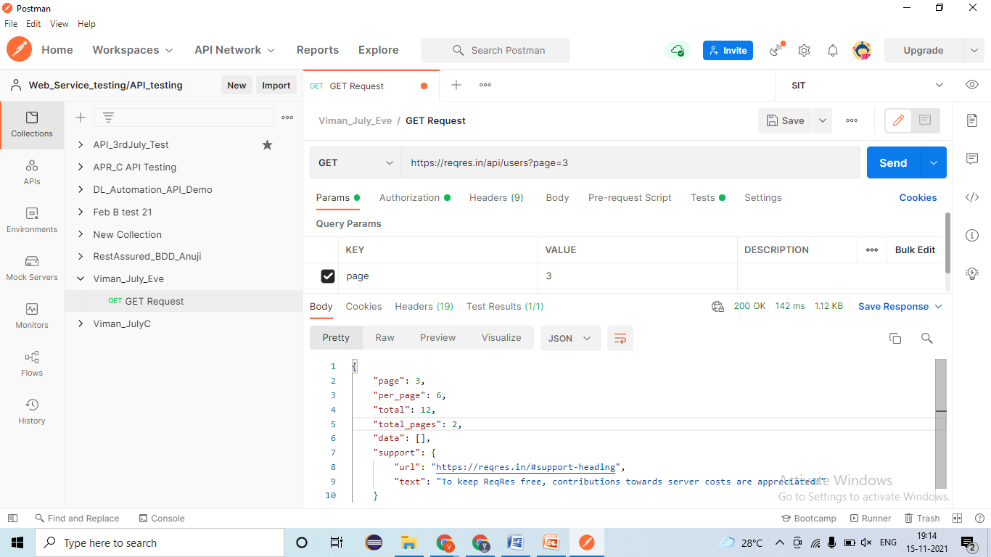
   5. Verify the page=4/5/6/7/etc employees data present in Rest service 2/ Server 2 🡪 EC= 200-ok=Pass 
2. Validating NEGATIVE test cases!
   1. Verify the bypassing charter in page=one/two/three employees data present in Rest service 2/ Server 2 🡪 EC= 400-Bas request=**Fail- defect** 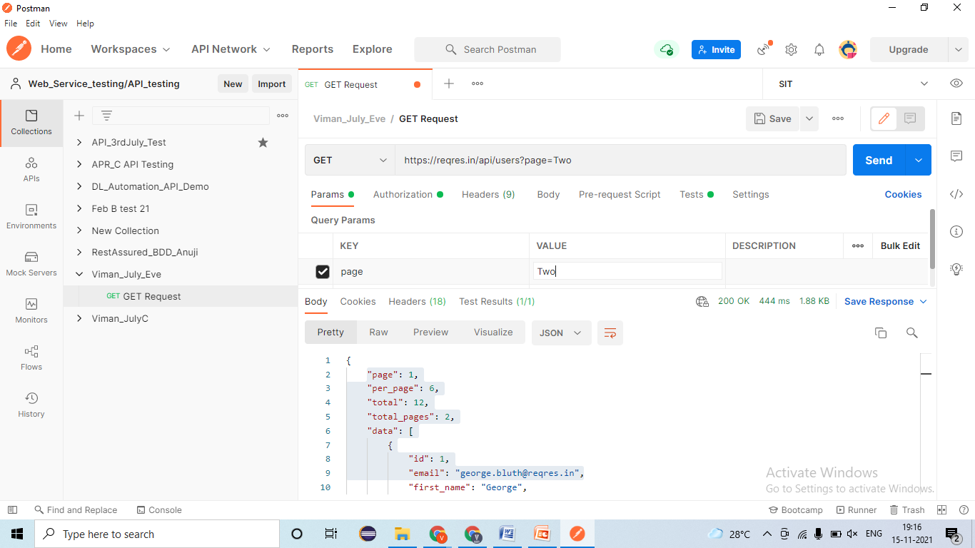
   2. Verify the page=Null/ Blank employees data present in Rest service 2/ Server 2 🡪 EC= 400-Bas request= **Fail- Defect** 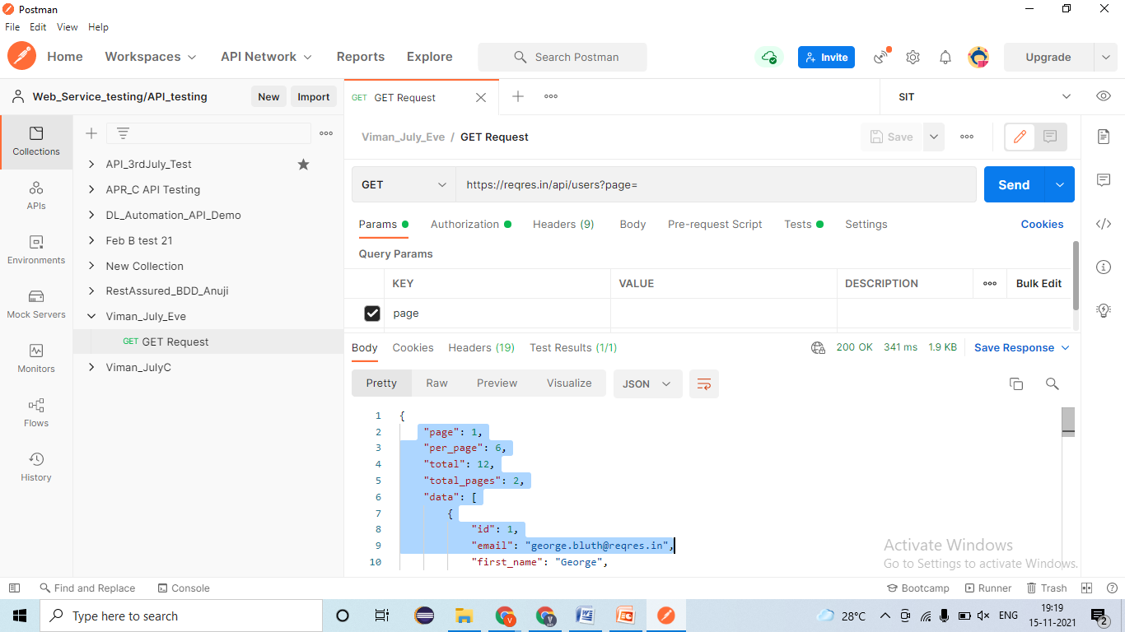
   3. Verify GET request by passing wrong URL/URI 🡪 EC= 404- Not Found= Pass 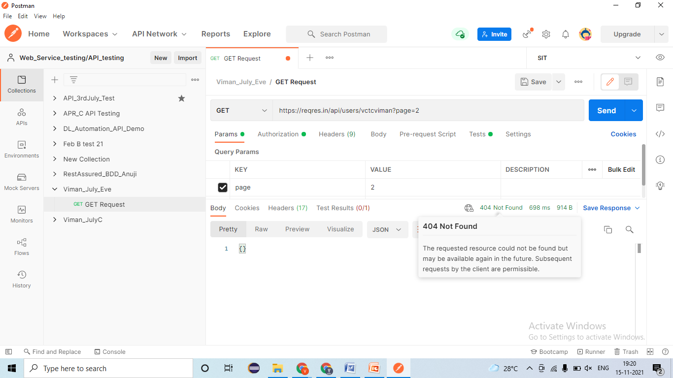
   4. Verify GET request by passing wrong Barrier token/ API Key 🡪 EC= 401- Un-authorized
   5. Verify by changing GET request into another request by 🡪 EC= 405- Method not allowed=Fail- defect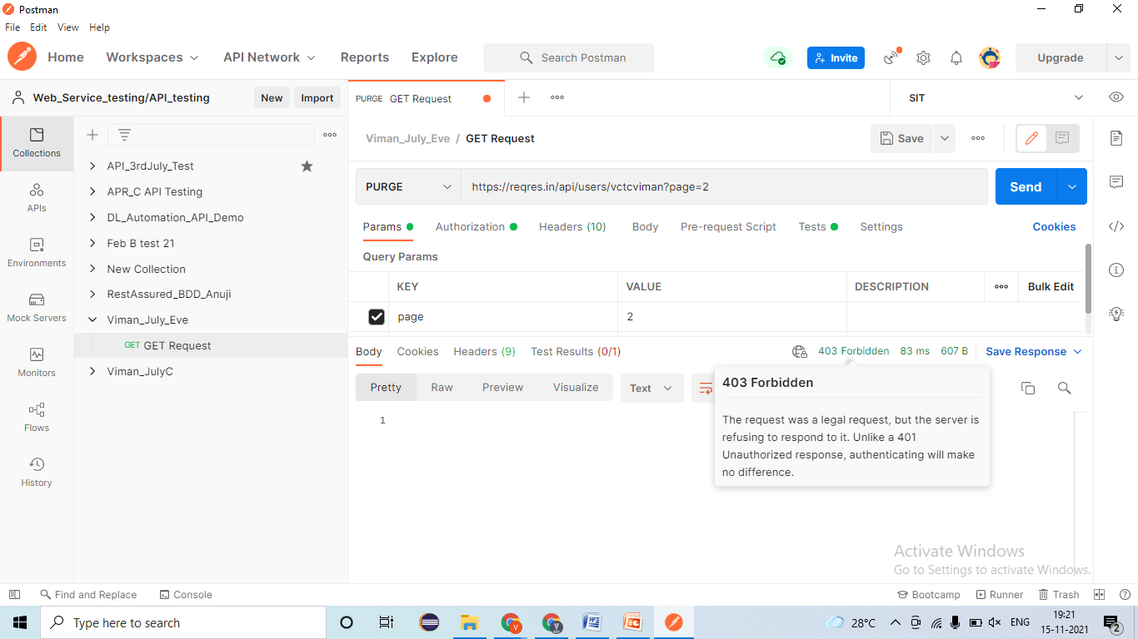

### POST Method/Request-

* **Developer will provides -**
* REST Service- **URl/URI file**= <https://reqres.in/api/users>
* **Body/ Payload-**

|  |
| --- |
| {  "name": "morpheus",  "job": "leader"  } |

* Authentication/ Barrier token/ Username & password = bdewafdfscvgbhgfsdf
* Time for response < 60 sec
* Unit Testing document- Steps for testing, URL/URI, Tables name, etc

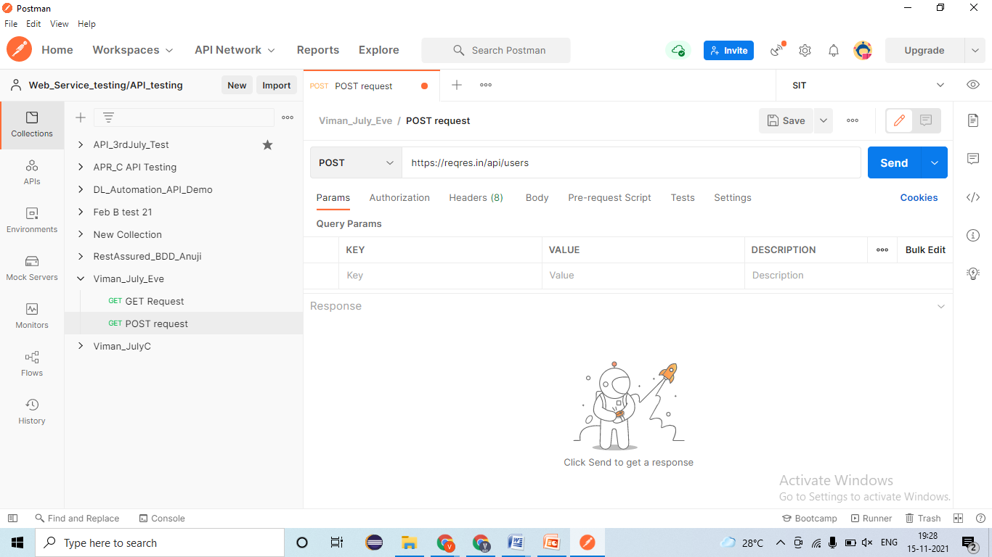

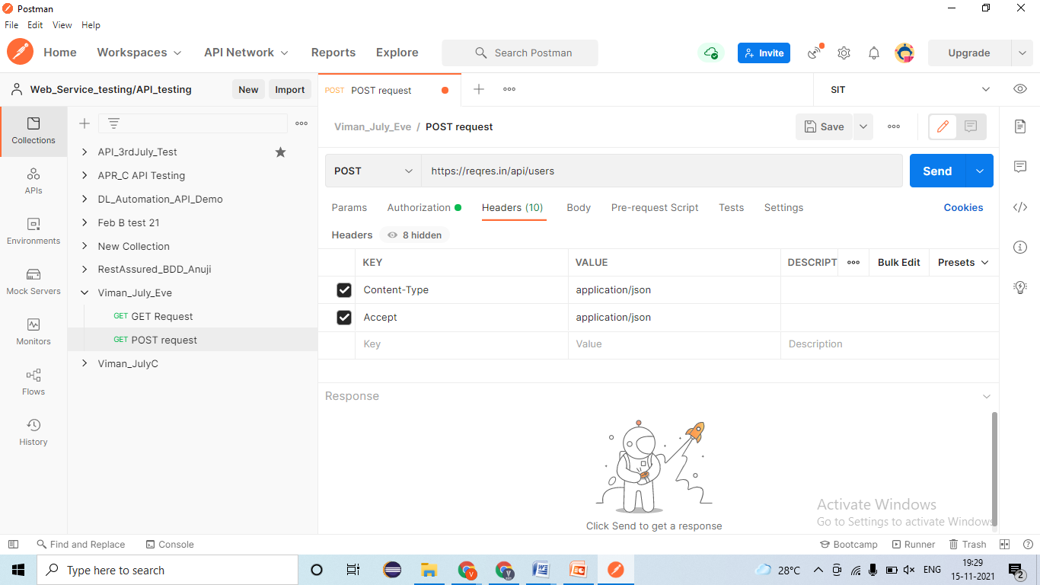

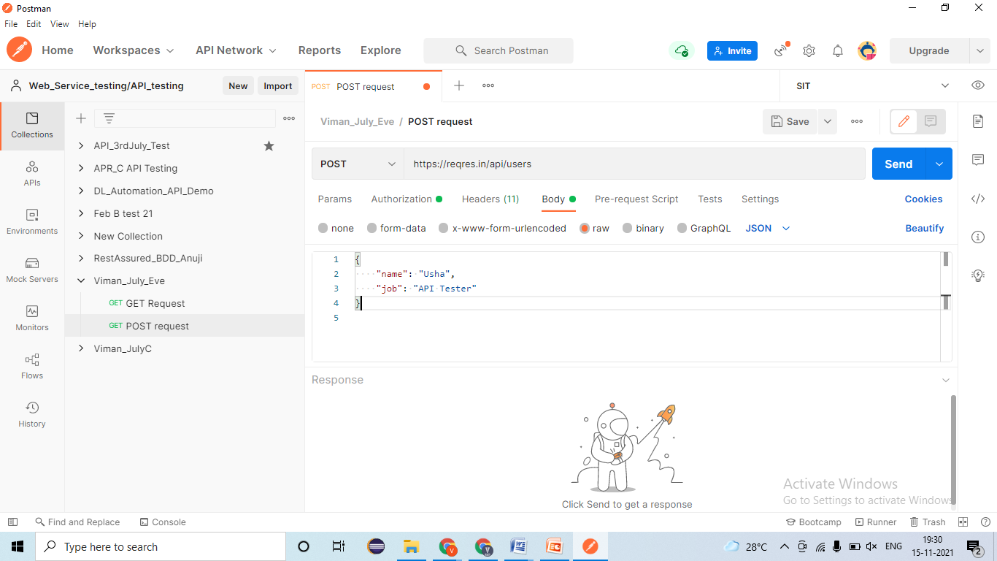

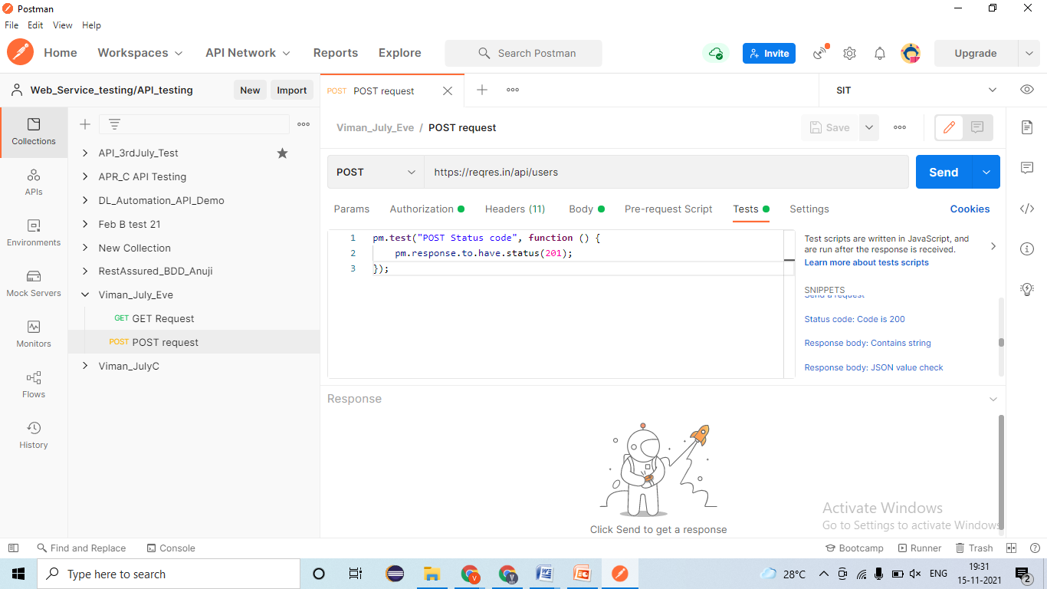

1. Validating Rest response🡪 EC- Rest response should be present=Pass 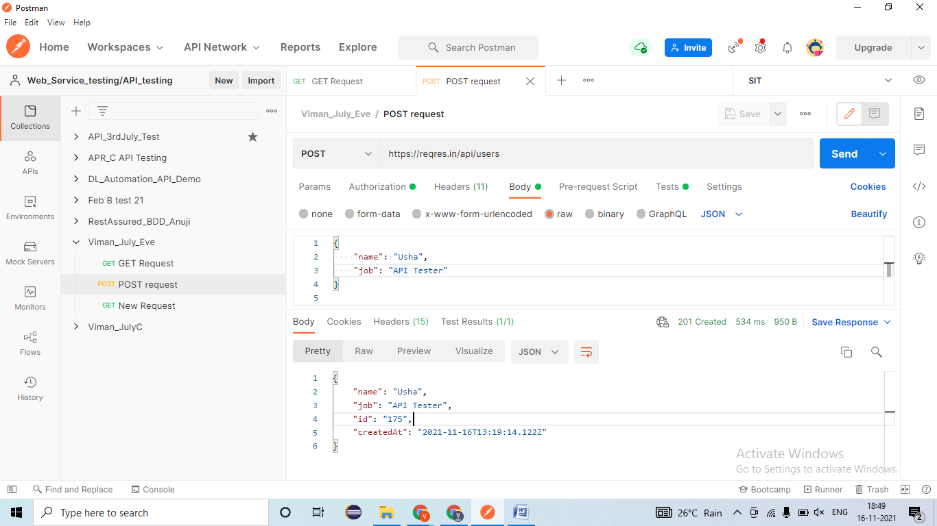
2. Validating Data and count of data in response🡪EC- Data should create only once =Pass 
3. Validating Tagname/Attributes presents in responses🡪EC- ID, Name, Job, CreatedAt =Pass 
4. Validating different Status code in responses🡪EC – 201- Created=Pass 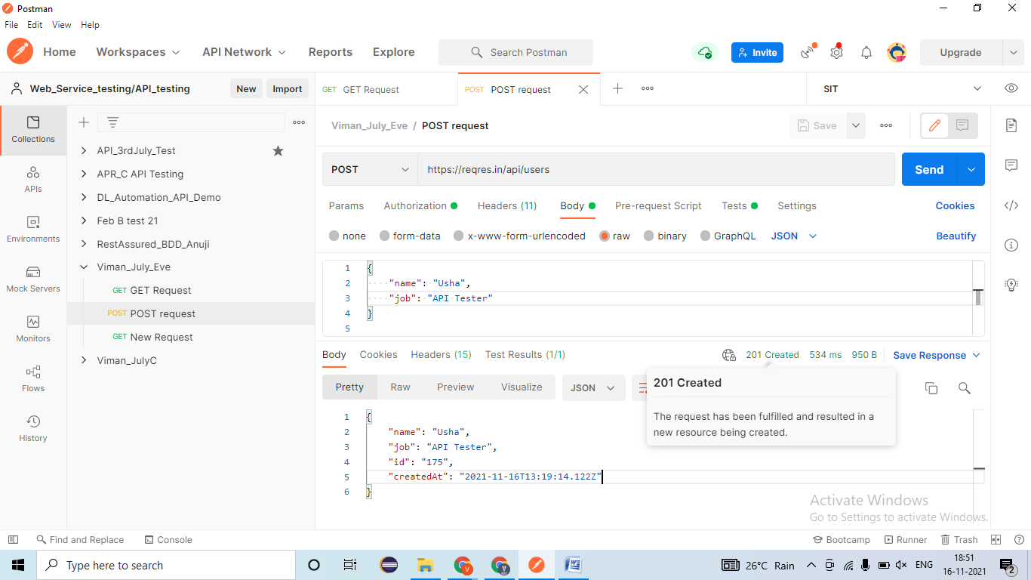
5. Validating Time taken for responses🡪 EC – resonse < 60sec= Pass 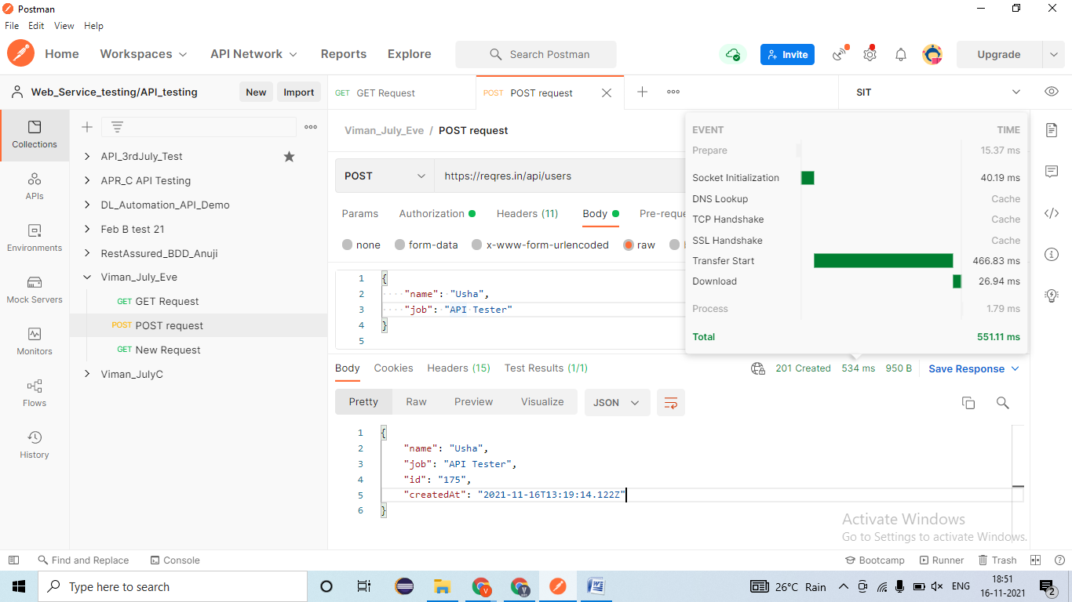
6. Applying Assertion for verification 🡪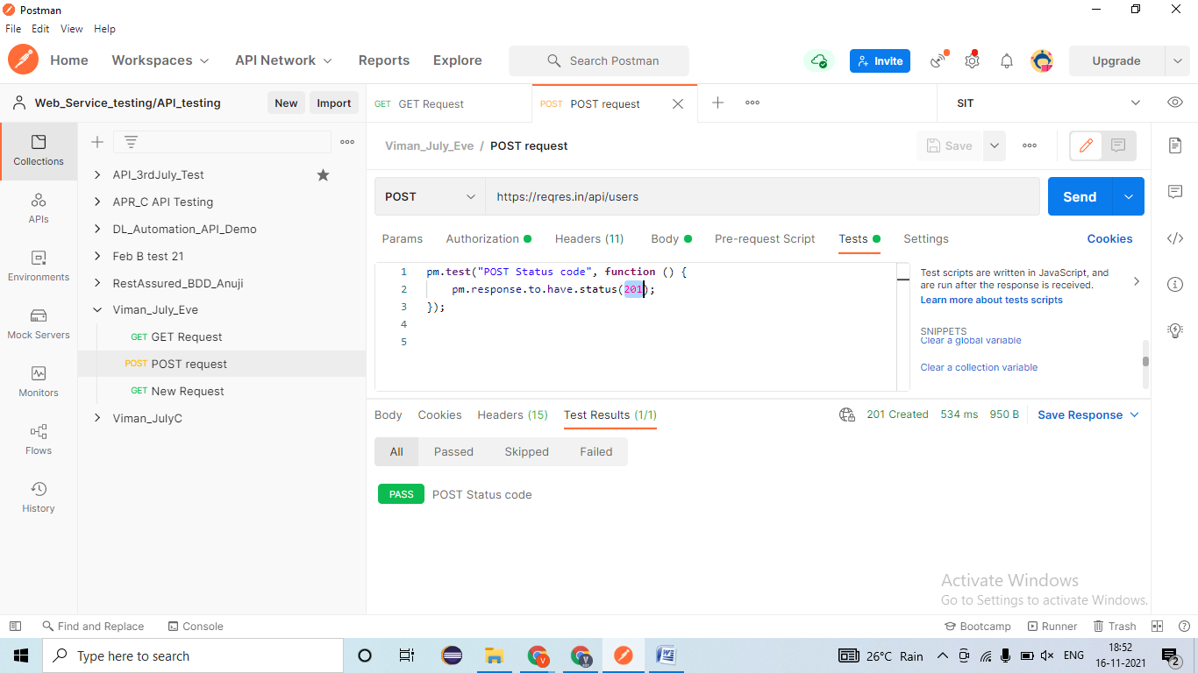
7. Validating the Functionality by passing test data
   1. Verify the POST request by passing API Tester as Job 🡪 EC- Data should be created & 201- created=Pass 
   2. Verify the POST request by passing Manual Tester as Job 🡪 EC- Data should be created & 201- created=Pass 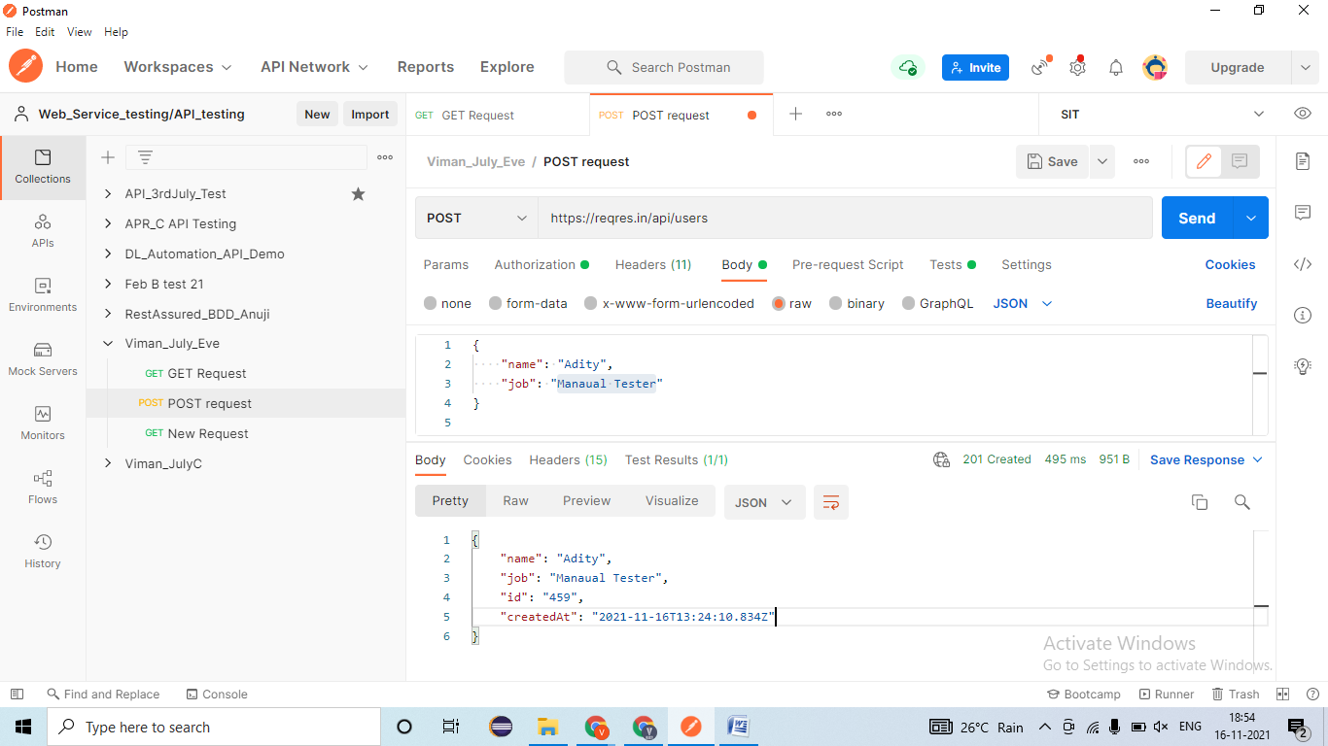
   3. Verify the POST request by passing Automation Tester as Job 🡪 EC- Data should be created & 201- created=Pass 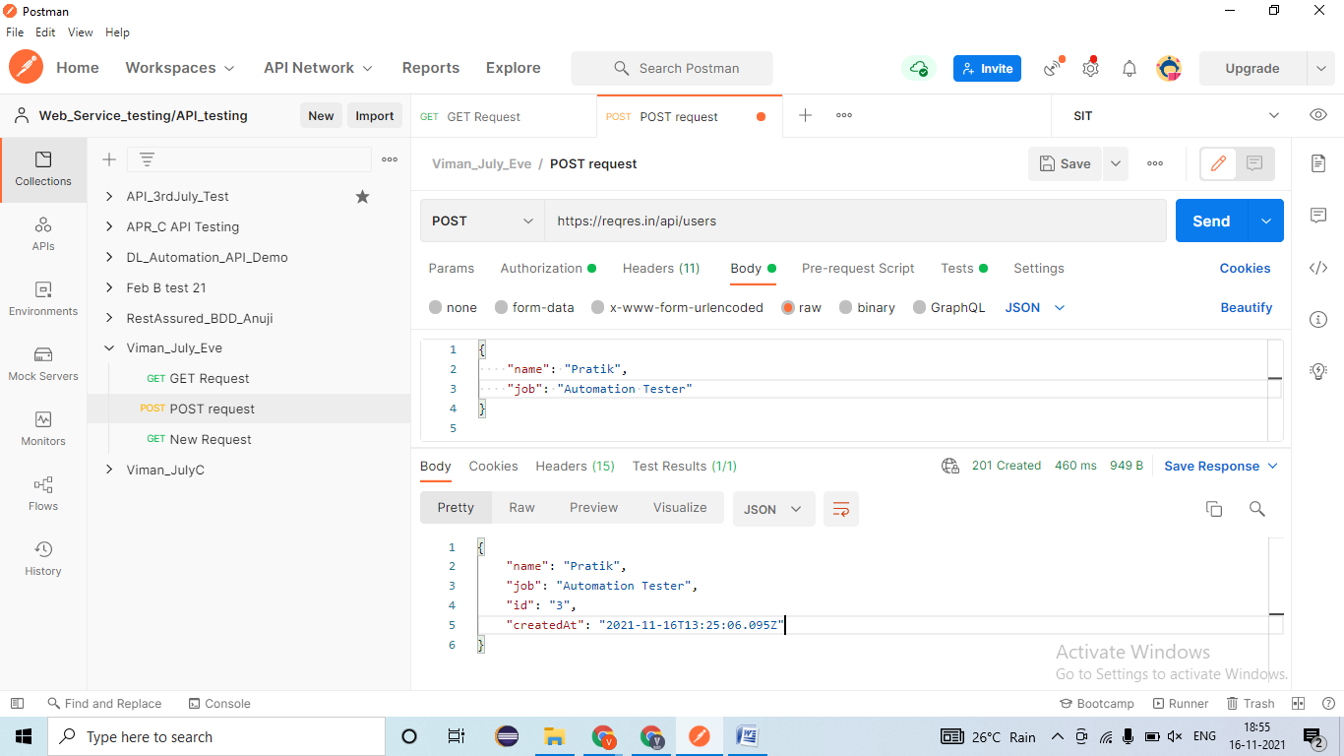
   4. Verify the POST request by passing DB Tester as Job 🡪 EC- Data should be created & 201- created=Pass 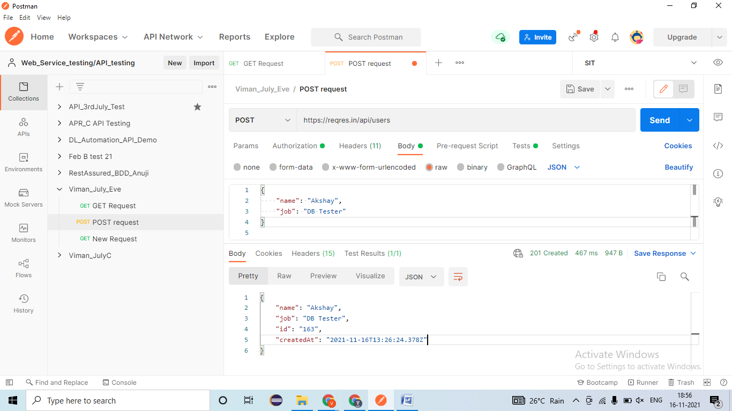
8. Validating NEGATIVE test cases!
   1. Verify the POST request by passing Wrong URI/URL (https://reqres.in/api/vctc/users)🡪 EC- 404- Not Found=Fail- defect (JIRA/ HPALM) 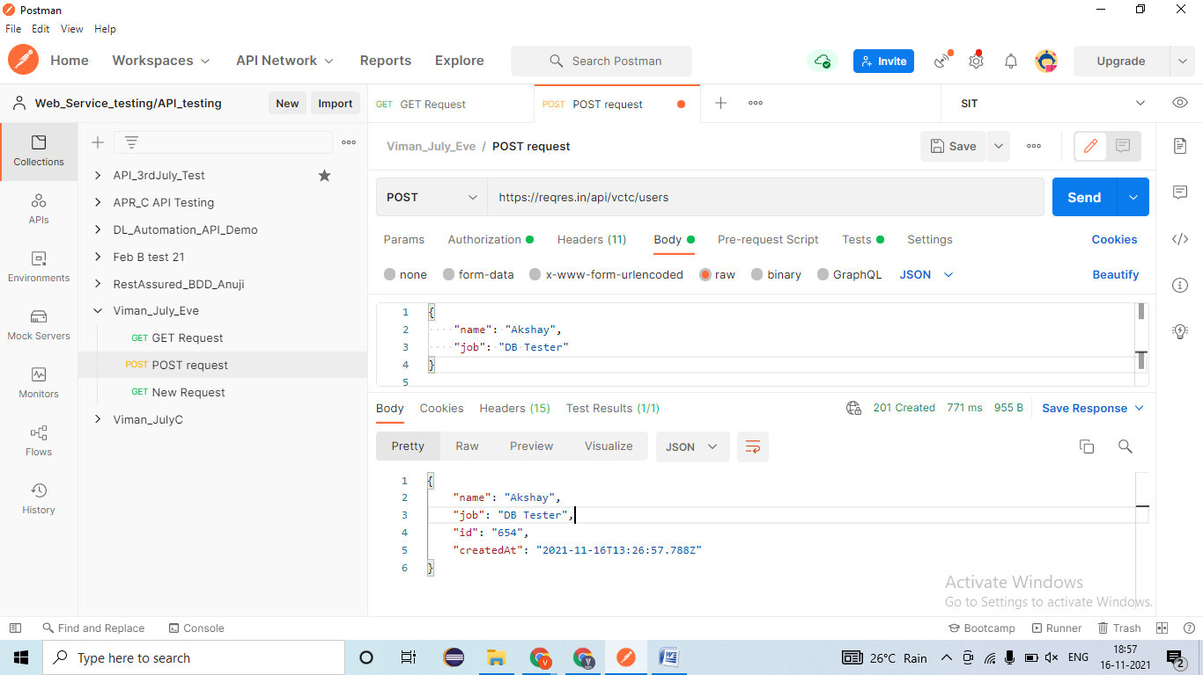
   2. Verify the POST request by passing Wrong URI/URL (https://reqres.in/api/vctc/users)🡪 EC- 404- Not Found=Pass 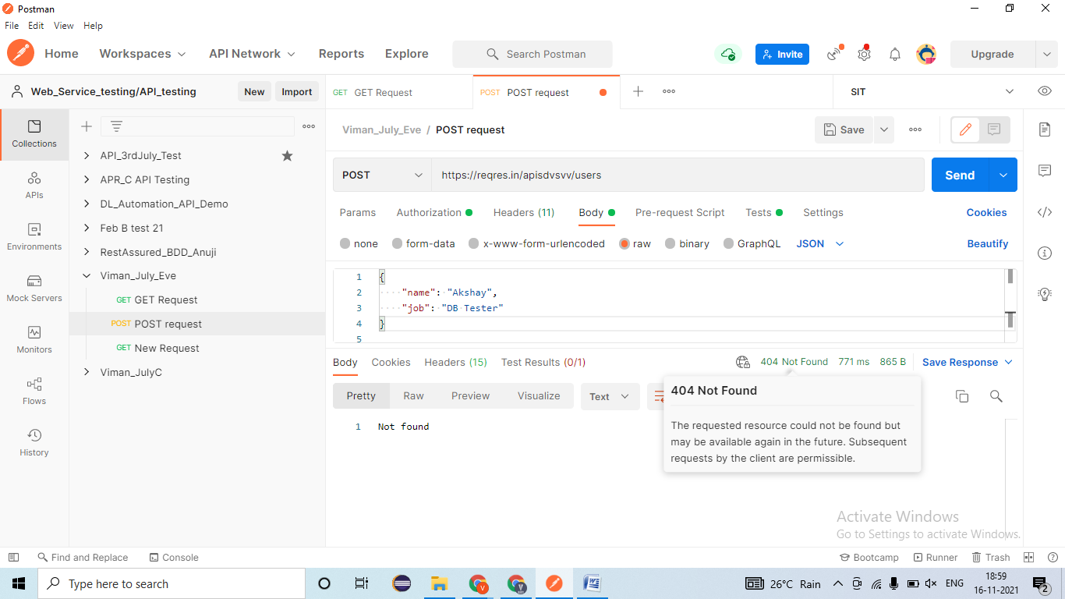
   3. Verify the POST request by passing Null/ blank Body/ Payload 🡪 EC- 400- Bad request=Pass 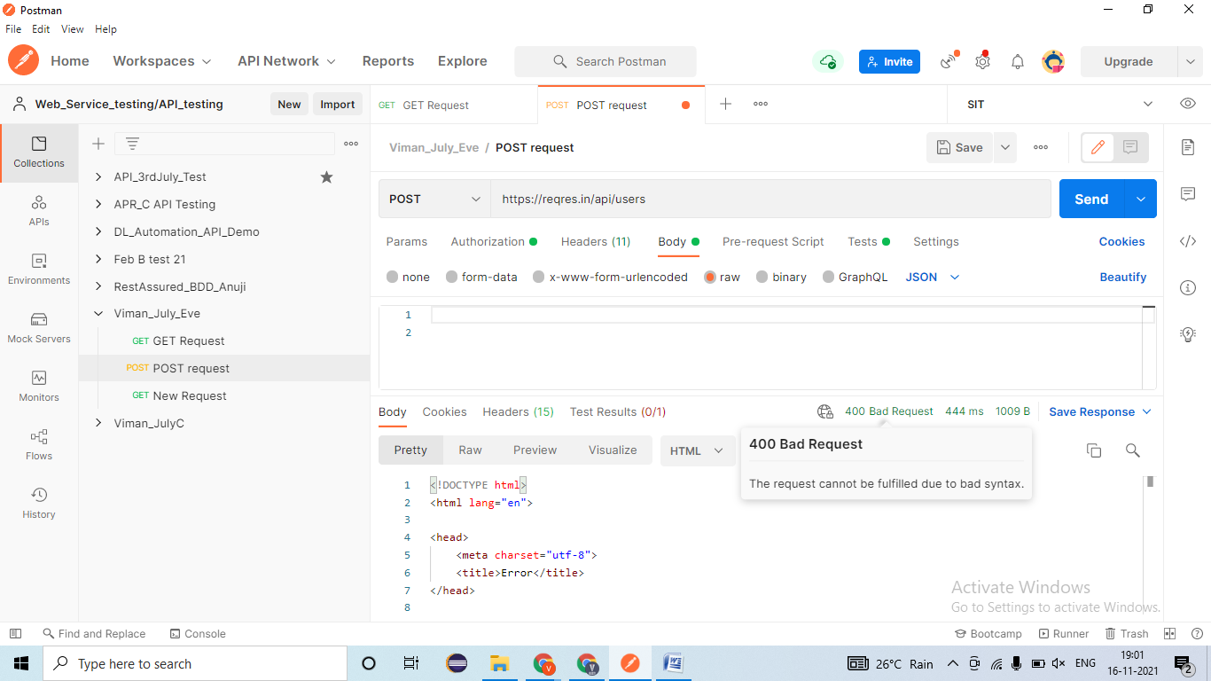
   4. Verify the POST request by passing wrong Body/ Payload 🡪 EC- 400- Bad request=Pass 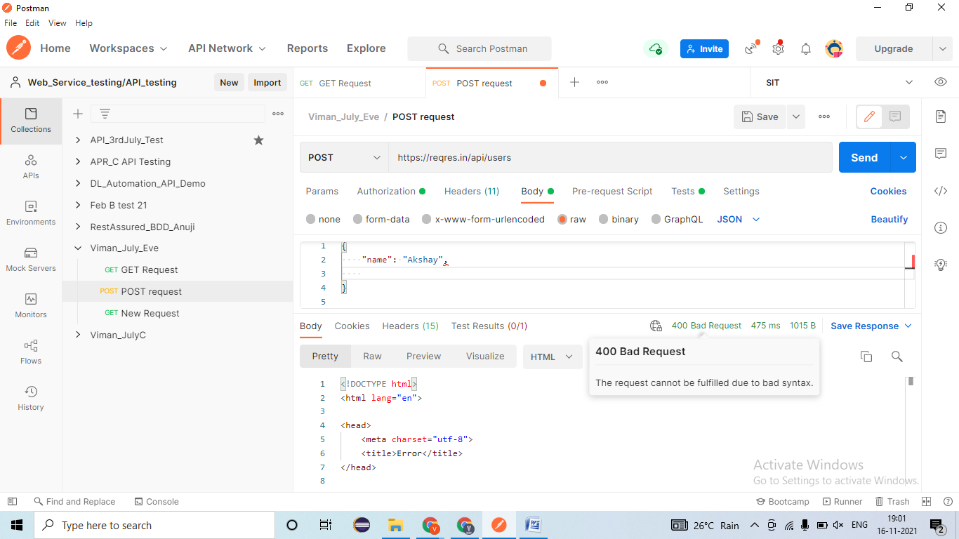
   5. Verify the POST request by passing wrong API key Body/ Payload 🡪 EC- 401- Un-authorized=
   6. Verify the by changing POST request into another method (TRANCE) 🡪 EC- 405- Method not allowed= Fail- defect 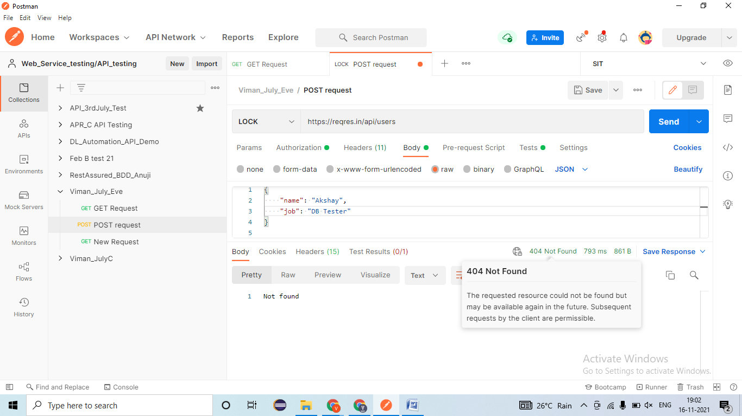

### PUT Method/Request-

* **Developer will provides -**
* REST Service- **URl/URI file**= <https://reqres.in/api/users/2>
* Body/ Payload-

|  |
| --- |
| {  "name": "morpheus",  "job": "leader"  } |

* Authentication/ Barrier token/ Username & password = bdewafdfscvgbhgfsdf
* Time for response < 60 sec
* Unit Testing document- Steps for testing, URL/URI, Tables name, etc

1. Validating Rest response🡪 EC- Rest response should be present=Pass
2. Validating Data and count of data in response🡪EC- Data should create only once =Pass
3. Validating Tagname/Attributes presents in responses🡪EC- Name, Job, CreatedAt =Pass
4. Validating different Status code in responses🡪EC – 201- Created=Pass
5. Validating Time taken for responses🡪 EC – resonse < 60sec= Pass
6. Applying Assertion for verification 🡪
7. Validating the Functionality by passing test data
   1. Verify the PUT request by changing API Tester Job to Automation Tester🡪 EC- Data should be updated & 202- Accepted=Fail - defect
   2. Verify the PUT request by changing Manual Tester Job to API Tester🡪 EC- Data should be updated & 202- Accepted=Pass
   3. Verify the PUT request by changing Automation Tester Job to Manual Tester🡪 EC- Data should be updated & 202- Accepted=Pass
   4. Verify the PUT request by changing DB Tester Job to API Tester🡪 EC- Data should be updated & 202- Accepted=Pass
8. Validating NEGATIVE test cases!
   1. Verify the PUT request by passing Wrong URI/URL🡪 EC- 404- Not Found=Fail- defect (JIRA/ HPALM)
   2. Verify the PUT request by passing Null/ blank Body/ Payload 🡪 EC- 400- Bad request=Fail - defect
   3. Verify the PUT request by passing wrong Body/ Payload 🡪 EC- 400- Bad request=Pass
   4. Verify the PUT request by passing wrong API key Body/ Payload 🡪 EC- 401- Un-authorized=
   5. Verify the by changing PUT request into another method (TRANCE) 🡪 EC- 405- Method not allowed= Pass

### DELETE Method/Request-

* **Developer will provides -**
* REST Service- **URl/URI file**= <https://reqres.in/api/users/2>
* Authentication/ Barrier token/ Username & password = bdewafdfscvgbhgfsdf
* Time for response < 60 sec
* Unit Testing document- Steps for testing, URL/URI, Tables name, etc

## Real REST API Testing-

API Key- abe5bdb0a984910eb4b5a6a82a0a245d

GET request- URL- api.openweathermap.org/data/2.5/weather?q={city name}&appid=[{API key}](https://home.openweathermap.org/api_keys)

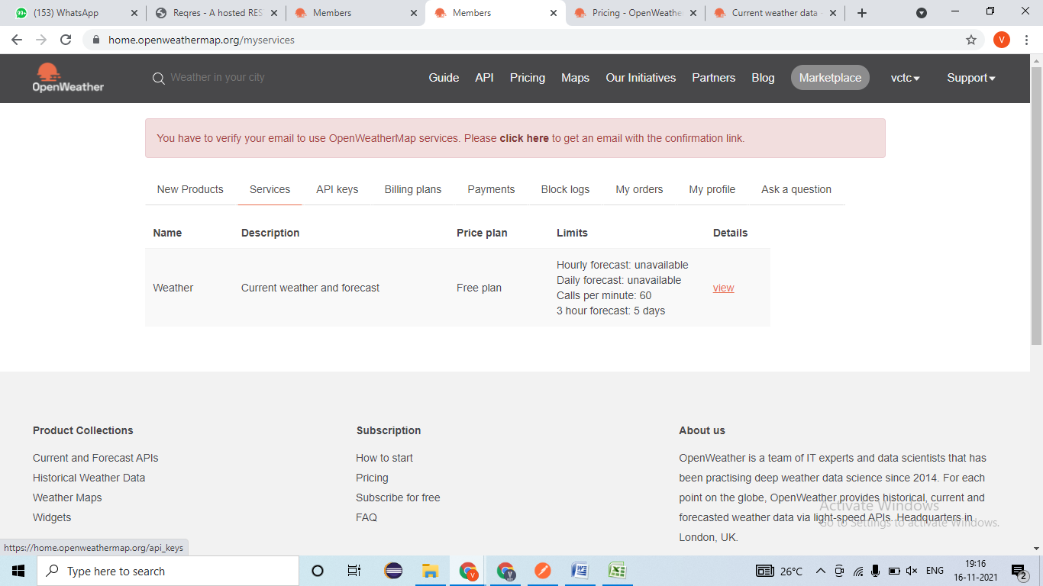

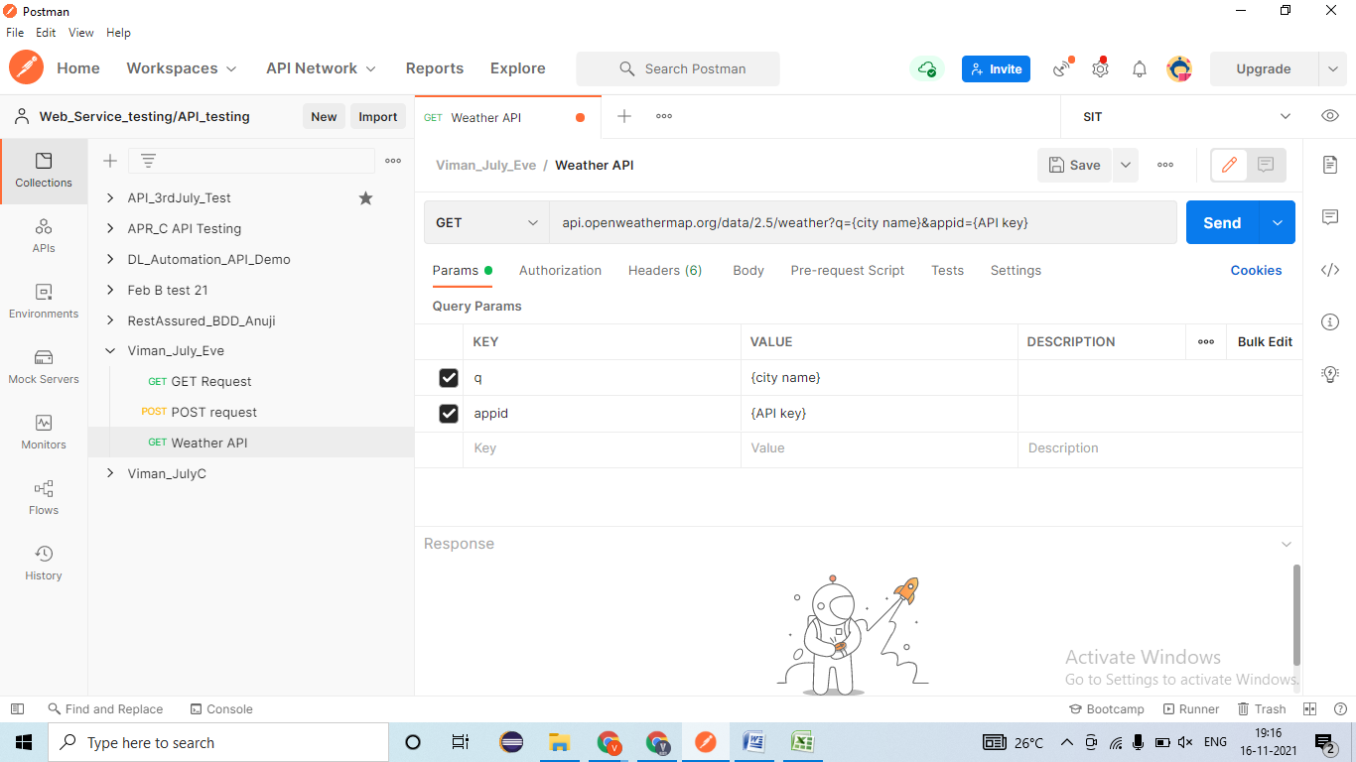

# Variables –

**Global variable-**

